GIST Blockchain Intelligence Convergence Center and River Vance Co., Ltd. hold a meeting with the Korean American Chamber of Commerce

– Discussion on establishing a global blockchain economic system

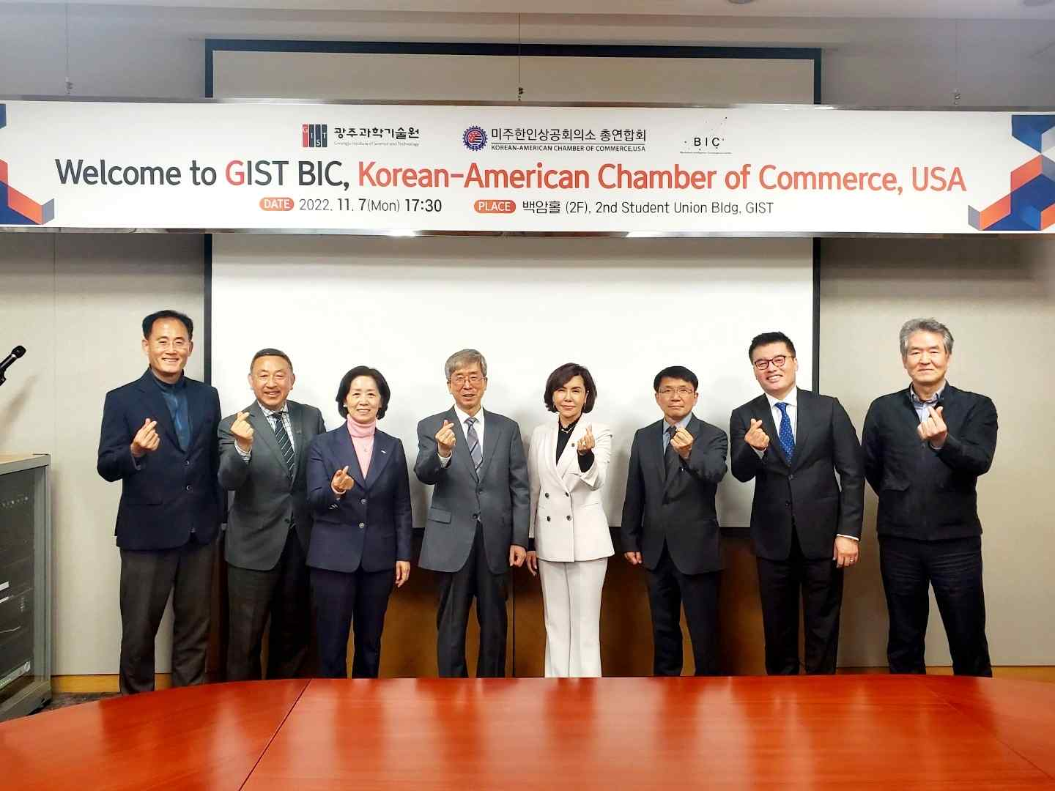
▲ Former GIST President Seung Hyeon Moon (fourth from left) and KACCUSA Global Business Director Mi-kyung Kim (fifth from the left) take a commemorative photo.

GIST (Gwangju Institute of Science and Technology, President Kiseon Kim) Blockchain Intelligence Convergence Center and start-up company River Vance Co., Ltd. (Center Director and CEO: Professor Heung-No Lee) held a meeting on November 7th (Mon) at GIST with the executives of the Korean American Chamber of Commerce.

The meeting was held with Blockchain Intelligence Convergence Center Director and River Vance Co., Ltd. CEO Heung-No Lee, GIST Invited Scholar Professor Seung Hyeon Moon, GIST Professor Byoung Seung Ham, Santa Clara Korean Chamber of Commerce Ho-yeol Bang, Santa Clara Korean Chamber of Commerce Vice Presdient In-beom Song, Global Business Director Mi-kyung Kim, Washington Chamber of Commerce Chairman Yong-guk Park, Korea ICT Convergence Association Chairperson Yang-soon Baek, GIST Technology Commercialization Center Director Seong-Geun Ki, GIST researcher Ji-oh Lee, researcher Haewoong Choi, researcher Seung-beom Kang, and researcher Joo-Sung Kang.

This meeting was held based on exchanges and cooperation between River Vance Co., Ltd. and the Korean American Chamber of Commerce. The two organizations signed a memorandum of understanding (MOU) on April 14 at the 8th meeting room of the National Assembly Members' Hall to advance into the American market and promote trade.

At this meeting, overcoming the trilemma of decentralization, scaling, and security, building a network to verify and test WorldLand* protocol suites such as Ethereum Istanbul was discussed in building a global blockchain economic system that can be used by the global village with open source code and publications.

* WorldLand: The WorldLand project, promoted by River Vance, is a project built by hard forking the latest version of the Ethereum mainnet under the motto of 'protecting the economic sovereignty of global citizens in the upcoming post-globalization era'. It aims to pursue the traditional blockchain path, emphasizing the importance of privacy and security. The core of this project, which started from the viewpoint that it is more important to upgrade PoW (Proof-of-Work) than to give up on security and decentralization, lies in the new consensus algorithm. Worldland's algorithm adopts the verifiable computation (VC) algorithm that has improved the existing hash-based PoW. Based on this, Worldland's blockchain is 'post-quantum security in both consensus and virtual machine', 'ASIC resistance of consensus engine', 'consensus that inherits the advantages of PoW and strengthens decentralization. It aims to have the aspect of a fully functional blockchain equipped with 'engine' function.

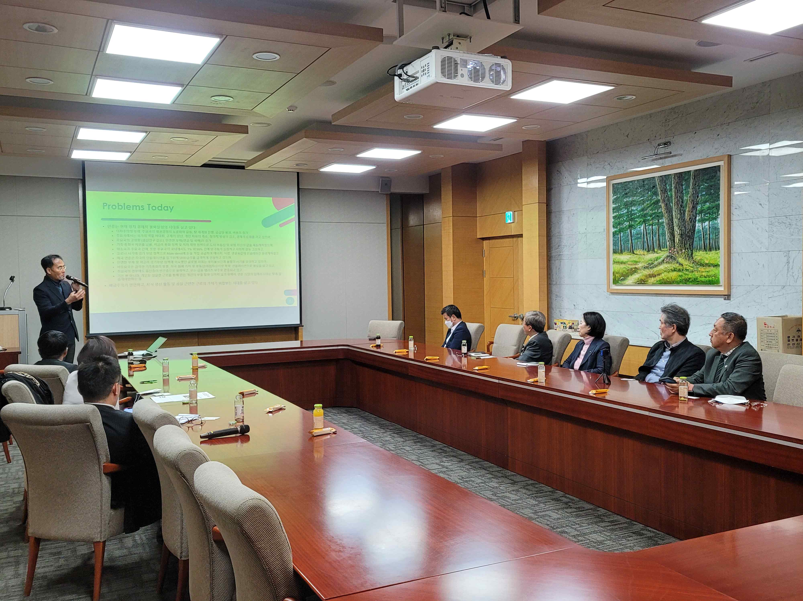
▲ Heung-No Lee, head of GIST ITRC Blockchain Intelligence Convergence Center and CEO of Rivervance Co., Ltd., is holding a meeting with the executives of the Korean American Chamber of Commerce held at GIST on the 7th.

GIST Blockchain Intelligence Convergence Center (BIC) was selected for the University ICT Research Center Development Support Project (ITRC) of the Ministry of Science and ICT in July of last year, and developed zero-knowledge sensing, cryptographic authentication, and blockchain-based cloud service convergence technology. Korea University, Seoul National University, and Ajou University are participating, including GIST, as the host organization.

River Vance Co., Ltd. is a Kyowon venture company established in January 2020 and is a decentralized blockchain total solution provider. Within two years of its establishment, the company succeeded in attracting angel investment in TIPS R&D in recognition of its strength in technology.



