Professor Kyoobin Lee, "Pay attention to the development of the robot industry using AI" <November Breakfast Forum> held

– GIST Academy, held the <November Breakfast Forum> on the 28th (Mon) with the theme of ‘Sharing R&D for Small and Medium Businesses’

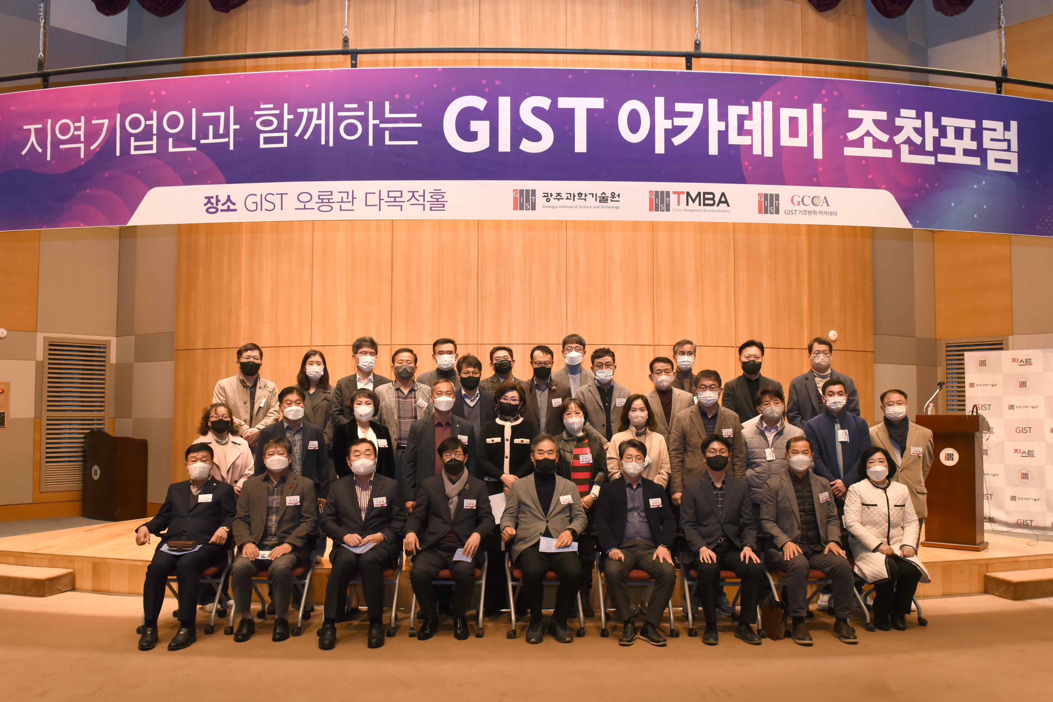
▲ Commemorative photo of GIST Academy holding November Breakfast Forum at Oryong Hall

GIST (Gwangju Institute of Science and Technology, President Kiseon Kim) Academy was held on a breakfast forum on November 28th (Mon) under the theme of ‘Sharing R&D of Small and Medium Enterprises (GIST, KAIST, DGIST, UNIST)’ at Oryong Hall, with about 60 representatives from Gwangju and Jeonnam region attending.

GIST School of Integrated Technology Professor Kyoobin Lee was a speaker at the forum and gave a lecture focusing on ▲ICT/SW divisions and core technologies shared by divisions ▲R&D planning and development of the SME R&D Sharing Center, focusing on the achievements of cooperation with companies.

The ICT/SW Division is carrying out a project to share various ICT/SW technologies of the four science and technology institutes, including artificial intelligence robot research of the GIST Artificial Intelligence Lab and KAIST's Human-Robot Interaction Lab, which are in charge of the division's operation, with domestic SMEs.

Professor Kyoobin Lee also introduced the contents of 'A-SKD that can detect low-resolution face areas', a recent research result. This achieves a high level of face recognition and detection performance even using low-resolution images and is expected to be used for identification in low-resolution images obtained through CCTV.

In addition, the results of joint research and development and industry-academia cooperation technology development were presented, such as the development of deep learning algorithms for estimating the location of implant placement (completed in May 2022) and the ongoing AI learning data construction project-hidden object inference data, and examples of their use explained. In particular, Professor Kyoobin Lee drew the attention of the participants by presenting examples of AI deep learning applications that are being applied in various forms in the robot industry.

Professor Lee explained research on cloud-based robotics research, such as unlearned object detection of hidden areas (UOAIS) and unlearned object stable placement model (SOP), as well as research on medical and deep learning algorithm development, and emphasized that artificial intelligence robots can be used in various industries.

The GIST Academy operates the Techno Management Business Academy (opened in 2010) and the Climate Change Academy (opened in 2016) as non-degree courses. The GIST Academy Breakfast Forum is held on the last Monday of every month, inviting experts from various fields as lecturers to alumni and executives of local companies.

The GIST Academy supports executives in each field to deeply understand changes in the business environment and global management strategies through lectures by the best experts in Korea, form a wide human network, and contribute to the vitalization of the local economy and industry-university cooperation.



