Beneficial start-up event held during GIST Science and Culture Week

– CEO Forum and Start-up Night where you can see GIST’s startups at a glance, held offline for the first time in 3 years

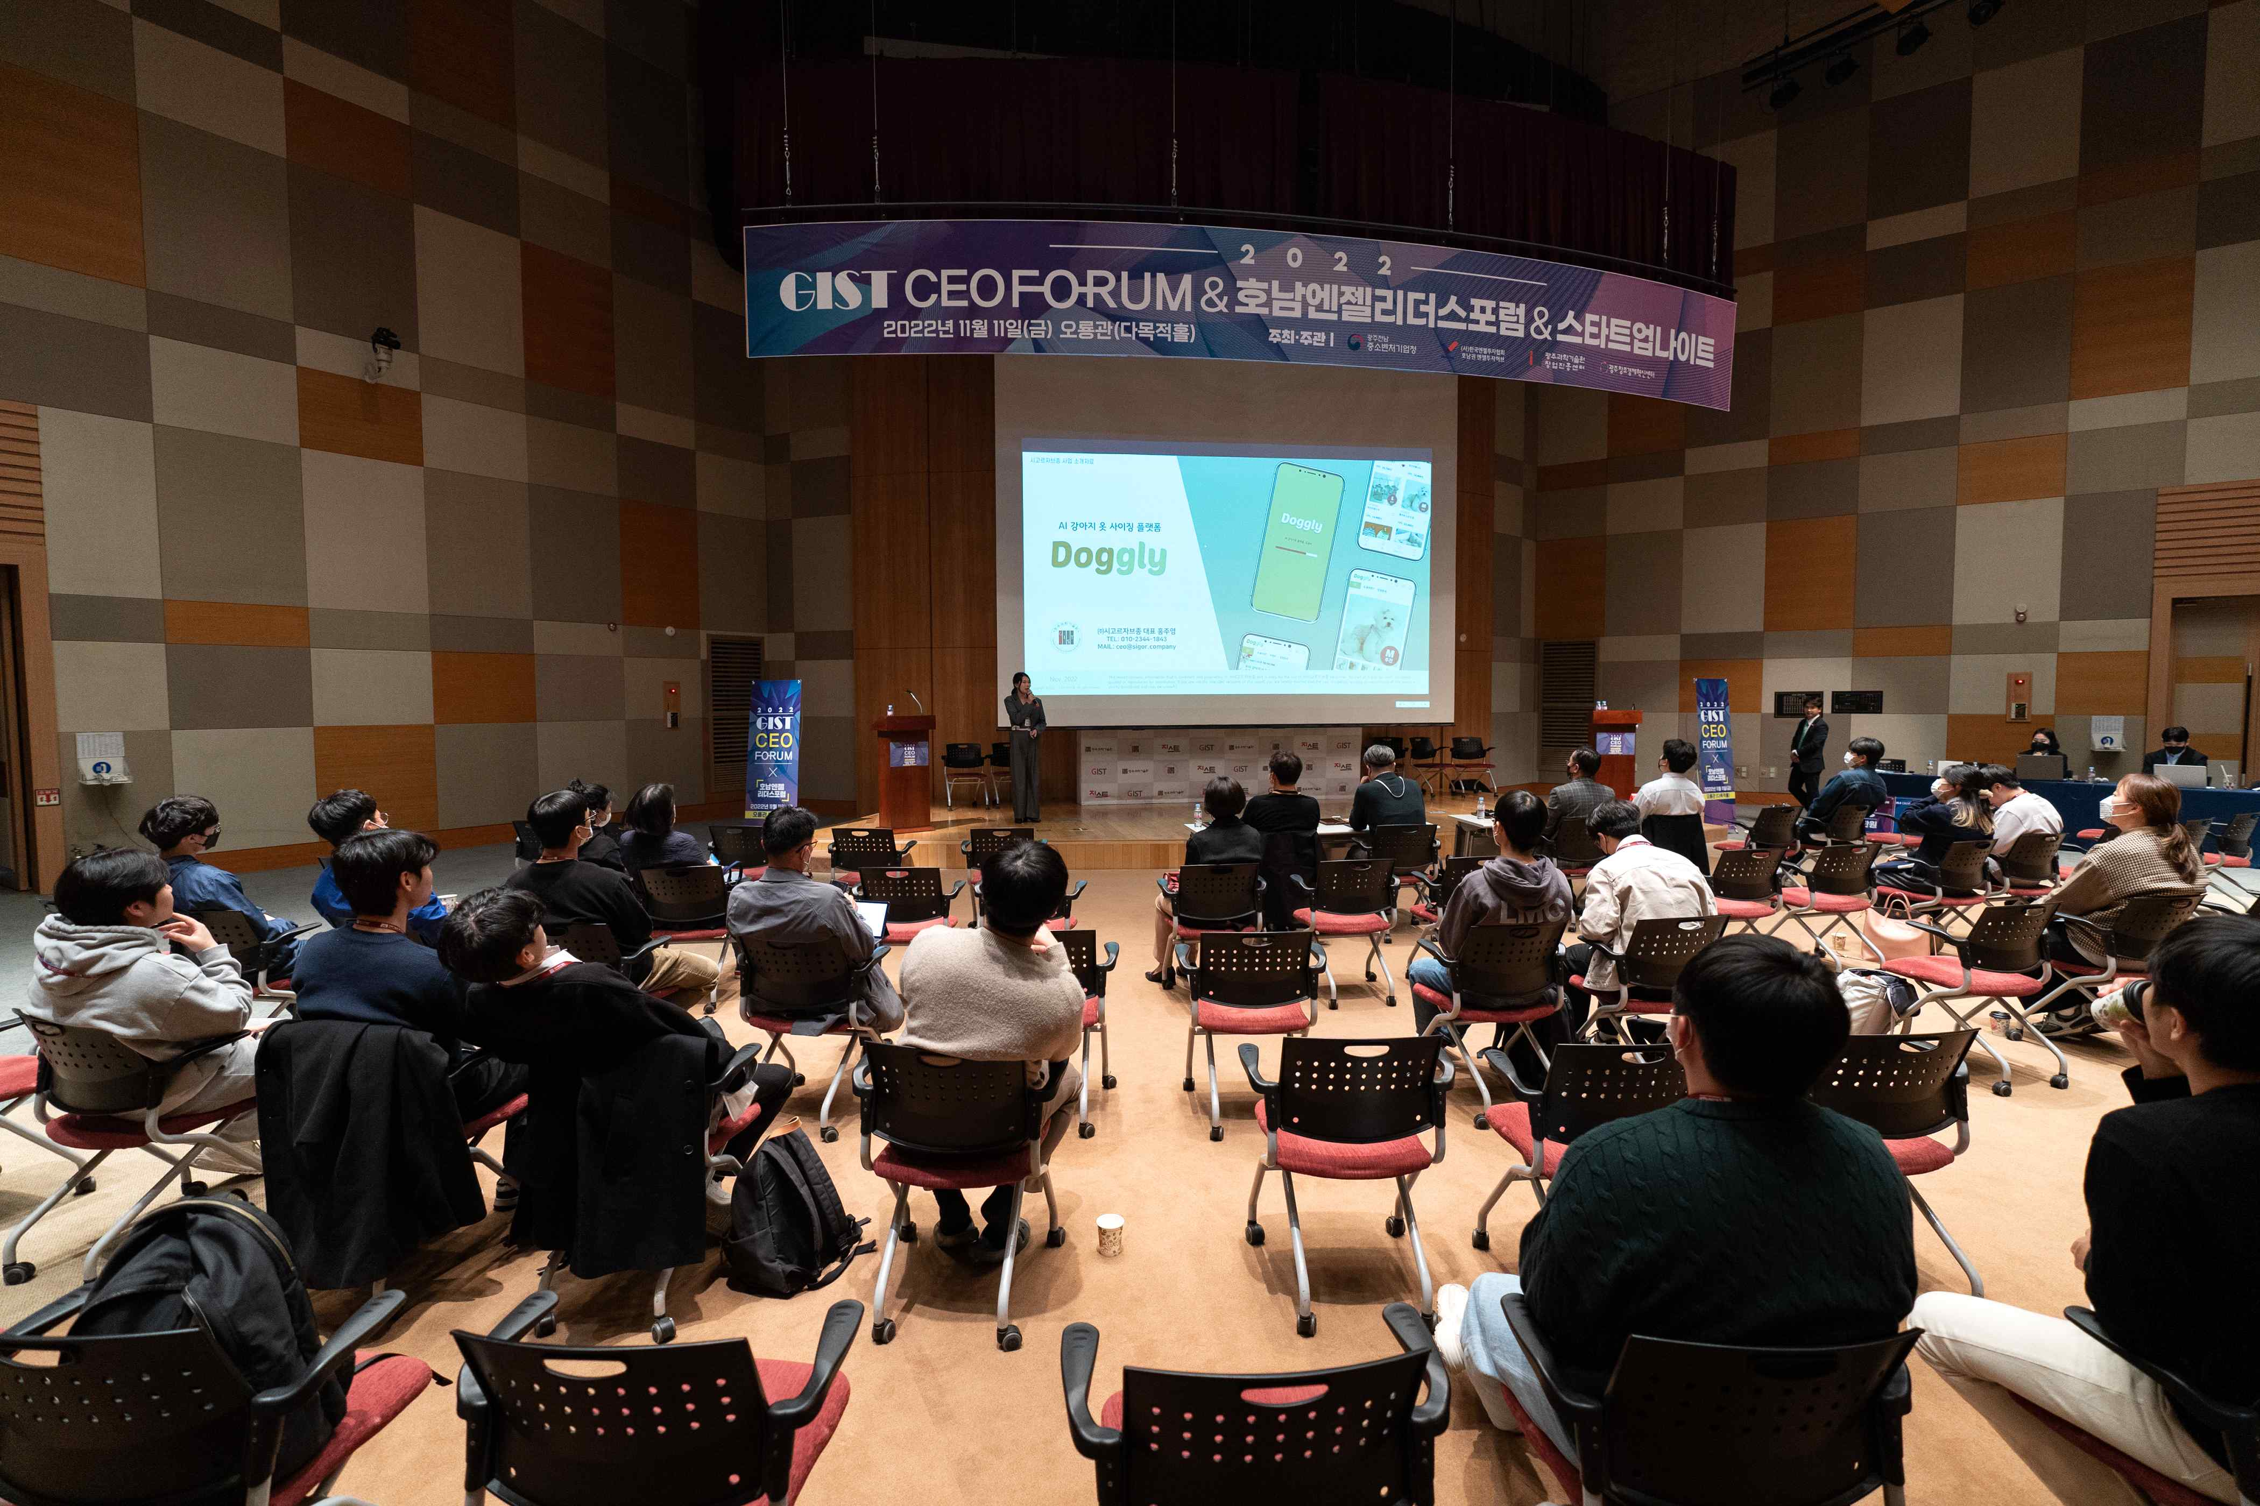
▲ <GIST CEO Forum> and <GIST START-UP NIGHT> were successfully held off-line at Oryong Hall three years after the COVID-19 pandemic.

<GIST CEO Forum>, a startup-related event representing GIST (Gwangju Institute of Science and Technology President Kiseon Kim), and <GIST START-UP NIGHT> was successfully held offline three years after the COVID-19 pandemic.

The two events hosted by the GIST Business Incubator were recently held online due to the impact of COVID-19. This year, <GIST Science and Culture Week> was held on November 11th (Friday) at Oryong Hall in a heated atmosphere with about 300 people attending, including GIST College and graduate students and officials from investment institutions.

The <GIST CEO Forum>, co-hosted with the Honam Angel Leaders Forum for the 7th time this year, is an event to discover excellent technology startup teams in the region and introduce various funding methods to startups.

At the forum, Chae-gwang Kim, vice president of the Korea Angel Investment Association, gave a speech on the topic of 'financing through angel investment' and discussed the method of meeting angel investors as a method of raising funds for startups and the mechanism by which angel investors find startups.

Il Seo, head of the center at Angel Investment Hub in the Honam region, had a time to introduce the Honam region policy fund to guide the formation of policy funds in Gwangju, Jeollanam-do, Jeonbuk, and Jeju regions.

In the talk concert that followed, TIPS (Tech Incubator Program for Startup), which is well-known as a funding task for technology-based startups, was held and introduced the process selected for TIPS and gave advice to GIST College and graduate students preparing to start a business ▲ Joo-young Hong, CEO of Sigorjavson Co., Ltd. ▲ Im Jin-ha, CEO of Group by HR Co., Ltd. ▲ GIST entrepreneurs, such as CEO Min-joon Kim of Cloudstone Co., Ltd. and director ae-wook Song.

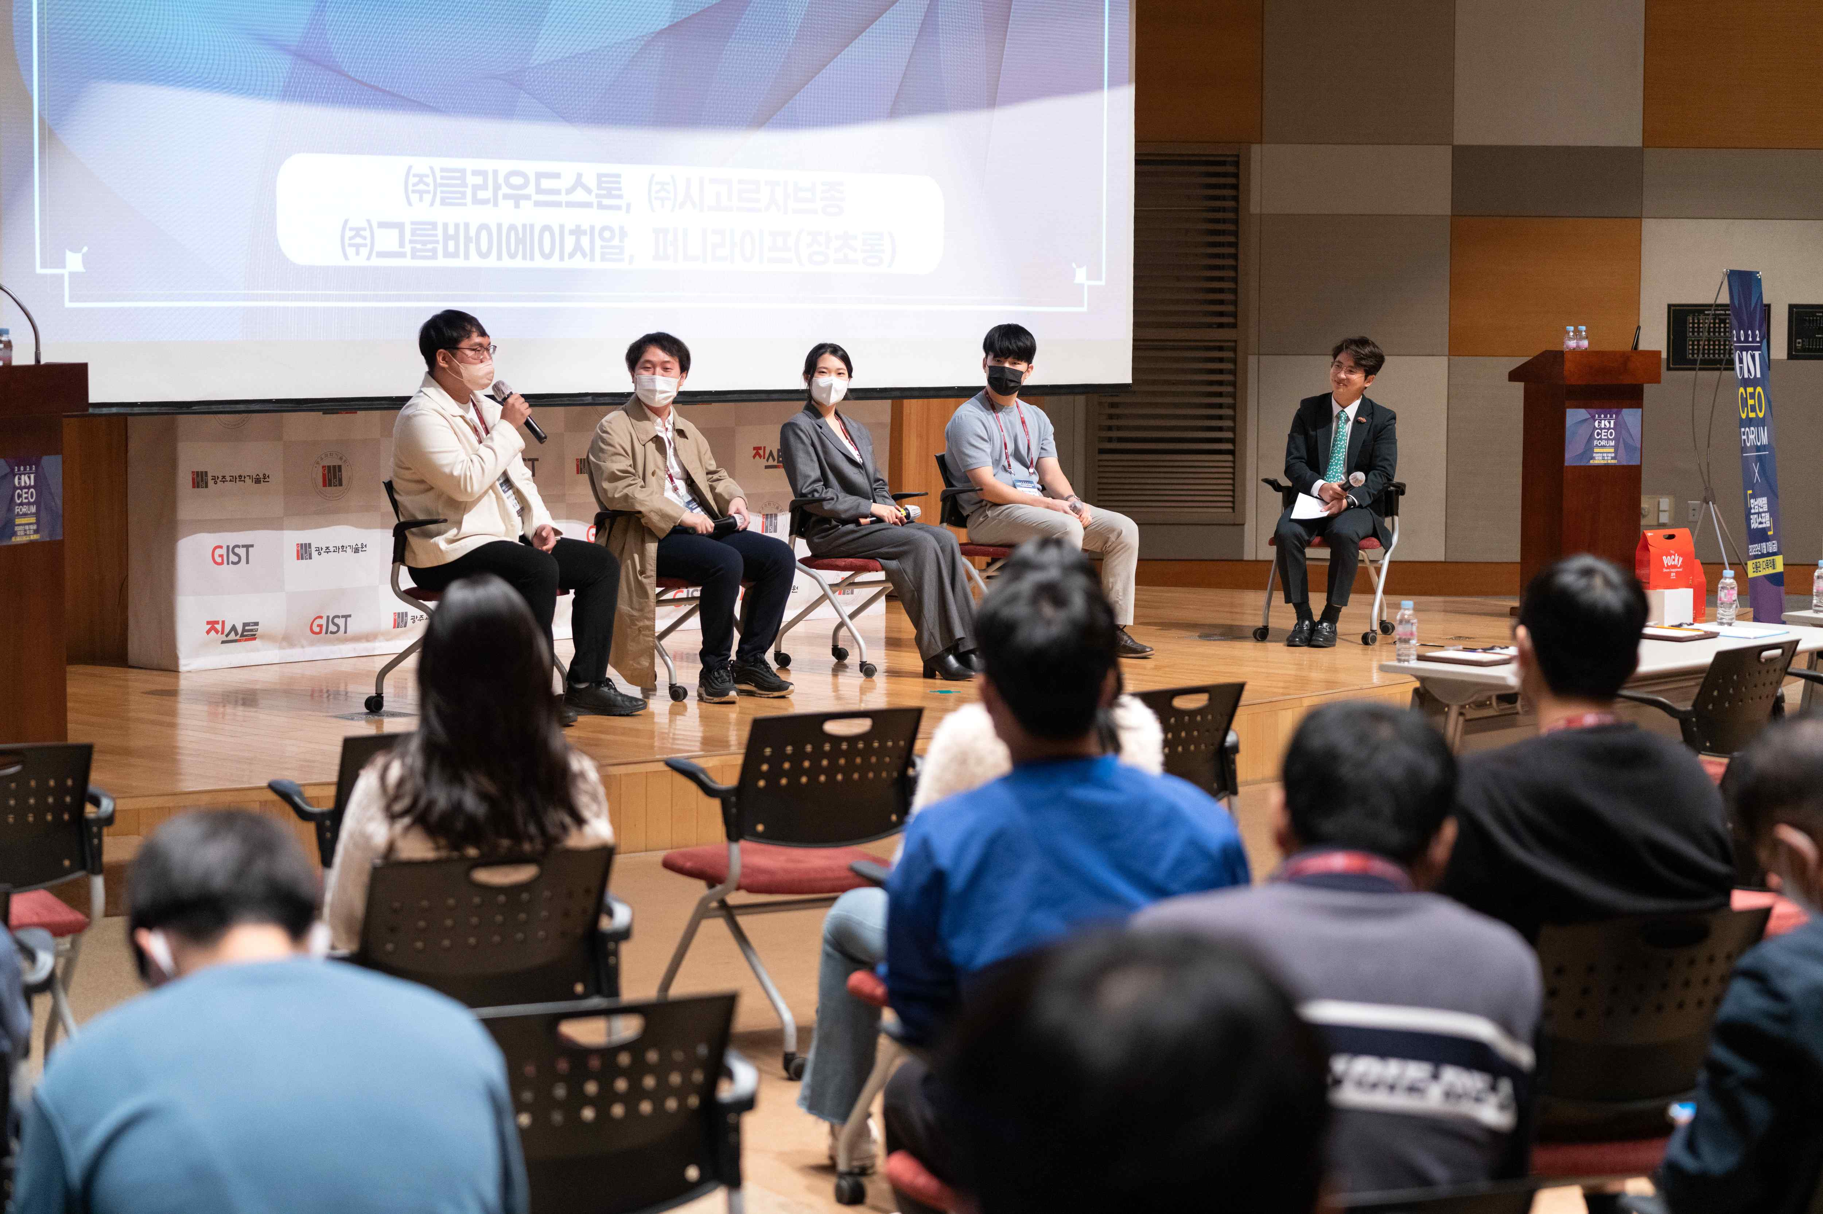
▲ Performing TIPS at the talk concert ▲ Cloudstone CEO Min-joon Kim and Director Dae-wook Song ▲ City Gorjavjong CEO Joo-young Hong ▲ GIST CEO Jin-ha Lim at TIPS It introduces selected courses and gives advice for GIST College and graduate students preparing to start a business.

Following the <GIST CEO Forum>, <Startup Night> was an event organized by GGE (Growing GIST Entrepreneur), an autonomous student startup organization.

GIST students who are challenging entrepreneurship, such as 'Bamsaem Game Studio (CEO Ha-yoon Lee)', operate 8 prototype experience booths and guide industry-university cooperation internship programs that connect startups and students, spreading entrepreneurship culture and providing useful entrepreneurship information.

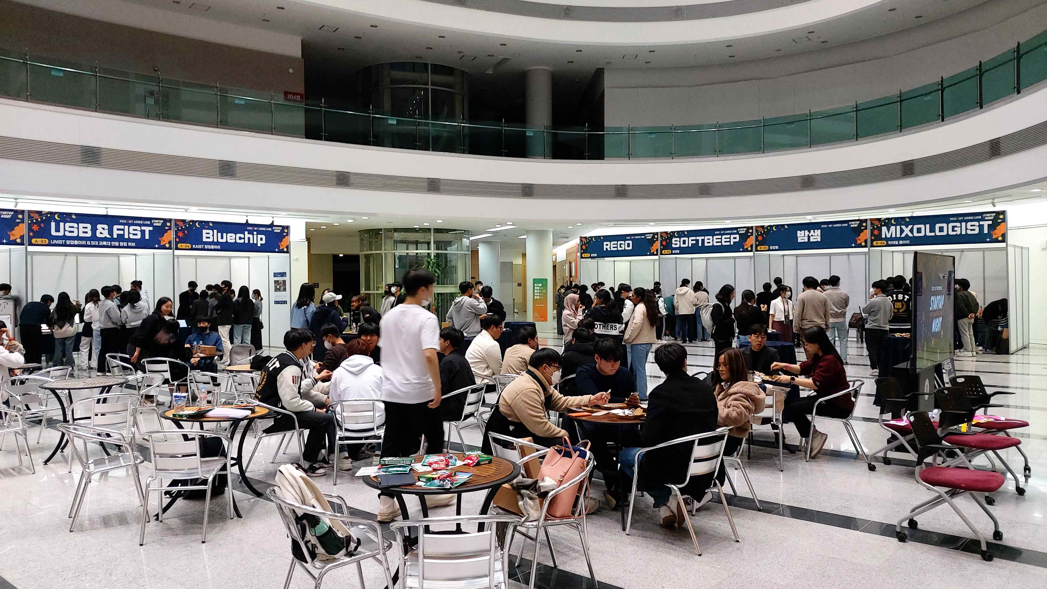
▲ A booth participating in the <GIST START-UP NIGHT> planned by GGE (Growing GIST Entrepreneur), a self-governing GIST student startup organization, was exhibited in the lobby of Oryong Hall.

GIST Business Incubator Director Byeong Kwan Cho said, "This start-up event was held offline for the first time in three years, and it became a fruitful festival to spread the start-up atmosphere and create a start-up boom. We will make efforts to establish GIST as a local startup mecca representing Gwangju and Jeonnam through more fruitful and fruitful events in the future."



