KAIST Small Business R&D Sharing Center held 'Industry-University Cooperation Strategy and Case Sharing Workshop for Small Business Technology Innovation'

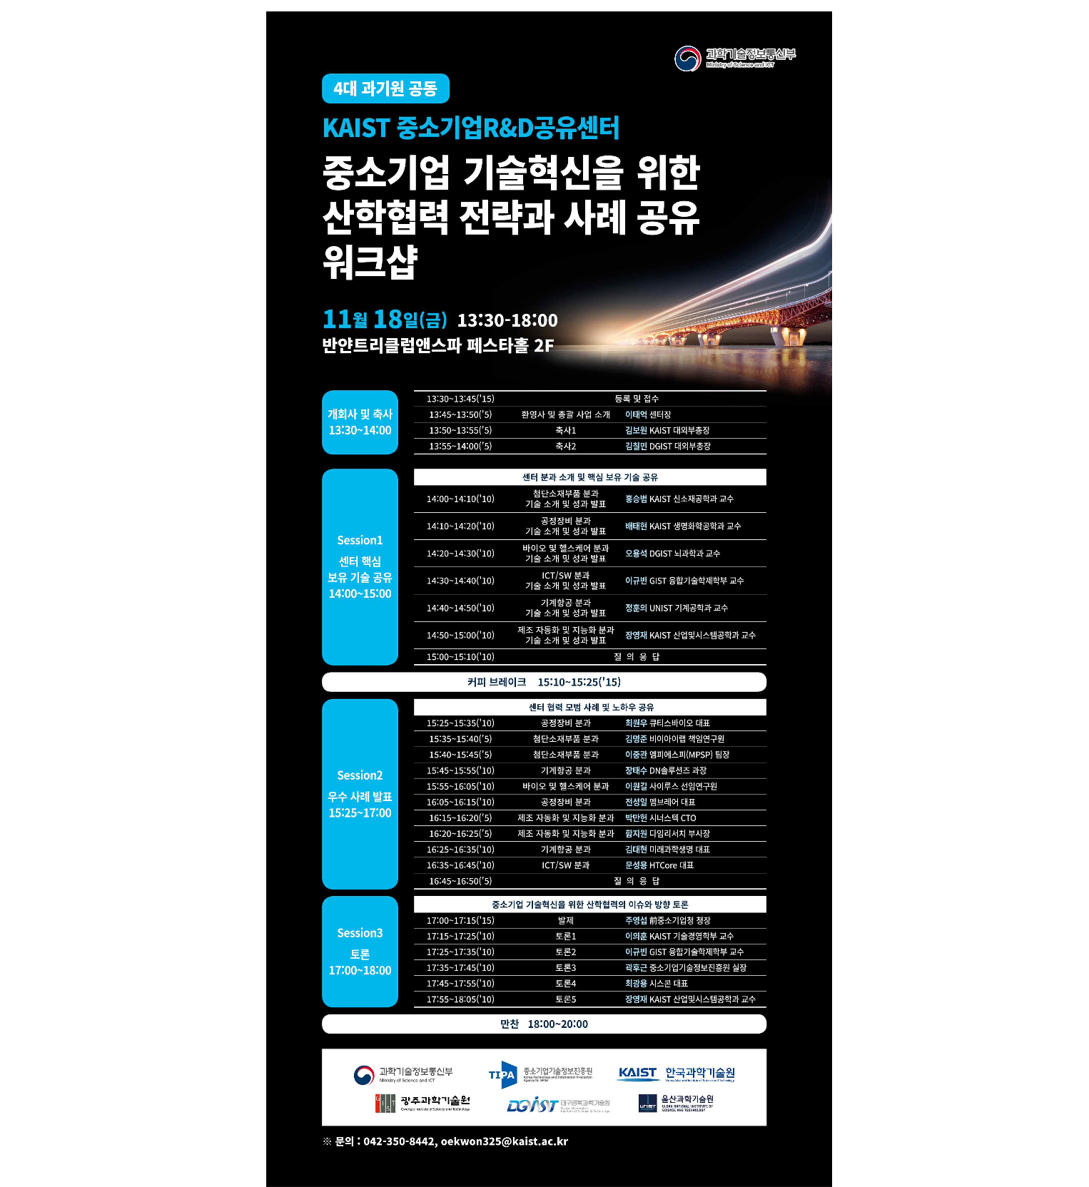

To discover strategic technologies and joint R&D of technologically innovative small and medium-sized enterprises, the SME R&D Sharing Center, in which four science and technology institutes (KAIST, GIST, DGIST, and UNIST) jointly cooperate with the support of the Ministry of Science and Technology announced on the 18th (Fri), from 1:30 pm, at the Banyan Tree Club & Spa Seoul Festa Hall that it would hold the 'Industry-University Cooperation Strategies and Cases for Small and Medium Enterprises Technology Innovation' workshop.

With the support of the Ministry of Science and ICT, the four science and technology institutes have been providing strategic technology discovery, joint technology development, technology transfer, consulting, test equipment support, and education and training for technologically innovative small and medium-sized enterprises.

In this workshop, 25 professors from 6 technical divisions, including advanced material parts, process equipment, bio and healthcare, ICT/SW, mechanical and aviation, manufacturing automation and intelligence division, 25 research labs, 59 small and medium-sized enterprises, 11 research institutes and hospitals, a total of 70 companies and institutions, and others form a team to share the achievements and practices of the past two years.

In addition, a discussion will be held on ‘issues and directions of industry-university cooperation for technological innovation of small and medium-sized enterprises’, centering on presentations made by the former head of the Small and Medium Business Administration, Young-seop Joo. In the discussion, Hugeun Kwak, head of the Policy Research Department of the Small and Medium Business Technology Information Promotion Agency, faculty members of each science and technology institute, and participating companies discussed how to fill the gap caused by differences in interests and goals between SMEs. Starting from a realistic problem situation, they sought ways to contribute to the creation of new growth engines through industry-university cooperation.

Tae-Eok Lee, director of the Small and Medium Business R&D Sharing Center (professor of Industrial and Systems Engineering, KAIST) said, “This workshop is not just about sharing the center’s achievements and success stories, but about 'what is the problem (WHAT)' and 'why is technological innovation process of SMEs important (WHY)' and 'how to solve the problem (HOW)' are the most simple but difficult parts for small and medium-sized enterprises to define. We hope that it will be a place where mid-sized companies can freely discuss strategies for leapfrogging into a 'virtual research center'."

Director Lee said, "The SME R&D Sharing Center will be able to serve as a bridge between the technology capabilities and knowledge accumulated in the Science and Technology Institute and the technology needs of SMEs with strong will to innovate."

This workshop can be attended by companies and individuals interested in technological innovation and industry-academic cooperation of small and medium-sized companies, and applications can be made in advance through the center's official mail account (smebridge@kaist.ac.kr) until the 17th.



