GIST - Inha University, Tashkent, Uzbekistan signed an MoU for mutual cooperation

- Looking forward to various cooperative activities such as exchange student programs and joint academic workshops in the future

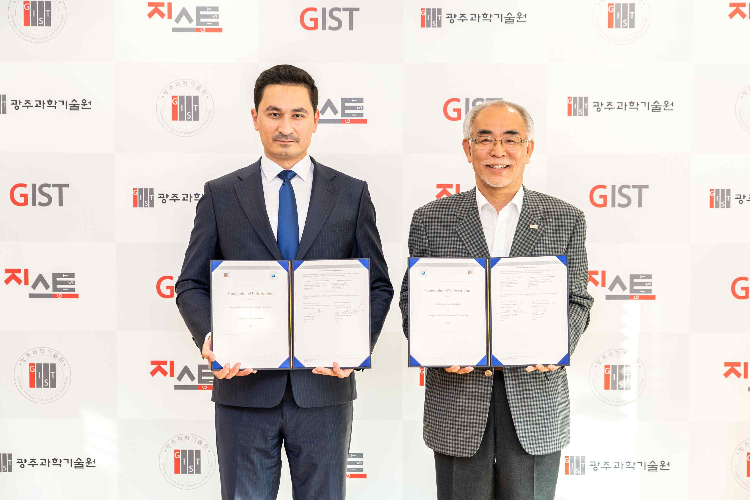
▲ GIST - Inha University, Tashkent, Uzbekistan MoU signing: A visiting group from Inha University in Tashkent visited GIST on the afternoon of the 10th to discuss international cooperation and take a commemorative photo after signing a business agreement. (From left) Muzaffar Dajalalov, President of Inha University in Tashkent, and GIST President Kiseon Kim

GIST (Gwangju Institute of Science and Technology, President Kiseon Kim) and Inha University in Tashkent, Uzbekistan signed a business agreement (MoU) on November 10 (Thursday) to promote various international cooperation such as the operation of the exchange student program and the promotion of international joint workshops.

The signing ceremony was held in the Office of the President at the GIST Administration Building between GIST President Kiseon Kim and Tashkent Inha University President Muzaffar Dajalalov.

Inha University in Tashkent is a new university established by signing a business agreement with Inha University in February 2014 at the request of the Uzbekistan government. Currently, it consists of two colleges: computer and information engineering and logistics with plans to open a graduate program in the future.

In particular, the visiting delegation from Inha University in Tashkent discussed ways to promote mutual cooperation in areas of GIST's strengths, such as computer science and artificial intelligence (AI) and expressed expectations for a developing cooperative relationship between the two institutions.

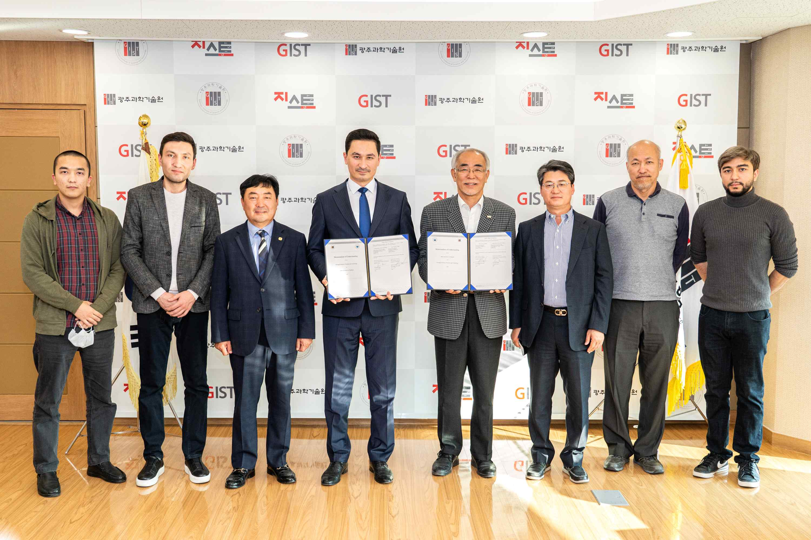
▲ GIST – Commemorative photo taken after signing an MoU with Inha University in Tashkent, Uzbekistan (from left) GIST Ph.D. student Ulugbek Kamdamof, Inha University, Tashkent International Relations Department Director Kahramon Ismailov, Musongji Oh CEO Incheol Park, Inha University, Tashkent President Muzaffar Dajalalov, GIST President Kiseon Kim, GIST Research Director Chang-Duk Jun, AI Graduate School Dean Jongwon Kim, and GIST master's student Anvaryon Yusupov

President of Inha University in Tashkent Muzaffar Dajalalov said, "We are delighted to be able to establish a partnership with GIST, a leading research university in science and technology. I hope that various exchanges such as human exchanges and research cooperation will take place in the future."

GIST President Kiseon Kim said, "GIST is located in Gwangju, a city with an active Uzbekistan community, and we hope that cooperation with Inha University in Tashkent will give Uzbekistan students an opportunity to study more at GIST."



