Can abandoned nets in the sea be located in real time? GIST conducts ‘fishing equipment monitoring marine demonstration’ using maritime IoT technology

- Information and Communication Convergence Research Center, an experiment in the southwest waters in March next year... Expected to contribute to ecosystem protection such as management of abandoned fishing gear

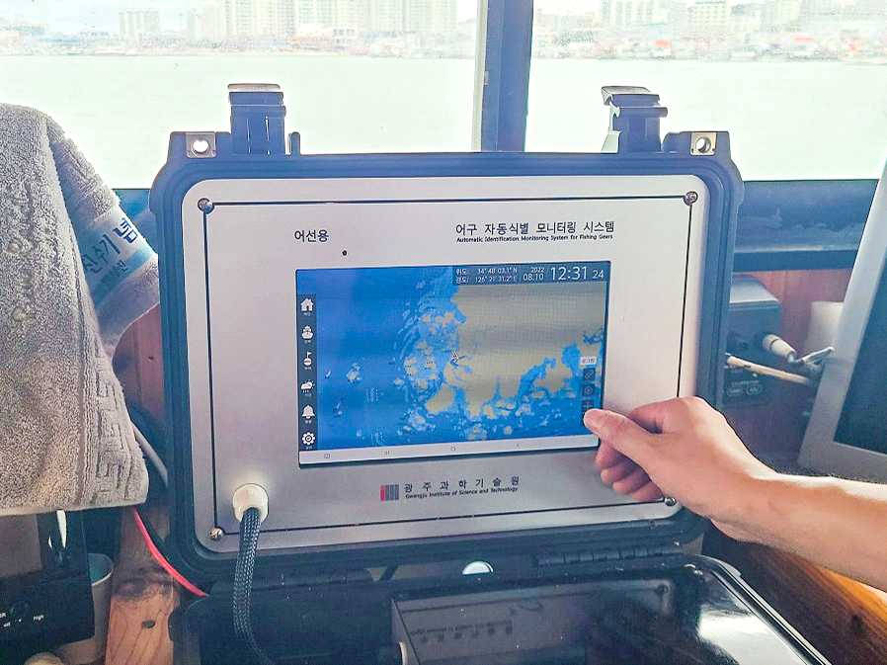

▲ Demonstration test operation of automatic identification monitoring system for fishing gear: Monitoring by installing a control system on fishing vessels

GIST (Gwangju Institute of Science and Technology, President Ki-eon Kim), in cooperation with local governments such as SK Telecom and Shinan-gun, conducted an ocean demonstration experiment to commercialize the 'fishing gear* automatic identification monitoring system' in the coastal fishing area of the southwest sea of Korea for 7 months from next March

The 'Automatic Fishing Gear Identification Monitoring System' being developed by the GIST Information and Communication Convergence Research Center is based on maritime IoT (Internet of Things) technology, and an electronic buoy* that transmits location information to each fishing gear is attached to the fishing vessel, management vessel (fishery management group), and land. It is a system that can monitor the owner, type, and location of fishing gear in real time through wireless communication with the company.

* fishing gear: A generic term for various tools or nets used for fishing.
* Buoy: An object that floats on water and is targeted. In case of fishing activity, it is used to indicate the position of fishing gear or anchor.

If this system is introduced, information on fishing gear in operation can be checked in real time through wireless communication at fishermen, management vessels, and integrated land control center. Utilizing real-time information, △ vessels can operate more safely, reducing maritime accidents △ it is possible to manage lost and abandoned fishing gear to protect the marine ecosystem and △ it is expected to contribute to increasing the income of fishermen.

Korea is in danger of being depleted of fishery resources due to overfishing of resources due to excessive use of fishing gear and pollution of the marine environment of abandoned fishing gear. The annual use of fishing gear in Korea's coastal fishing and aquaculture farms is estimated to be 131,000 tons, 2.5 times more than the appropriate amount, and 44,000 tons, 23.5% of this, are thrown into the sea, emerging as the main culprit causing marine environmental pollution.

In addition, Korea implements the Total Allowable Catch (TAC) system, which sets an upper limit on the catch by fish species to prevent the depletion of fish stocks. The scope of management is limited as the enforcement consists of patrolling ports, ports, and marine fishing guidance ships.

In order to develop the fishery industry into a sustainable fishing industry, the ‘real name system for fishing gear’ is being implemented, which requires the installation of a marker that displays the real name of fishing gear using ordinary cloth or plastic planks. Due to the low effectiveness, the need for a fishing gear positioning electronic system capable of real-time monitoring on land through wireless communication has been raised.

The Information and Communication Convergence Research Center uses SK Telecom's communication infrastructure to analyze the wireless communication range and coverage of maritime IoT communication in the actual operating environment in the Southwest Sea area from March to September next year. In order to secure the possibility of the practical use of the electronic phrase real-name system, they plan to conduct a demonstration test of the automatic phrase identification monitoring system.

To this end, the center establishes the same environment as the actual fishing situation of fishing boats and conducts small preliminary demonstration tests through demonstration equipment by directly using a system developed by fishermen operating in coastal waters between Mokpo and Heuksando Island, Jeollanam-do. It is establishing a communication data collection plan and an operation plan for large-scale marine demonstration to materialize marine IoT communication coverage.

Since 2017, the Information and Communication Convergence Research Center has formed a consortium with 16 organizations, including Sinan-gun, Jeollanam-do, SK Telecom, and Mokpo Coastal Network Association, to develop related technologies: It is conducting research and development in three areas: △ marine IoT wireless communication-based fishing gear identification buoy △ fishing gear identification control system △ lost fishing gear management technology, and also establishing management plans for each fishing target.

In this project, by applying LoRa and LTE Cat.M1 communication technology of LPWAN (Low Power Wide Area Network) suitable for maritime operation, a 25km maritime IoT range was secured.

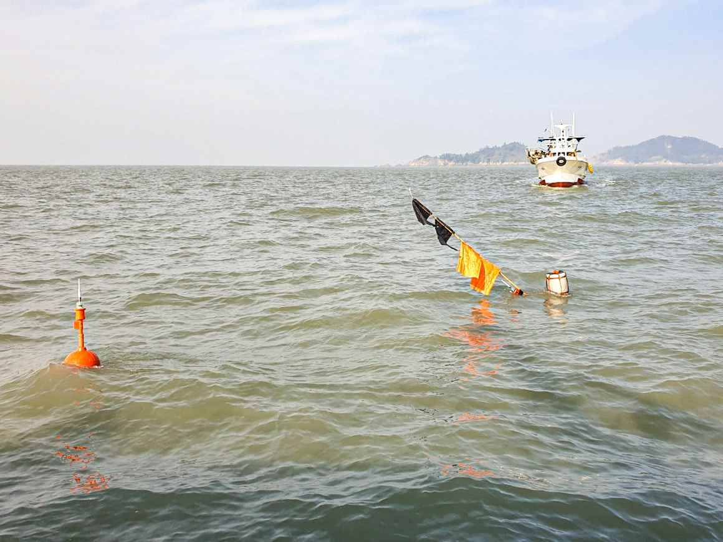
▲ Attachment of fishing gear automatic identification buoy and operation of demonstration test: Conduct a demonstration test of fishing gear management by attaching an electronic buoy for automatic identification of fishing gear to the coastal gill net

This communication technology can secure wide maritime IoT communication coverage through communication base stations in coastal areas and islands by utilizing the existing SK Telecom communication infrastructure.

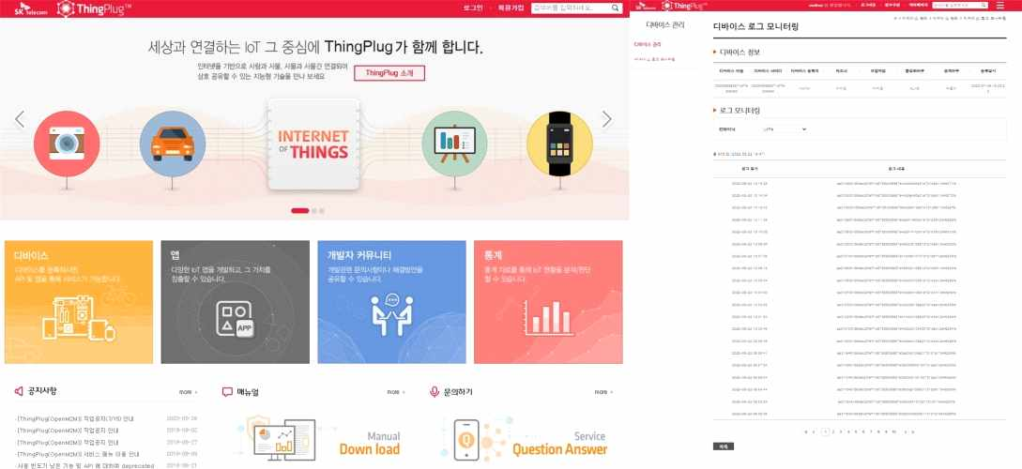
▲ Electronic buoy data collection using SKT IoT platform ThingPlug: Store location information of electronic buoy through SKT LoRa

Professor Yeongyoon Choi said, "The automatic identification and monitoring system for fishing gear is expected to secure the effectiveness of the fishing gear real-name system and contribute to the reduction of lost gear by enabling the management of fishing vessels and fishing gear on land."



