Israeli Ambassador to Korea - President Kiseon Kim discuss strengthening cooperation in science and technology between Korea and Israel

- Israeli Embassy visiting GIST on the 7th... After a pleasant conversation, visited the Korea Culture Technology Institute to experience convergence content
- On the occasion of the 60th anniversary of the establishment of diplomatic relations between Korea and Israel this year, discussions on strengthening cooperation and expanding exchanges such as sending students

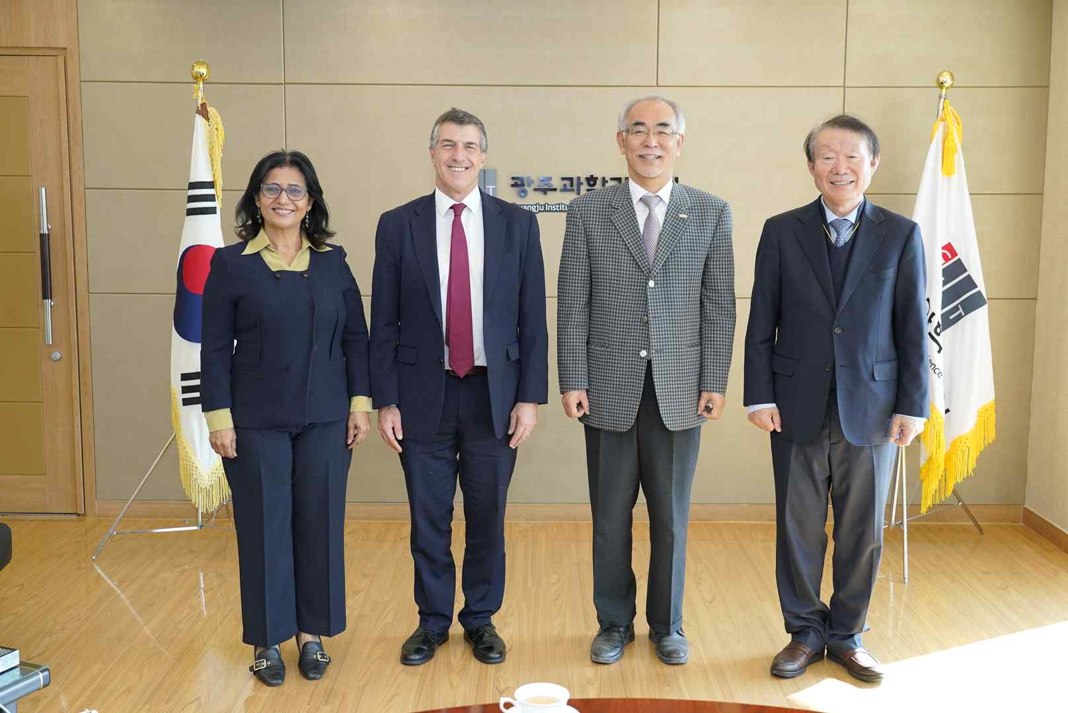
▲ A delegation of the Israeli ambassador to Korea visited GIST on the morning of the 7th to discuss strengthening scientific and technological cooperation and expanding exchanges between GIST and Israel and took a commemorative photo. (From left) Israeli Ambassador's wife Naomi Tor, Israeli Ambassador Akiva Tor, GIST President Kiseon Kim, and Visiting Professor Myoung-Kyu Park

A delegation from the Israeli Embassy in Korea, including Ambassador Akiva Tor, visited GIST (Gwangju Institute of Science and Technology, President Kiseon Kim) on November 7 (Mon.) to discuss ways to strengthen cooperation in the technical field and expand exchanges.

Akiva Tor graduated from the Hebrew University, a national university in Jerusalem, Israel, and served as the Israeli ambassador to Korea in 2020 after serving as the deputy director of the Palestinian Secretariat of the Israeli Ministry of Foreign Affairs and the Israeli consul general in San Francisco and the Pacific Northwest.

The Israeli ambassador to Korea, who arrived at GIST in the morning, listened to the current status of GIST's exchanges and cooperation with overseas universities, including the Technion Israel Institute of Technology, in the Office of the President in the Administration Building, and discussed plans to expand exchanges with Israel in the future.

Since 2016, GIST has supported up to two students per year to participate in the E&I program* operated by Technion Israel Institute of Technology, helping them grow into young entrepreneurs with entrepreneurial spirit and global mind. Plans are actively considering resuming exchanges that have been suspended since the COVID-19 pandemic from next year.

* E&I (Entrepreneurship & Innovation) program: A global educational program to cultivate entrepreneurship operated by Technion Institute of Technology, a leading Israeli university.

The Israeli Embassy in Korea delegation showed great interest in GIST College's educational curriculum in the humanities, social sciences, arts and sports to nurture excellent GIST excellent students, startup performance, support systems, and creative scientific experts.

The visiting delegation also visited the GIST Korea Culture Technology Institute, which conducts convergence research by exchanging with various academic fields, to develop artificial intelligence technology and art, and they had time to directly experience content that fused with culture.

Ambassador Akiva Tor said, "It was impressive that GIST, a science and engineering university in Korea that advances science and technology, nurtures talented people based on various basic education including the humanities. Further cooperation between GIST and Israel is expected in the future."

President Kiseon Kim said, "GIST is constantly striving to nurture creativity through basic liberal arts and humanities in the undergraduate program. GIST's educational method for nurturing excellent scientific experts is very similar to the challenging spirit unique to Israel, a startup powerhouse, so we will support more active cooperation in science and technology with Israel."



