<2022 GIST Science and Culture Week> held with local residents

- For two weeks from the 31st (Mon), various events such as Student Festival, Poet Ho-seung Chung's special lecture, Movie Day, etc.

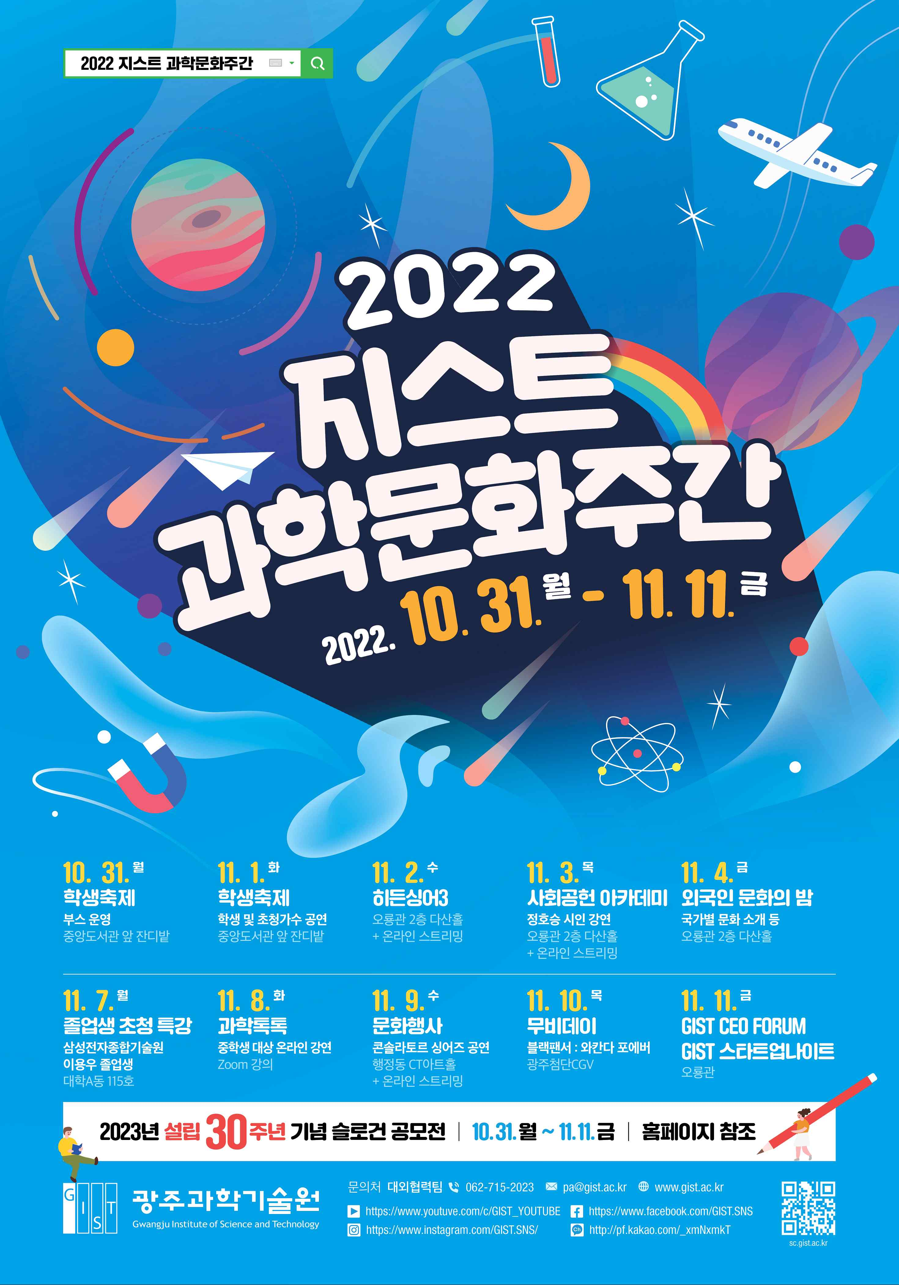
▲ 2022 GIST Science and Culture Week event poster

GIST (Gwangju Institute of Science and Technology, President Kiseon Kim) will hold the <2022 GIST Science and Culture Week> event for communication with the local community and spread of a healthy science culture for about two weeks from October 31 (Mon) to November 11 (Fri).

<GIST Science and Culture Week>, held every year from October to November, is a science and culture event composed of various programs and events that not only GIST members but also Gwangju citizens can enjoy together.

<GIST Science and Culture Week>, which marks its 4th anniversary this year, is expected to be a more diverse and richer event than any other year, with a total of 12 programs including student festivals, special lectures, and movie screenings.

In the first week of the event, the GIST student festival ▲ "2022 Lumiere" will be held from October 31st (Mon) to November 1st (Tue). GIST's best singer selection competition ▲ Hidden Singer 3 will be held on November 2nd (Wed), and ▲'Society Contribution Academy Lecture' with poet Ho-seung Chung will be held on November 3rd (Thu). On November 4 (Fri), you can meet cultures, foods, and talent shows from around the world through ▲ Foreign Culture Night, led by GIST international students.

On November 7 (Mon), the 2nd week of the event, ▲ 'Special Lecture by Graduates' will be held, where GIST graduates tell their juniors about their school life know-how. On November 8 (Tuesday), an online lecture called ‘Science Talk Talk’, an online lecture that easily introduces science through Zoom, will be held for middle school students in Jeollanam-do. On November 9 (Wednesday), a ▲ ‘Cultural Event’ classical performance with GIST and the Consolator Singers is prepared. On November 10 (Thursday), ‘Movie Day’ will be held at the cutting-edge CGV, where not only GIST members but also local residents can watch movies for free through pre-registration on a first-come, first-served basis.

On the last day of the event, November 11 (Thursday), there will be events with the theme of entrepreneurship. ▲'GIST CEO FORUM', where GIST members and local residents who dream of starting a business can network, and ▲'GIST Startup Night' to create a startup culture for local college students and graduate students will be held.

You can participate in some of this year's events through YouTube live broadcasting, and you can check the event information and how to participate at any time on the <GIST Science and Culture Week> website (sc.gist.ac.kr).

In addition, ahead of the 30th anniversary of establishment next year, as a special event of <Science and Culture Week>, ▲'GIST 30th Anniversary Slogan Contest' for GIST members will be held for two weeks.

GIST President said, "<GIST Science and Culture Week>, which has been held since 2019, has established itself as a local event to revitalize the weary daily life of GIST members and local residents. GIST, which is looking forward to the 30th anniversary of its establishment next year, will strive to grow together with local residents and become a beloved university in the region."



