'HPC-AI public infrastructure data center' opens

- Established at the GIST Super Computing Center on the 26th...14 billion won investment by 2023... 14 billion won investment by 2023
- Pilot operation from this coming November... “Expect the effect of building an AI education and research ecosystem”

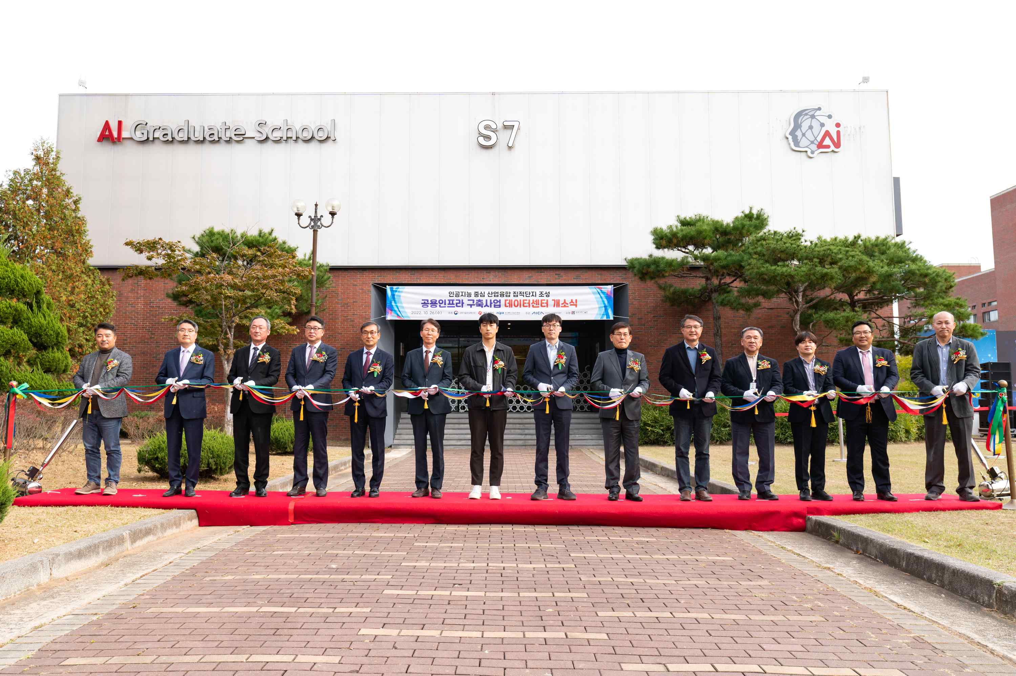
▲ At the opening ceremony of the data center for the public infrastructure construction project, major participants are cutting the ribbon.

A high-performance computing-artificial intelligence (HPC-AI*)-based public infrastructure data center in Gwangju, the center of artificial intelligence, will open on the 26th (Wednesday) and start trial operation from November.

The opening ceremony was held at 2 p.m. at the AI Graduate School of GIST (Gwangju Institute of Science and Technology, President Kiseon Kim) with officials from the Ministry of Science and ICT, Gwangju Metropolitan City, Information and Communication Industry, GIST, Chonnam National University, Chosun University, and Honam University.

* High Performance Computing-Artificial Intelligence (HPC-AI): To solve large-scale artificial intelligence computational problems, it refers to the construction and utilization of high-performance computing clusters that are interwoven with high-speed networking and used as if they were one large computer.

The ‘HPC-AI public infrastructure construction project’ hosted by the Artificial Intelligence Industrial Convergence Complex Project Group and carried out by the GIST Super Computing Center is being carried out as part of the <Artificial Intelligence Centered Industrial Convergence Complex Construction Project*>.

This project has been underway since 2021 to provide public infrastructure for education, research, and development in domestic industry-academia research institutes centered on AI convergence universities by building supercomputers consisting of △ HPC-AI-based computing, networking, and storage △ data center space, facilities, and providing education, training, and development environment.

* Artificial intelligence-centered industrial convergence cluster construction project: About 411.9 billion won will be invested for 5 years (2020-2024) in the 3rd district (47,246m²) of the Gwangju Advanced Science Industrial Complex and is a project to innovate the local industrial structure through AI convergence and create an artificial intelligence-centered industrial ecosystem by consolidating various infrastructures, companies, human resources, and technologies such as AI data centers

To this end, the Ministry of Science and ICT, Gwangju Metropolitan City, the Information and Communication Industry Promotion Agency, and the AI Industry Convergence Project Group and GIST will cooperate to invest a total of KRW 14 billion by 2023. GIST was selected as the host organization for this project last year.

The ‘HPC-AI public infrastructure’ built in the GIST Super Computing Center has a maximum computational amount of 6 petaflops (PF). It provides 10 petabytes (PB) of storage space, including 1 petabyte (PB) of all-flash, and 200 gigabytes (GB) of high-speed fabric networking.

Through this, it is possible to effectively support multi-node HPC-AI computing, which uses 320 top-end GPUs as one, while providing data at a speed of 150 gigabytes per second (GB) or more, which was difficult to provide in the existing domestic GPU infrastructure.

In addition, an integrated control room, data center room, and power and cooling infrastructure room were newly built to install and operate the HPC-AI public infrastructure. AI Studio and Mobility Studio provided by the Dreaming Child (AI) space located in the AI Graduate School building. Support spaces such as Media Studio and TED Hall are fully equipped.

In the future, the HPC-AI public infrastructure will be widely used to support AI computing for research and education through cooperation with AI convergence universities, and to provide customized HPC-AI computing services for domestic industry-university research institutes and global partners who need large-scale learning.

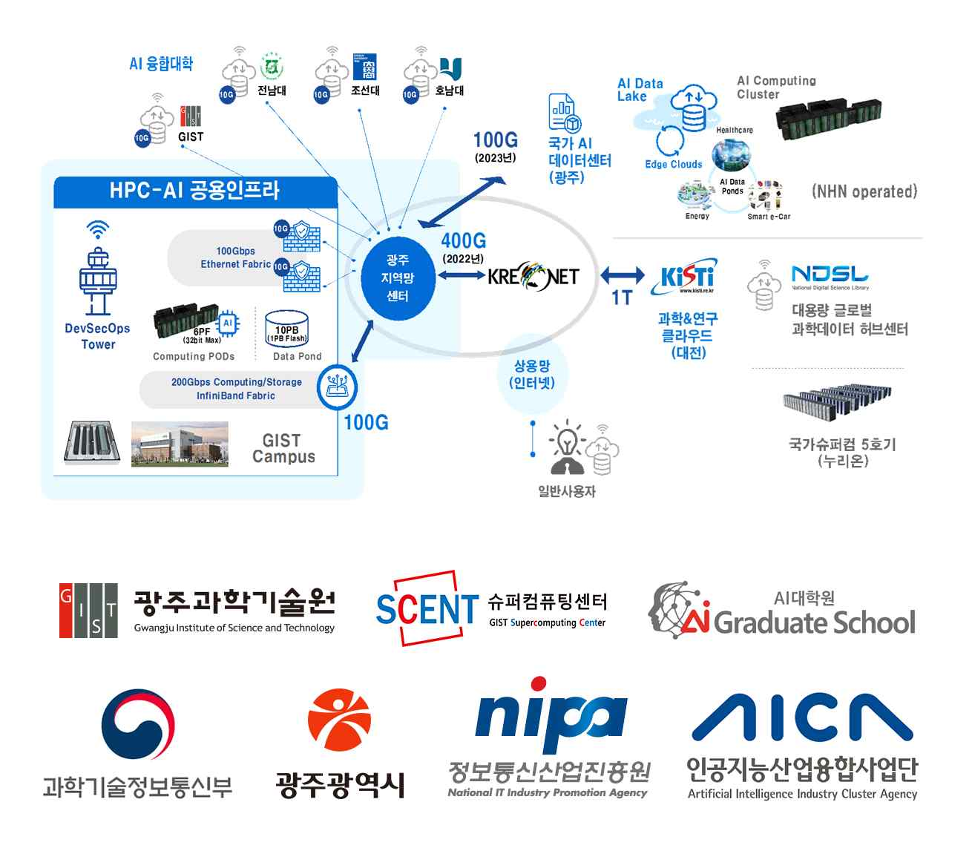
▲ Concept diagram of the construction and operation of ‘HPC-AI public infrastructure’

In particular, the 'GIST Super Computing Center', one of the top 10 specialized centers designated by the Ministry of Science and ICT in early August of this year, specializes in artificial intelligence clusters based on the HPC-AI public infrastructure built this time. Among the fields (automobile/healthcare/energy/cultural content), it will also strive to create an industry-academic-research-institute ecosystem based on simulations related to autonomous driving and mobility in the automobile sector.

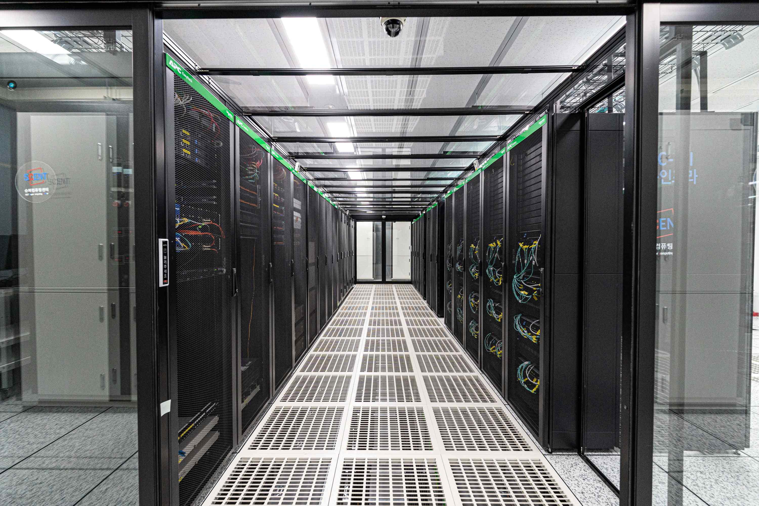
▲ ‘HPC-AI public infrastructure cluster’ built at GIST AI Graduate School (Super Computing Center)

In this way, industry, academia, research institutes, and government agencies will lead the revitalization of AI research and utilization to enhance competitiveness by focusing on specialized AI fields. It is expected to contribute to the establishment of the foundation for convergence of various artificial intelligence industries while contributing to the preparation of data and artificial intelligence leading model production and distribution systems.

GIST President Kiseon Kim said, "This project is very meaningful in that it builds an infrastructure that can be used jointly for convergence research and education using artificial intelligence and provides various opportunities as a foundation for industry, academia, research and government to collaborate. GIST, as the host organization, will do its best for AI-based regional innovation, job creation, and nurturing of advanced artificial intelligence specialists through the establishment of this infrastructure."



