GIST Techno Management Business Academy Golf Club, donated to the Gwangju Rehabilitation Association for the Disabled

– Scholarship support for youth from low-income families with disabilities

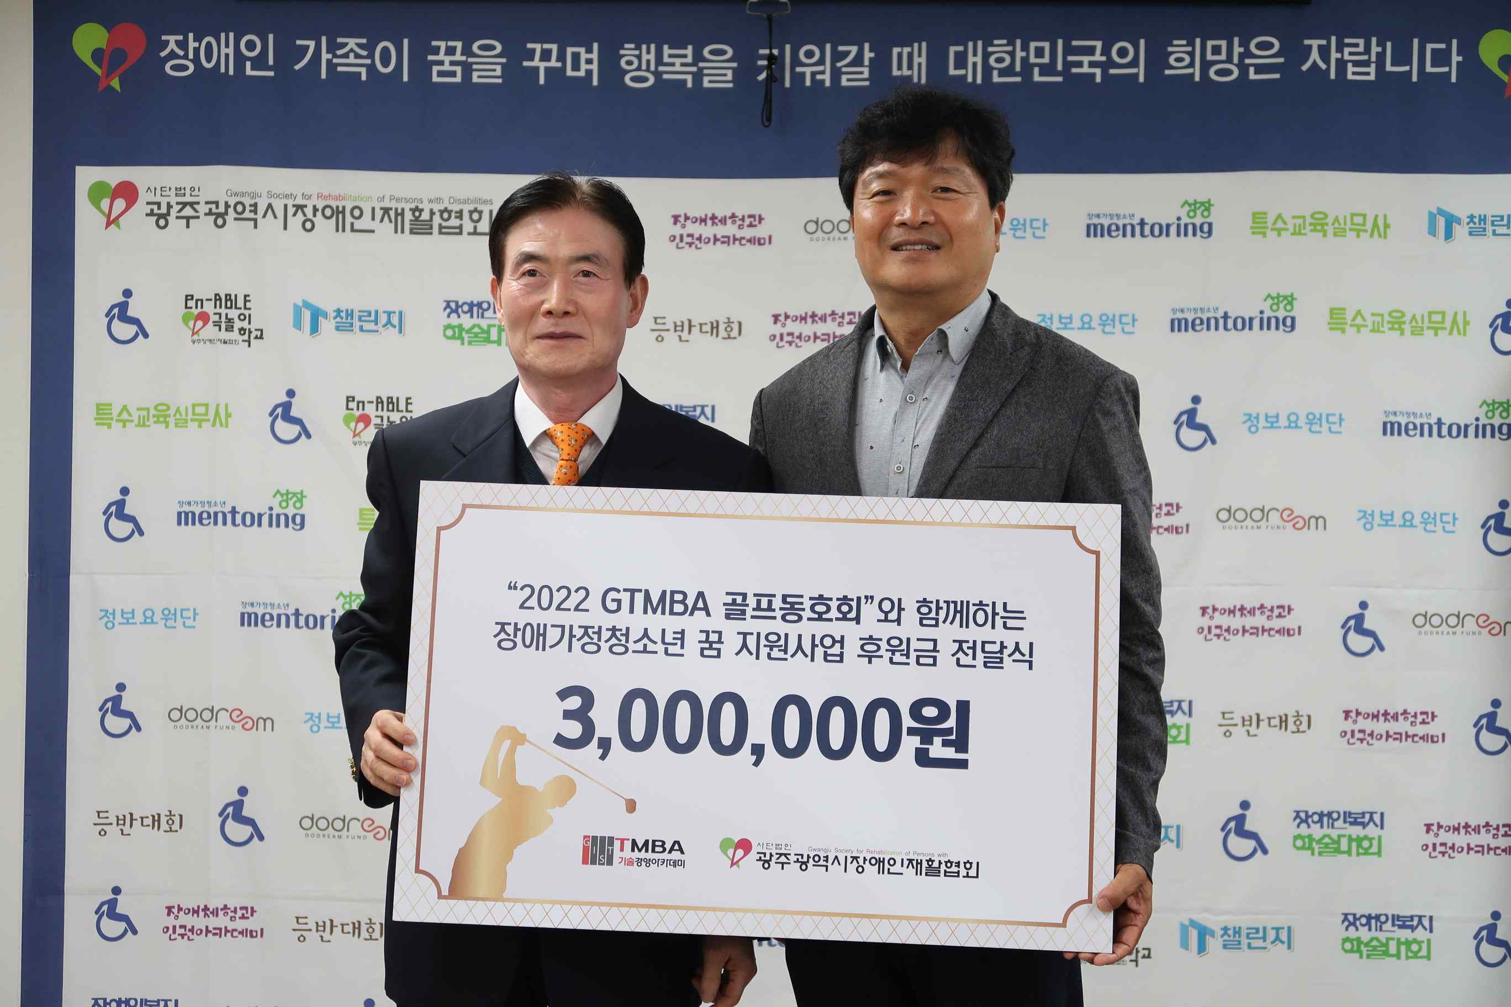
▲ GIST Techno Management Business Academy Golf Club donated 3 million won for scholarships to the Gwangju Rehabilitation Association for the Disabled on October 21 (Fri). (From left) Gwangju Rehabilitation Association for the Disabled President Jong-man Na and GTMBA Golf Club President Kyung-ho Jeong

GIST (Gwangju Institute of Science and Technology, President Kiseon Kim) Techno Management Business Academy (hereinafter referred to as GTMBA) Golf Club donated 3 million won for scholarships to the Gwangju Rehabilitation Association for the Disabled on October 21 (Fri).

The GTMBA Golf Club, established in 2020, is chaired by Kyung-ho Jeong, CEO of Jeongam Trading Co., Ltd. Chairman Jeong has been working hard to promote exchange and vitality among alumni. He decided to sponsor the Rehabilitation Association for the Disabled again this year as he did last year in order to improve the community and help the underprivileged.

Chairman Jeong said, "I want to let many people know that even small actions in everyday life can contribute to sharing. In the future, we will continue to practice sound social service activities and make an active effort to spread a culture of sharing and donation in the local community."

Gwangju Rehabilitation Association for the Disabled President Jong-man Na said, "The warm heart of the GTMBA golf club will be a great help for disabled students to realize their dreams. The donation will be used for various projects to improve the quality of life of students with disabilities, such as welfare promotion, rehabilitation, and self-reliance."

The GTMBA Golf Club delivered a donation of 5 million won to the GIST social contribution project that supports low-income students in September along with this donation to youths from families with disabilities.

The GTMBA is a top technology management course, offering the best expert lectures in Korea to provide an overview of the corporate environment and global management strategy. It is contributing to the vitalization of the local economy and industry-university cooperation by cultivating a sense of culture and forming a wide human network.

This year's 12th curriculum started in March and will run until November and is held every Tuesday at 7pm at Oryonggwan.



