GIST signed a 4-party agreement for the construction of the GIST Welfare Club (tentative name)

– On the 19th, the donation agreement was signed between GIST-KBI Hanam-Daedam Construction Co., Ltd. and The Nine Architects Office

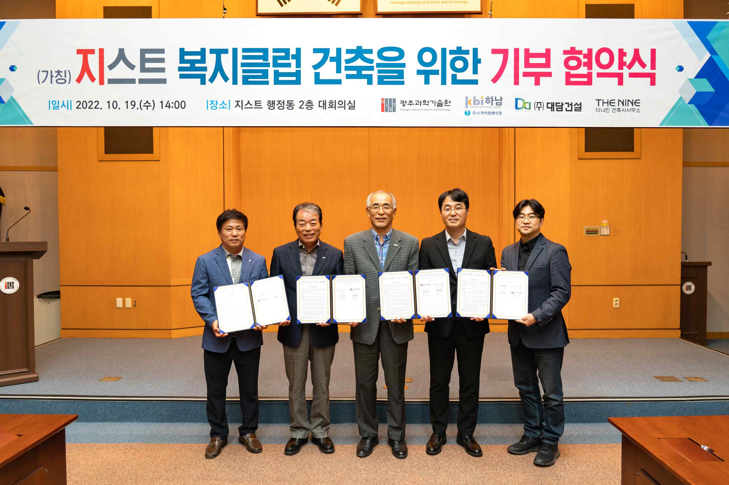
▲ In the afternoon of the 19th (Wednesday), in the conference room on the 2nd floor of the GIST Administration Building, 'GIST-KBI Hanam-Daedam Construction Co., Ltd.-The Nine Architects' signed a four-party donation agreement for the GIST Welfare Club (tentative name) and is taking a commemorative photo. (From left) Daedam Construction Co., Ltd. Managing Director Myung-hwan Lee, KBI Hanam Hanam Chairman Jung-joo Koh, GIST President Kiseon Kim, The Nine Architects Office CEO Ja-hong Koo, and one other person

GIST (Gwangju Institute of Science and Technology, President Kiseon Kim) continues to receive donations and participation in the construction of the 'GIST Welfare Club (tentative name)', which is being built through fundraising.

On the afternoon of October 19th (Wednesday), GIST held the <Contribution Agreement Ceremony forGIST Welfare Club Construction (tentative name)> in the GIST Administrative Building. ‘The Nine Architects Office’ and Daedam Construction Co., Ltd. announced that they have decided to participate in the design and construction of the welfare club, respectively.

Through this agreement △ GIST will provide a building site △ The Nine Architects is donating personnel for architectural design △ Daedam Construction Co., Ltd. will participate as a construction contractor of a welfare club by joining the will of KBI Hanam/Sky Funeral Hall Chairman Jung-joo Koh, who recently donated 1 billion won to build a welfare club.

Previously, in September, Chairman Jung-joo Koh held a development fund donation ceremony and donated 1 billion won to GIST. The development funds will be fully used for the construction of the GIST Welfare Club through this four-party agreement.

Chairman Jung-joo Koh said, "I hope that the GIST Welfare Club will become a place of communication and harmony within the GIST and reborn as a representative science and technology landmark of our region where various convergence technologies and ideas are born."

President Kiseon Kim said, "Thank you for your generous donations from various companies for the GIST Welfare Club, which can realize a place of communication within GIST. We hope that the welfare club will become a network that represents the region in the future, and with this help, GIST will strive to become a world-class research university."

The signing ceremony was attended by GIST President Kiseon Kim, Research Institute Director Chang-Duk Jun, Chairman Jung-joo Koh, Daedam Construction Co., Ltd. Managing Director Myung-hwan Lee, and The Nine Architects Office CEO Ja-hong Koo.



