GIST to hold 'Capacity Building Meeting' for successful start-ups of prospective entrepreneurs

– Provide systematic start-up programs to strengthen the capabilities of prospective entrepreneurs and create synergy

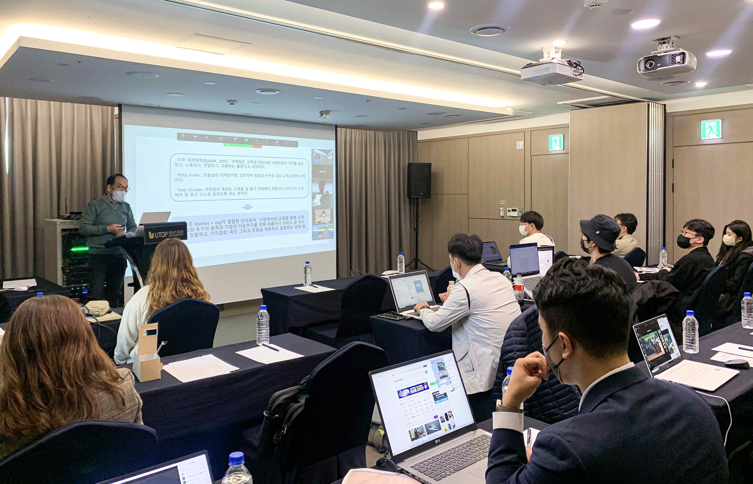
▲ GIST Business Incubator successfully completed the ‘2022 Preliminary Startup Package Specialized Meeting’ for prospective entrepreneurs on October 19 (Wednesday) at the UTOP Boutique Hotel in Gwangju.

GIST (Gwangju Institute of Science and Technology, President Kiseon Kim) Business Incubator (Director Byeong-Kwan Cho) successfully completed the 2022 Preliminary Startup Package Specialization Meeting by actively utilizing the start-up mentor pool and infrastructure and related institutions (preliminary start-up package organizations).

GIST evaluates the superiority and commercialization potential of business items, focusing on the technologies of D.N.A fields such as digital, network, and artificial intelligence (AI). By evaluating the possibility of commercialization, support material and human resources can be provided so that the start-up can be commercialized.

The 3rd meeting held at the UTOP Boutique Hotel in Gwangju on October 19th (Wednesday) for a total of 19 prospective founders provided ▴ mentoring on investment directions according to each item of founders ▴ networking between founders ▴ specialized program support information, etc. By linking the essential education for business start-up practical training and the meeting, it was possible to provide sufficient mentoring and information sharing between founders.

GIST Business Incubator Director Byeong-Kwan Cho said, "GIST is serving as a guide for prospective entrepreneurs to reduce trial and error and to quickly succeed in starting a business. Following the mandatory education, this event was prepared to systematically and closely grasp the difficulties of founders through a meeting and to help solve problems through mentoring."

The 'Preliminary Startup Package' support project of the Ministry of SMEs and Startups is a program that provides practical start-up support such as start-up education and mentoring, market connection, and global expansion, as well as commercialization financial support for the smooth start-up commercialization of prospective founders with innovative technology start-up ideas.

In early December, for the (preliminary) founders of the 2022 preliminary startup package specialization (D.N.A. sector), the 2022 AI software exhibition support and media and IR (company briefing) support program will be held for investment attraction and promotion.



