Senior-Friendly Industrial Support Center-Gwangju Design Promotion Agency sign business agreement

– Cooperation in establishing an advanced system for the aging-friendly industry according to digital transformation

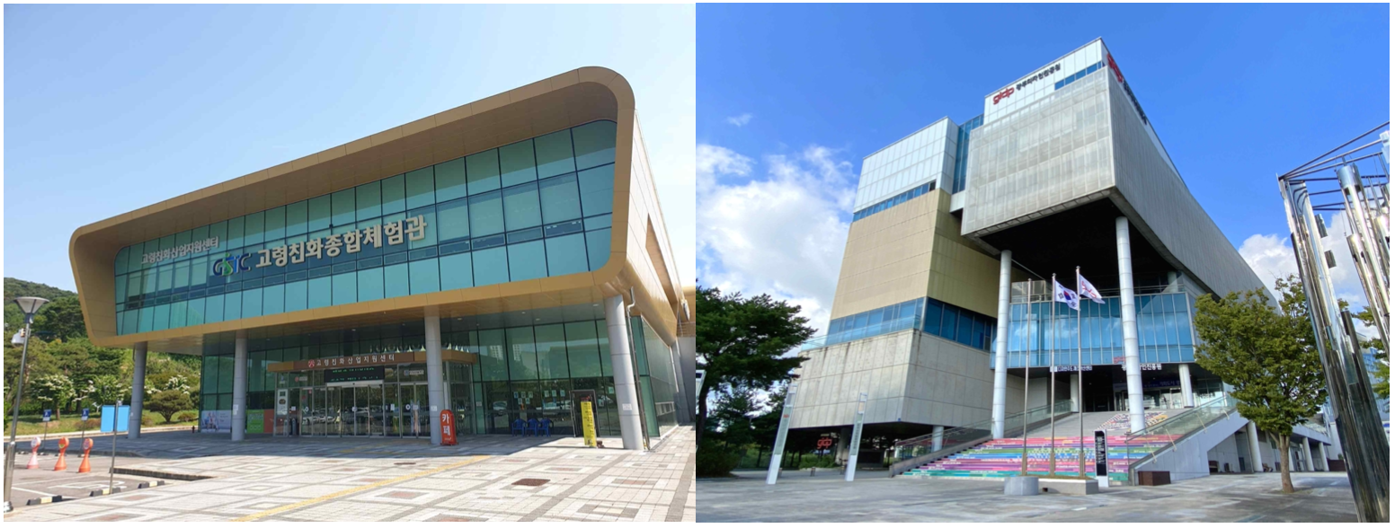▲ GIST Senior-friendly Industry Support Center and Gwangju Design Promotion Institute

GIST (Gwangju Institute of Science and Technology, President Kiseon Kim), Senior-Friendly Industry Support Center (Director Chang-Myung Oh) and Gwangju Institute of Design Promotion (Director Jin-hee Song) signed a business agreement on the 18th (Tuesday) to establish an advanced system for aging-friendly industries and to revitalize the local economy.

Using this written agreement as an opportunity, the two organizations plan to cooperate and actively exchange, such as △ joint use of equipment specialized in the design industry △ joint policy proposal and business planning for regional economic development △ discovery and nurturing excellent companies.

The Gwangju Institute of Design Promotion is leading the advancement of the design industry, strengthening the competitiveness of local industries through new development strategies in regional specialized industries and design fields, and striving to drive the development of the local economy.

Senior-Friendly Industry Support Center Director Chang-Myung Oh said, "By sharing the convergence technology, equipment, and personnel possessed by the two institutions and establishing a multifaceted mutual cooperation system, it will be possible to create a great synergy effect in responding to changes in the aging-friendly industry ecosystem caused by digital transformation."

Gwangju Institute of Design Promotion Director Jin-hee Song said, "As part of the ‘Industrial Innovation Foundation Project’, we are creating a physical foundation for design collaboration and support to support the entire product development cycle of local design-using companies. It will contribute to the convergence of the local industry and the design industry by utilizing various equipment to be built."

On the other hand, the GIST Senior-Friendly Industry Support Center is striving to build an age-friendly industry ecosystem through the creation of a universal design standardization base for the elderly and technology commercialization.

