GIST CT Research Center, AI-based immersive cultural heritage content exhibition

- From October 13th to 18th, an exhibition under the theme of ‘Asian cultural heritage’ was held at Seocho Youth Center in Seoul
- Media wall, application of cutting-edge cultural technologies such as mixed reality 3D, and cultural heritage experience such as Seokguram and stone pagodas

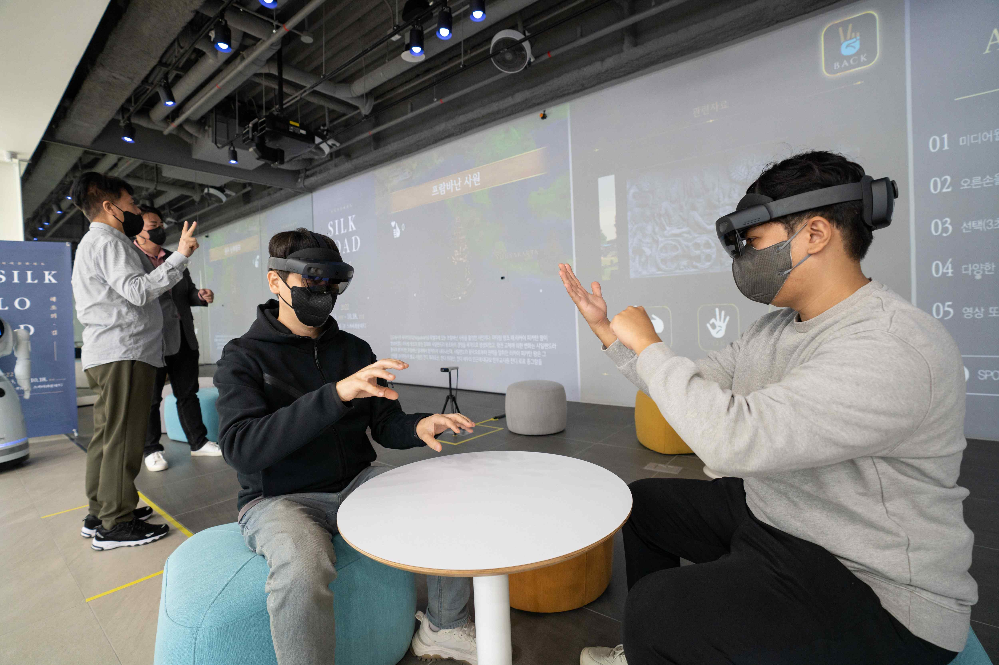
▲ 3D cultural heritage assembly experience with HoloLens equipment (front) and media wall content experience (rear)

GIST (Gwangju Institute of Science and Technology, President Kiseon Kim) Korea Culture Technology Institute (Director Moongu Jeon) has developed technology to effectively view and vividly experience cultural heritage information in an XR (eXtended Reality) environment and will hold an exhibition in Seoul.

This exhibition, titled <SILK ROAD – Path of Hyecho>, will be held from October 13th (Thu) to 18th (Tuesday) in the exhibition room on the first floor of the Seocho Youth Center in Seoul. It is an information-exploring exhibition to experience the cultural heritage of Korea and Asia along the travel route of the Shilla monk Hyecho.

This exhibition, where recently developed cultural technology is applied, will have three areas including ▴ gesture and behavior recognition-based media wall ▴ mixed reality 3D cultural heritage experience ▴ AI-based image and video.

In the [Media Wall] exhibition, you can browse through videos and images that introduce the Silk Road, where the exchange of civilizations between the East and the West took place, and the Wangocheonchukgukjeon of Hyecho in the Shilla period by exploring through simple gestures.

The [Mixed Reality 3D] exhibition is at Seokguram Grotto while wearing a holo-lens device that allows the virtual image and real space to be superimposed. You can observe cultural heritage such as Dabotap in detail and experience the process of assembling and dismantling stone pagodas in three dimensions.

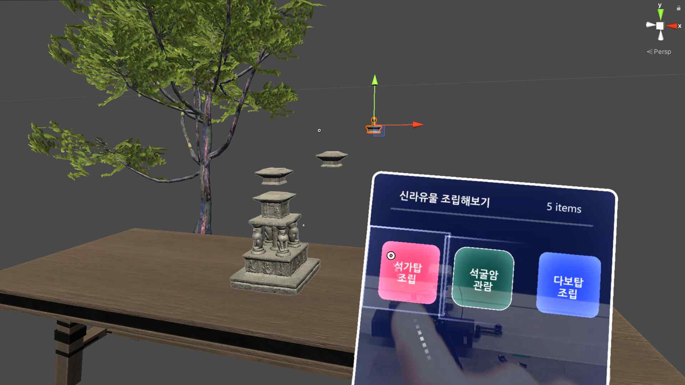
▲ HoloLens display implementation image

The [AI-based image video] exhibition learns various domestic stone pagoda images with artificial intelligence technology and then reconstructs the features into virtual images and shows them to the audience.

The technology applied to the exhibition is part of the cultural technology R&D project of the Ministry of Culture, Sports and Tourism (task name: Intelligent agent-based smart stage exhibition dynamic space-aware media wall platform technology development, period: 2020.05. ~ 2022.12.). It was developed for the operation of AI-based visualization and immersive smart media wall so that visitors can experience various things in the exhibition space.

Korea Culture Technology Institute Director Moongu Jeon said, "In a situation where virtual reality and mixed reality technologies are developing rapidly, related technologies have been developed so that cultural heritage-related information can be viewed more vividly and realistically. Through demonstration of exhibition service, we plan to secure visitor experience and activity data and continue technology development."

Tthe Korea Culture Technology Research Institute is a cultural technology research institute established in GIST in accordance with Article 17-5 of the Culture Industry Promotion Act (designation of a cultural technology research institution belonging to the Ministry of Culture, Sports and Tourism) for (AI) based art convergence creation. It is carrying out a number of projects such as media façade mapping technology, and it is concentrating on research and development of core cultural technologies to lead the development of the national cultural industry.



