Two GIST books selected as ‘2022 Sejong Books’

- Visiting Professor Seung-Hyeon Moon <Electrochemical Process of Ion Exchange Membrane>... A scholarly book for researchers in the field
- Office of GIST Welfare administrator Deuk-jin Lee <A Story of the Constitution to My Daughter>... A textbook on law read as examples of movies and novels

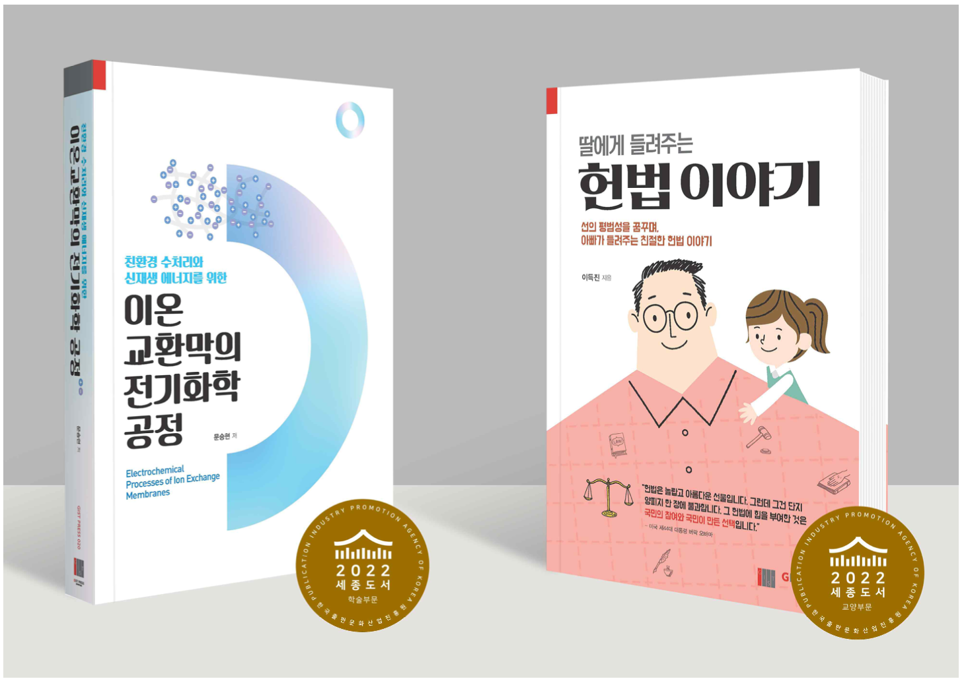▲ (From left) Cover of <Electrochemical Process of Ion Exchange Membrane> and <A Story of the Constitution to My Daughter> of GIST PRESS, which was selected as Sejong Book in 2022

GIST (Gwangju Institute of Science and Technology, President Ki-seon Kim) PRESS published two books that were selected as the ‘2022 Sejong Books’.

‘Sejong Books’ is a project promoted by the Ministry of Culture, Sports and Tourism and the Korea Publishing Culture Industry Promotion Agency to revitalize the production of excellent publication contents and to improve the reading culture of the people. The selected books are distributed to over 2,500 public libraries, specialized libraries, small libraries, and elementary, middle, and high schools across the country.

The books of GIST PRESS selected this year are <Electrochemical Process of Ion Exchange Membrane>, a specialized book for researchers, and <A Story of the Constitution to My Daughter>, a general education book on the Constitution.

<Electrochemical Process of Ion Exchange Membrane>, which was selected in the Sejong Book Academic Division, is a book written by Professor Seung-Hyeon Moon (School of Earth Sciences and Environmental Engineering) for graduate students and researchers in the field. It provides basic knowledge of electrochemistry, polymer chemistry, and process technology necessary for researchers who manufacture ion exchange membranes or develop electrochemical processes using ion exchange membranes.

In particular, the terms and principles necessary for researchers who are starting research in the field of water treatment or energy conversion processes using ion exchange membranes are organized in an easy-to-understand manner.

The author and Visiting Professor Seung-Hyeon Moon mentioned that it is urgent to present scientific and technological alternatives to reduce greenhouse gas and realize a carbon-neutral society. Through this book, he said, "I hope that the ion exchange membrane will be used as a means to solve environmental and energy problems."

<A Story of the Constitution to My Daughter>, which was selected in the Sejong Books Liberal Arts Division, starts with the question, “What kind of country is our country?” about the meaning of the Constitution and the spirit and values it contains. It covers basic rights and explains what kind of country we, the masters of the Republic of Korea, should dream of, as easily and kindly as a father tells his children.

Office of GIST Welfare administrator Deuk-jin Lee wrote the book, which covers 45 familiar topics related to the Constitution, including the significance of the Constitution and the basic principles of the Constitution, the reason for the existence of the state and state violence, human rights, the concept and effect of basic rights, human dignity and the right to pursue happiness, the right to equality, and various freedoms and social rights. It deals with the subject in an interesting way, citing examples from movies and novels.

The author said, "As a constitutionalist who wants to fill the deep groove of Korea's ideological and regional conflicts with the glue of the community called the Constitution, I hope that this book will serve as a sonata for good people who protect each other with the ‘banality of good’ as well as a question posed to the people, the sovereign people of the Republic of Korea, so that evil is not routinely practiced by the given circumstances."



