GIST Institute for Artificial Intelligence – GG56 Korea signed a business agreement in the field of artificial intelligence (AI)

– Establish a joint cooperation system and promote win-win development to derive new business fields using artificial intelligence

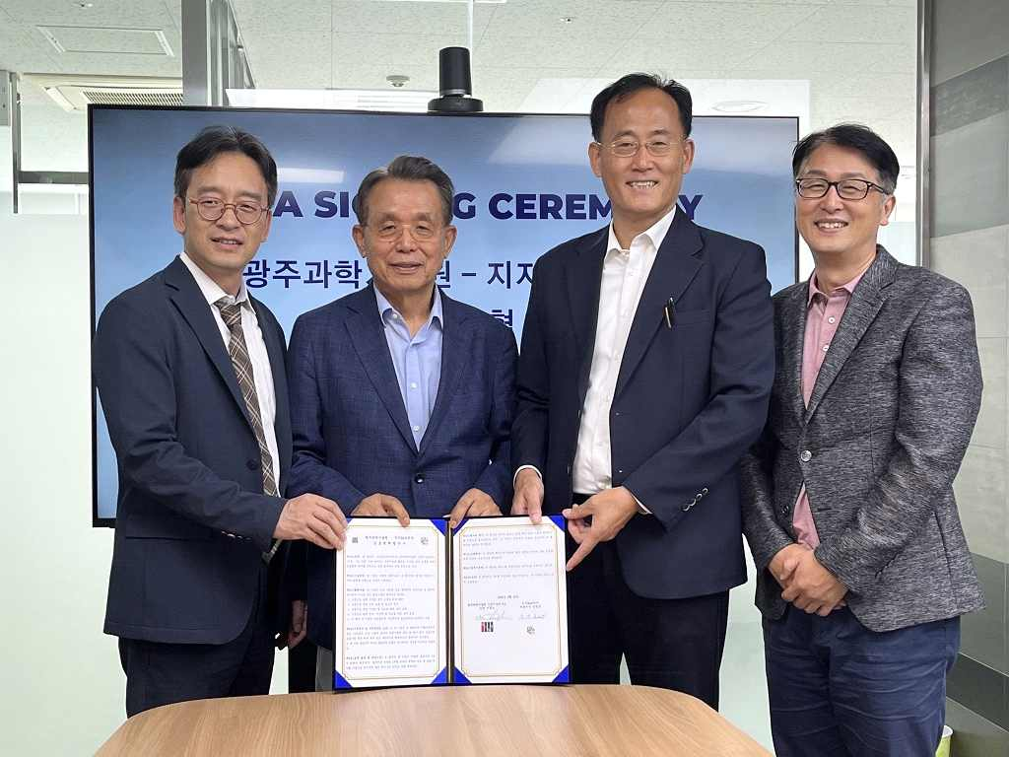
▲ GIST Institute for Artificial Intelligence (Director Heung-No Lee) and GG56 Korea (CEO Young-gun Kim) are taking a commemorative photo after signing a business agreement to advance into the new artificial intelligence industry. (From left) GG56 Korea CEO Young-gun Kim, Founder Seung-soo Han, GIST Institute for Artificial Intelligence Director Heung-No Lee, and LiberVance Strategy Director Hang-jin Kim

GIST (Gwangju Institute of Science and Technology, President Kiseon Kim) Institute for Artificial Intelligence (Director Heung-No Lee) and GG56 Korea (CEO Young-gun Kim), a global blockchain IT platform company, recently signed a memorandum of agreement (MOA) to to promote mutually beneficial development and establish a joint cooperation system to advance into new industries using artificial intelligence.

GG56 Korea is a blockchain-based metadata startup that combines satisfaction evaluation system SoT (Satisaction of Things) with metaverse to conduct various surveys such as satisfaction, preference, public opinion, and propensity surveys and collects data.

It has developed 'Pass&Go', a digital pass-pass solution that authenticates negative results of vaccination and corona test, and the blockchain project Bitour Chain (MSOT). In the first half of this year, it has attracted an investment of 3 million dollars (about 3.7 billion won) from YBM and Yuhan Corporation.

This business agreement was promoted to maximize synergy between the AI-related business owned by GIST Institute for Artificial Intelligence and the blockchain business promoted by GG56 Korea.

The two institutions will ▴ cooperate for the promotion of new artificial intelligence-related industries ▴ exchange personnel and share information ▴ develop areas for cooperation with the government, local governments and global partners, etc.

GIST Institute for Artificial Intelligence Director Heung-No Lee said, "We hope that this MOU will be the start of building a strategic partnership. In the field of artificial intelligence, it is expected that the two organizations will be able to continue to discover new businesses that can greatly innovate the global society in the future and promote cooperation."

GG56 Korea CEO Young-gun Kim said, "We will build a sustainable blockchain ecosystem by upgrading the service by utilizing GIST's AI technology, and at the same time, we will strive to activate the service by upgrading the reward system that can be gained by participation."

The GIST Institute for Artificial Intelligence is a research institute that prepares for the future society and leads the spread of artificial intelligence technology. With the vision of realizing a ‘smart inclusive society’, it is planning and promoting specific projects with the goal of convergence of AI, blockchain, cloud, and data (ABCD) technologies to achieve research results and infrastructure, promote national projects, and promote industry-university cooperation.



