"Science and sharing through science and technology" GIST hosts 'Hope Water Purifier' donation ceremony for Myanmar refugee camp

- In cooperation with the National Assembly and science and technology organizations, including lawmaker Yong-bin Lee, 100 water purifiers were produced and donated

- Myanmar Refugee Representative Chairman visits GIST... “Contribute to the prevention of infectious diseases in refugee villages and improvement of the environment”

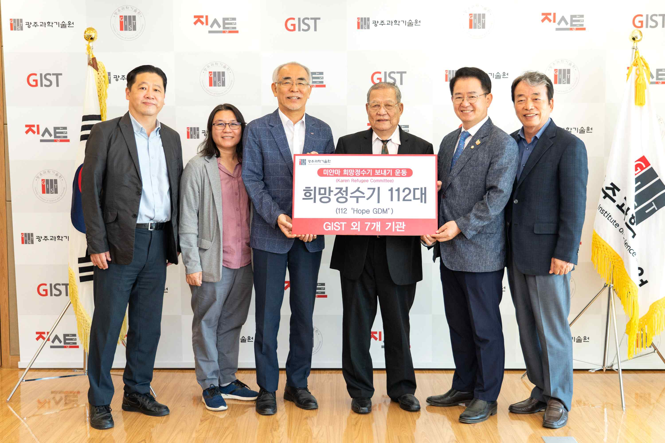
▲ On the morning of September 30 (Friday), a donation ceremony to support 112 ‘Hope Water Purifiers’ that will provide clean and safe drinking water to Myanmar is held and a commemorative photo is being taken in the President’s Office on the 5th floor of the GIST Administrative Building.
(From left) GIST International Environmental Research Institute Director Kyoung-Woong Kim, Secretary to the Chairman of the Representative Committee of the Myanmar Refugee Commission Vannida Phakdeephanaporn, GIST President Kiseon Kim, Myanmar Refugee Committee Chairman Robert Saw, National Assembly member Yong-bin Lee, GIST Development Foundation Chairman Jong-joo Koh

“I am grateful for the solidarity and generosity of the Republic of Korea, an advanced country in science and technology.” (Chairman Saw Robert Htwe, Myanmar Refugee Committee)

A donation ceremony for the 'Hope Water Purifier', produced by the National Assembly in cooperation with domestic science and technology organizations such as GIST (Gwangju Institute of Science and Technology, President Kim Kiseon), was held at GIST on September 30 for refugees in Myanmar who are experiencing political turmoil after the military coup last year.

The donation ceremony was held with attendance of Saw Robert Htwe (Chairman, Karennan Min Organization), President Kiseon Kim, National Assembly member Yong-bin Lee (Democratic Party of Korea), GIST Development Foundation Chairman Jong-joo Koh, and GIST International Environmental Research Institute Director Kyoung-Woong Kim (professor in the School of Earth Sciences and Environmental Engineering).

‘Hope Water Purifier’ is a membrane filtration water purification device manufactured to operate only by gravity without electricity using the water treatment technology of GIST International Environmental Research Institute and the material technology of Amo Green Tech.

It removes particulate contaminants and bacteria present in water with high efficiency by passing polluted water through the membrane using water pressure due to gravity. It does not require a separate electricity supply and can be used continuously for at least 10 years without special maintenance, so it is very useful in disaster areas and evacuation areas.

In particular, the Hope Water Purifier, developed with water treatment equipment technology, is a customized small-scale water treatment system that can be optimally combined according to local conditions where various geographical and economic difficulties exist. In 2016, it was selected as one of the ‘15 promising technologies for global cooperation’ by the Ministry of Science and ICT.

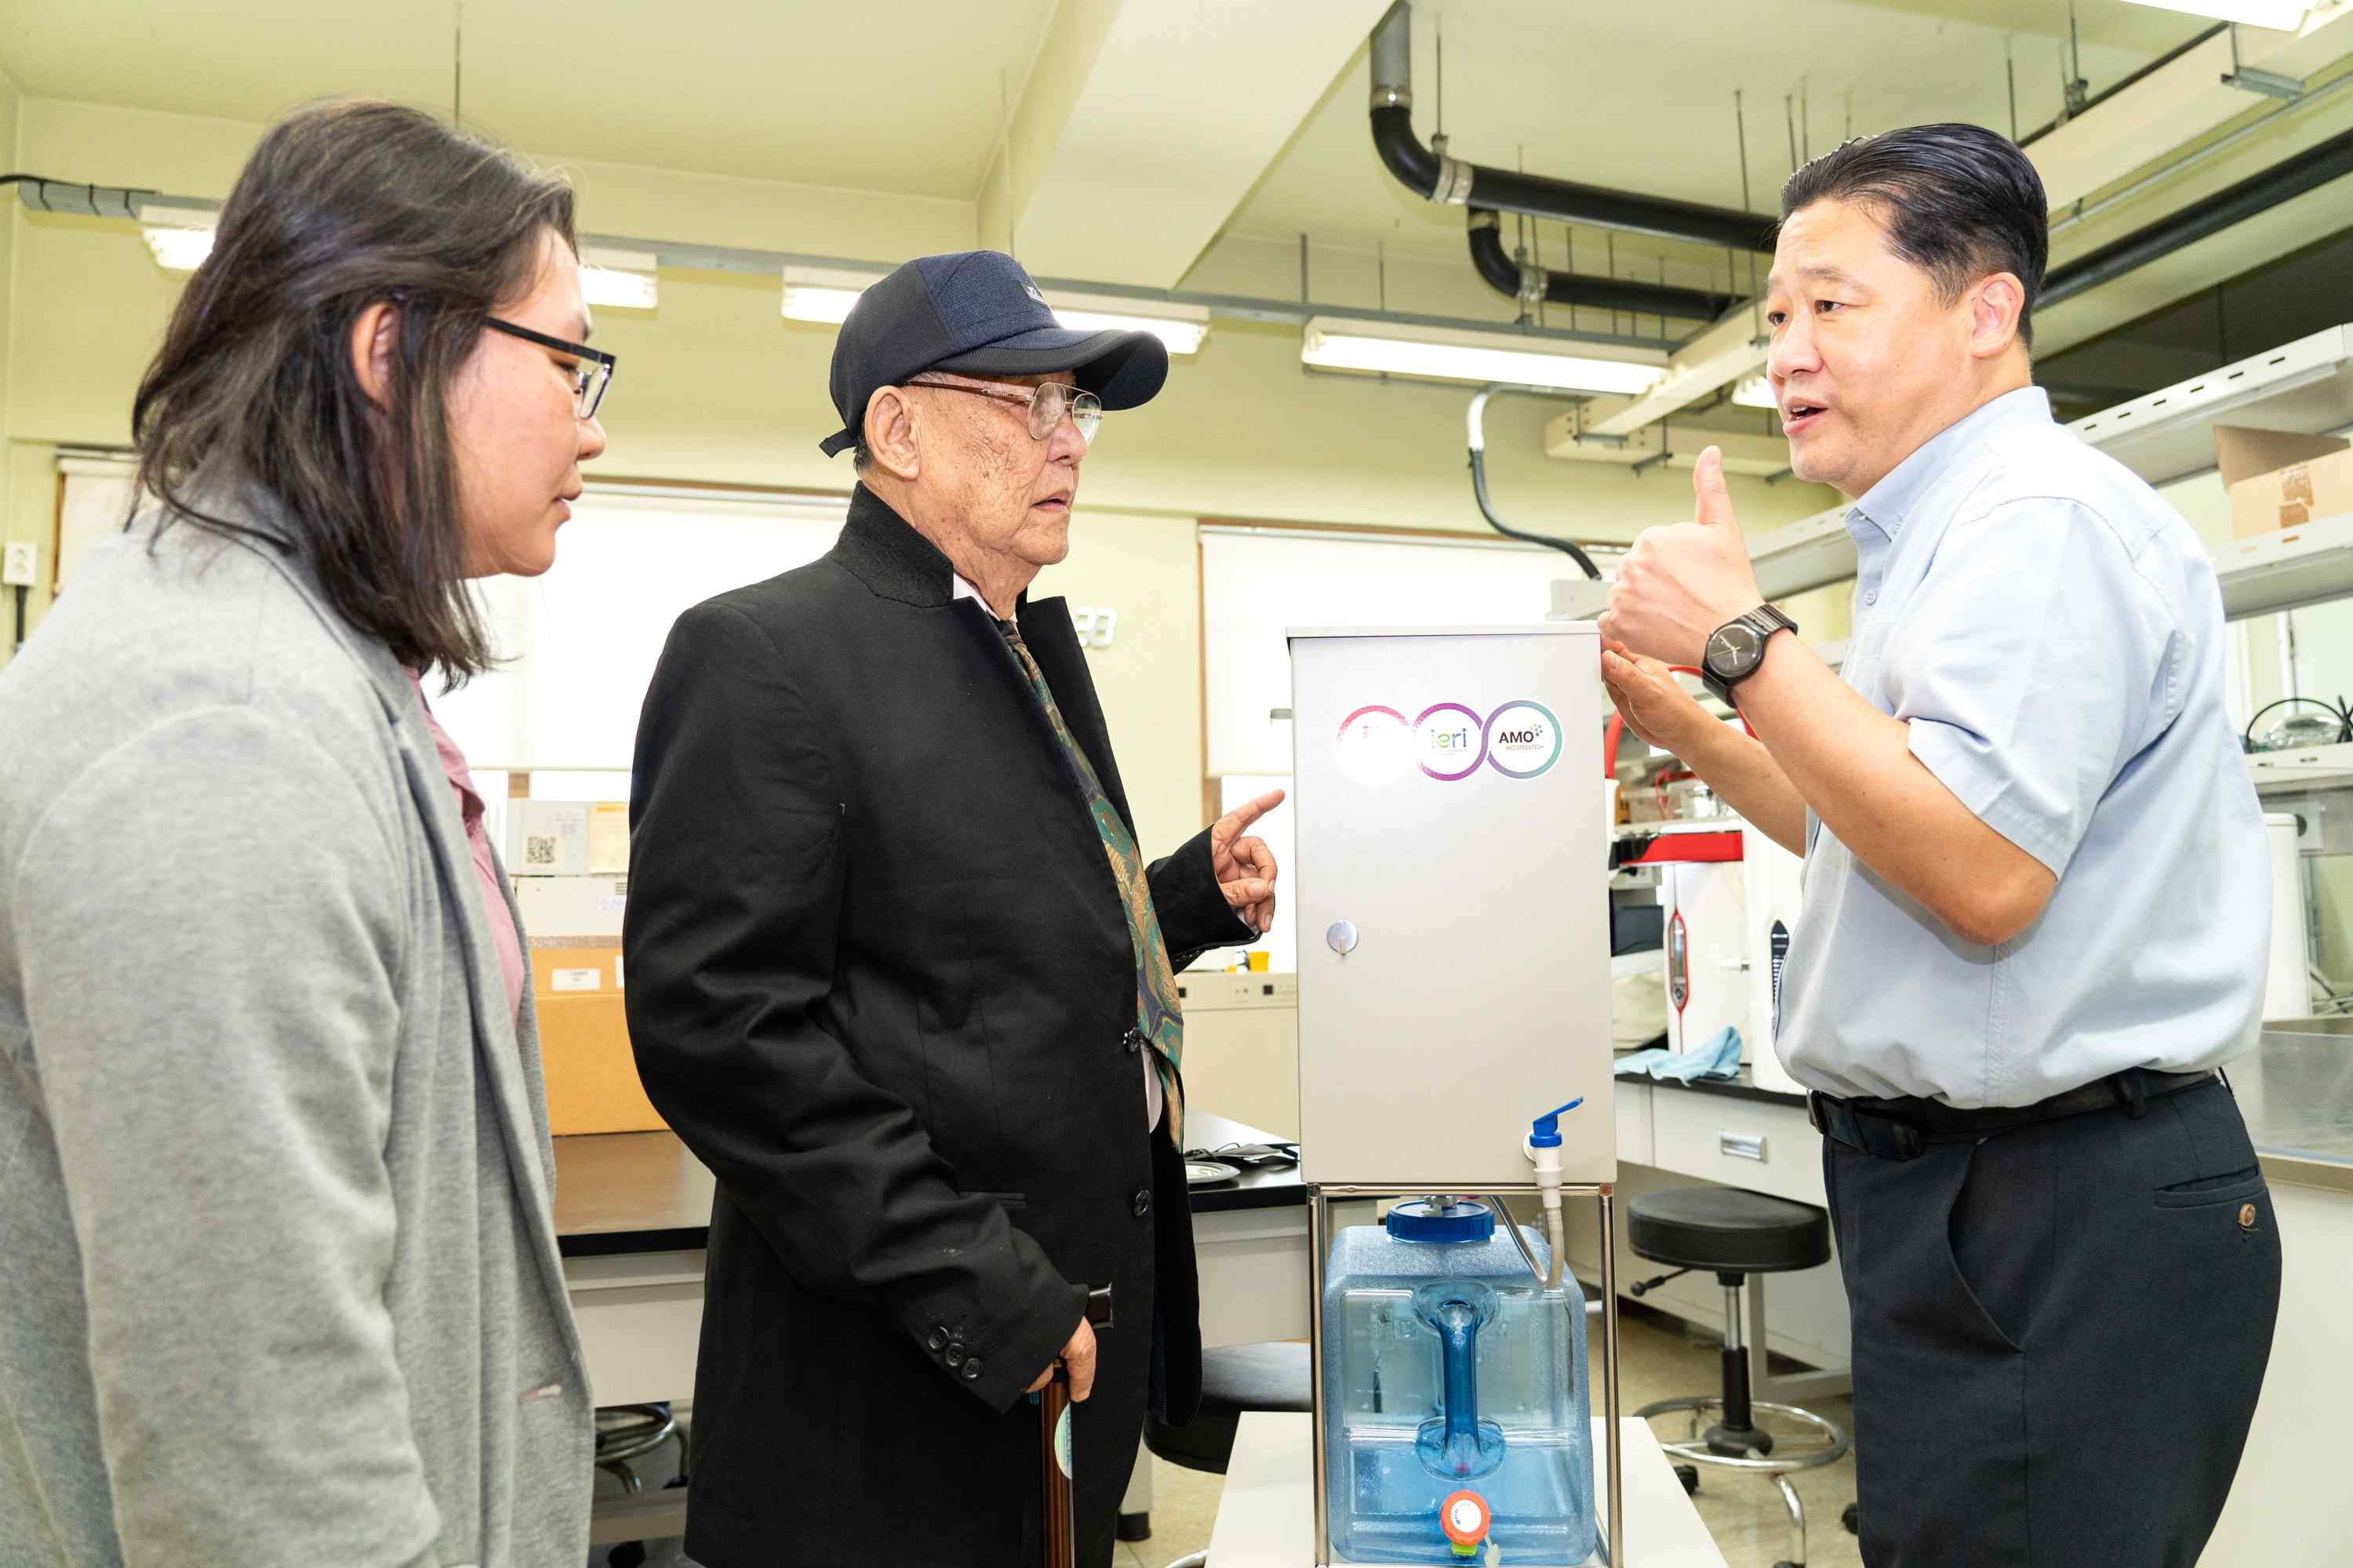
▲ GIST International Environmental Research Institute Director Kim Kyung-woong is explaining the manufacturing process and advantages of the water purification system to the visiting group including Robert Saw, Chairman of the Myanmar Refugee Committee who visited GIST.

This support project has been carried out since August last year at the suggestion of National Assemblyman Yong-bin Lee (Democratic Party of Korea, Gwangju Gwangsan-gu Gap) who heard the news that local citizens of Myanmar, who had lost their livelihoods in a military coup, were suffering from water shortages at their shelters.

To this end, the science and technology community, including the ‘Meeting of Parliamentarians for the Restoration of Peace and Democracy in Myanmar’, the Science and Technology Association, the Korea Federation of Science and Technology Societies, the Korea Atomic Energy Research Institute, the Graduate School of Science and Technology, and the Korea Science and Creativity Foundation participated in the donation.

The 112 Hope Water Purifiers produced by GIST International Environmental Research Institute with donations will be delivered to Myanmar refugee camps by the end of this year in cooperation with the Karen Refugee Committee (KRC) located on the Myanmar-Thailand border.

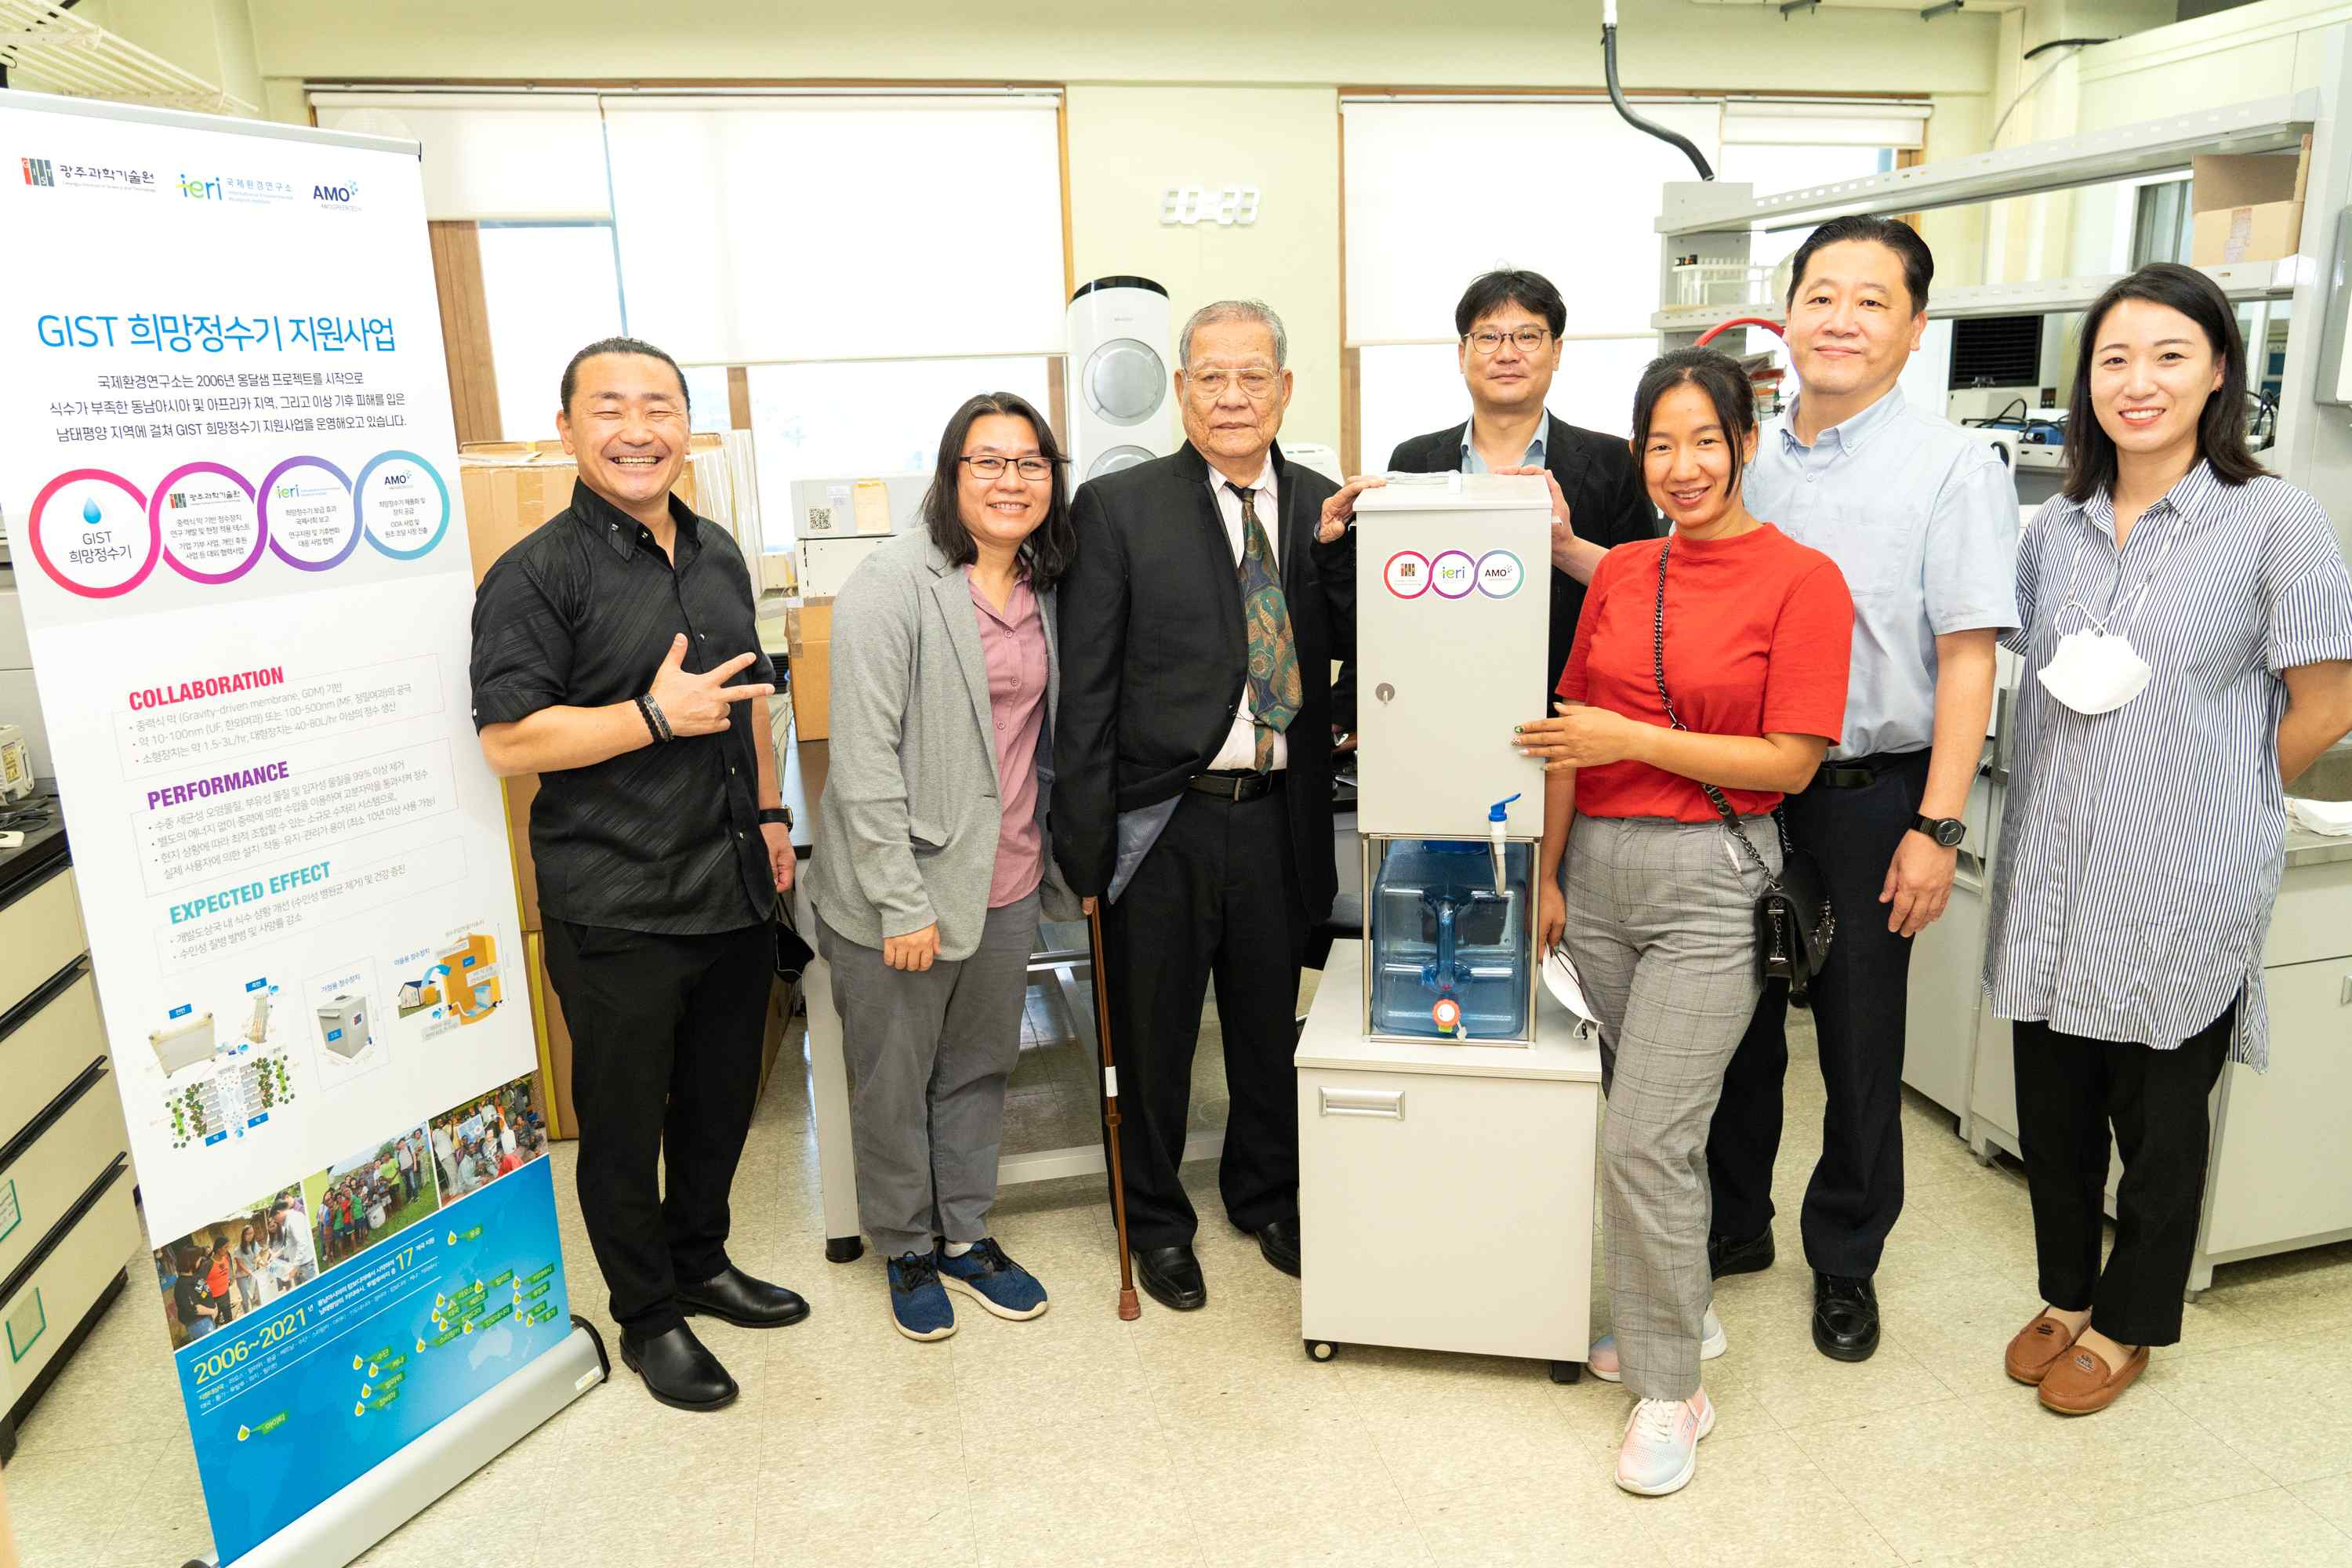
▲ On the morning of the 30th (Friday), a visiting delegation including Robert Saw, Chairman of the Myanmar Refugee Committee, who attended the donation ceremony for the ‘Hope Water Purifier’ made by GIST, visits the International Environmental Research Institute and takes commemorative photo in front of the ‘Hope Water Purifier’.

Chairman Robert Saw, who participated in the demonstration of the Hope Water Purifier on this day, said, "The Hope Water Purifier is an essential relief item for refugees scattered in the jungle on the Myanmar-Thailand border. It is expected to greatly contribute to the prevention of water-borne infectious diseases such as diarrhea and typhoid and to improve the poor living conditions of refugees."

GIST President Kiseon Kim said, "The 「Hope Water Purifier Support Project」 is a good example of how science and technology can contribute to ensuring a healthy and safe life for mankind. With the help of the Republic of Korea's scientific and technological capabilities and the spirit of solidarity, let's create a world where Myanmar refugees can get out of the difficult environment as soon as possible and the international and socially disadvantaged can be freer and happier."



