KBI Hanam Chairman Jung-joo Koh donates KRW 1 billion to the GIST Development Fund

– Held a donation agreement ceremony on the 28th... “(tentative name) Please use it to build the GIST Welfare Club”

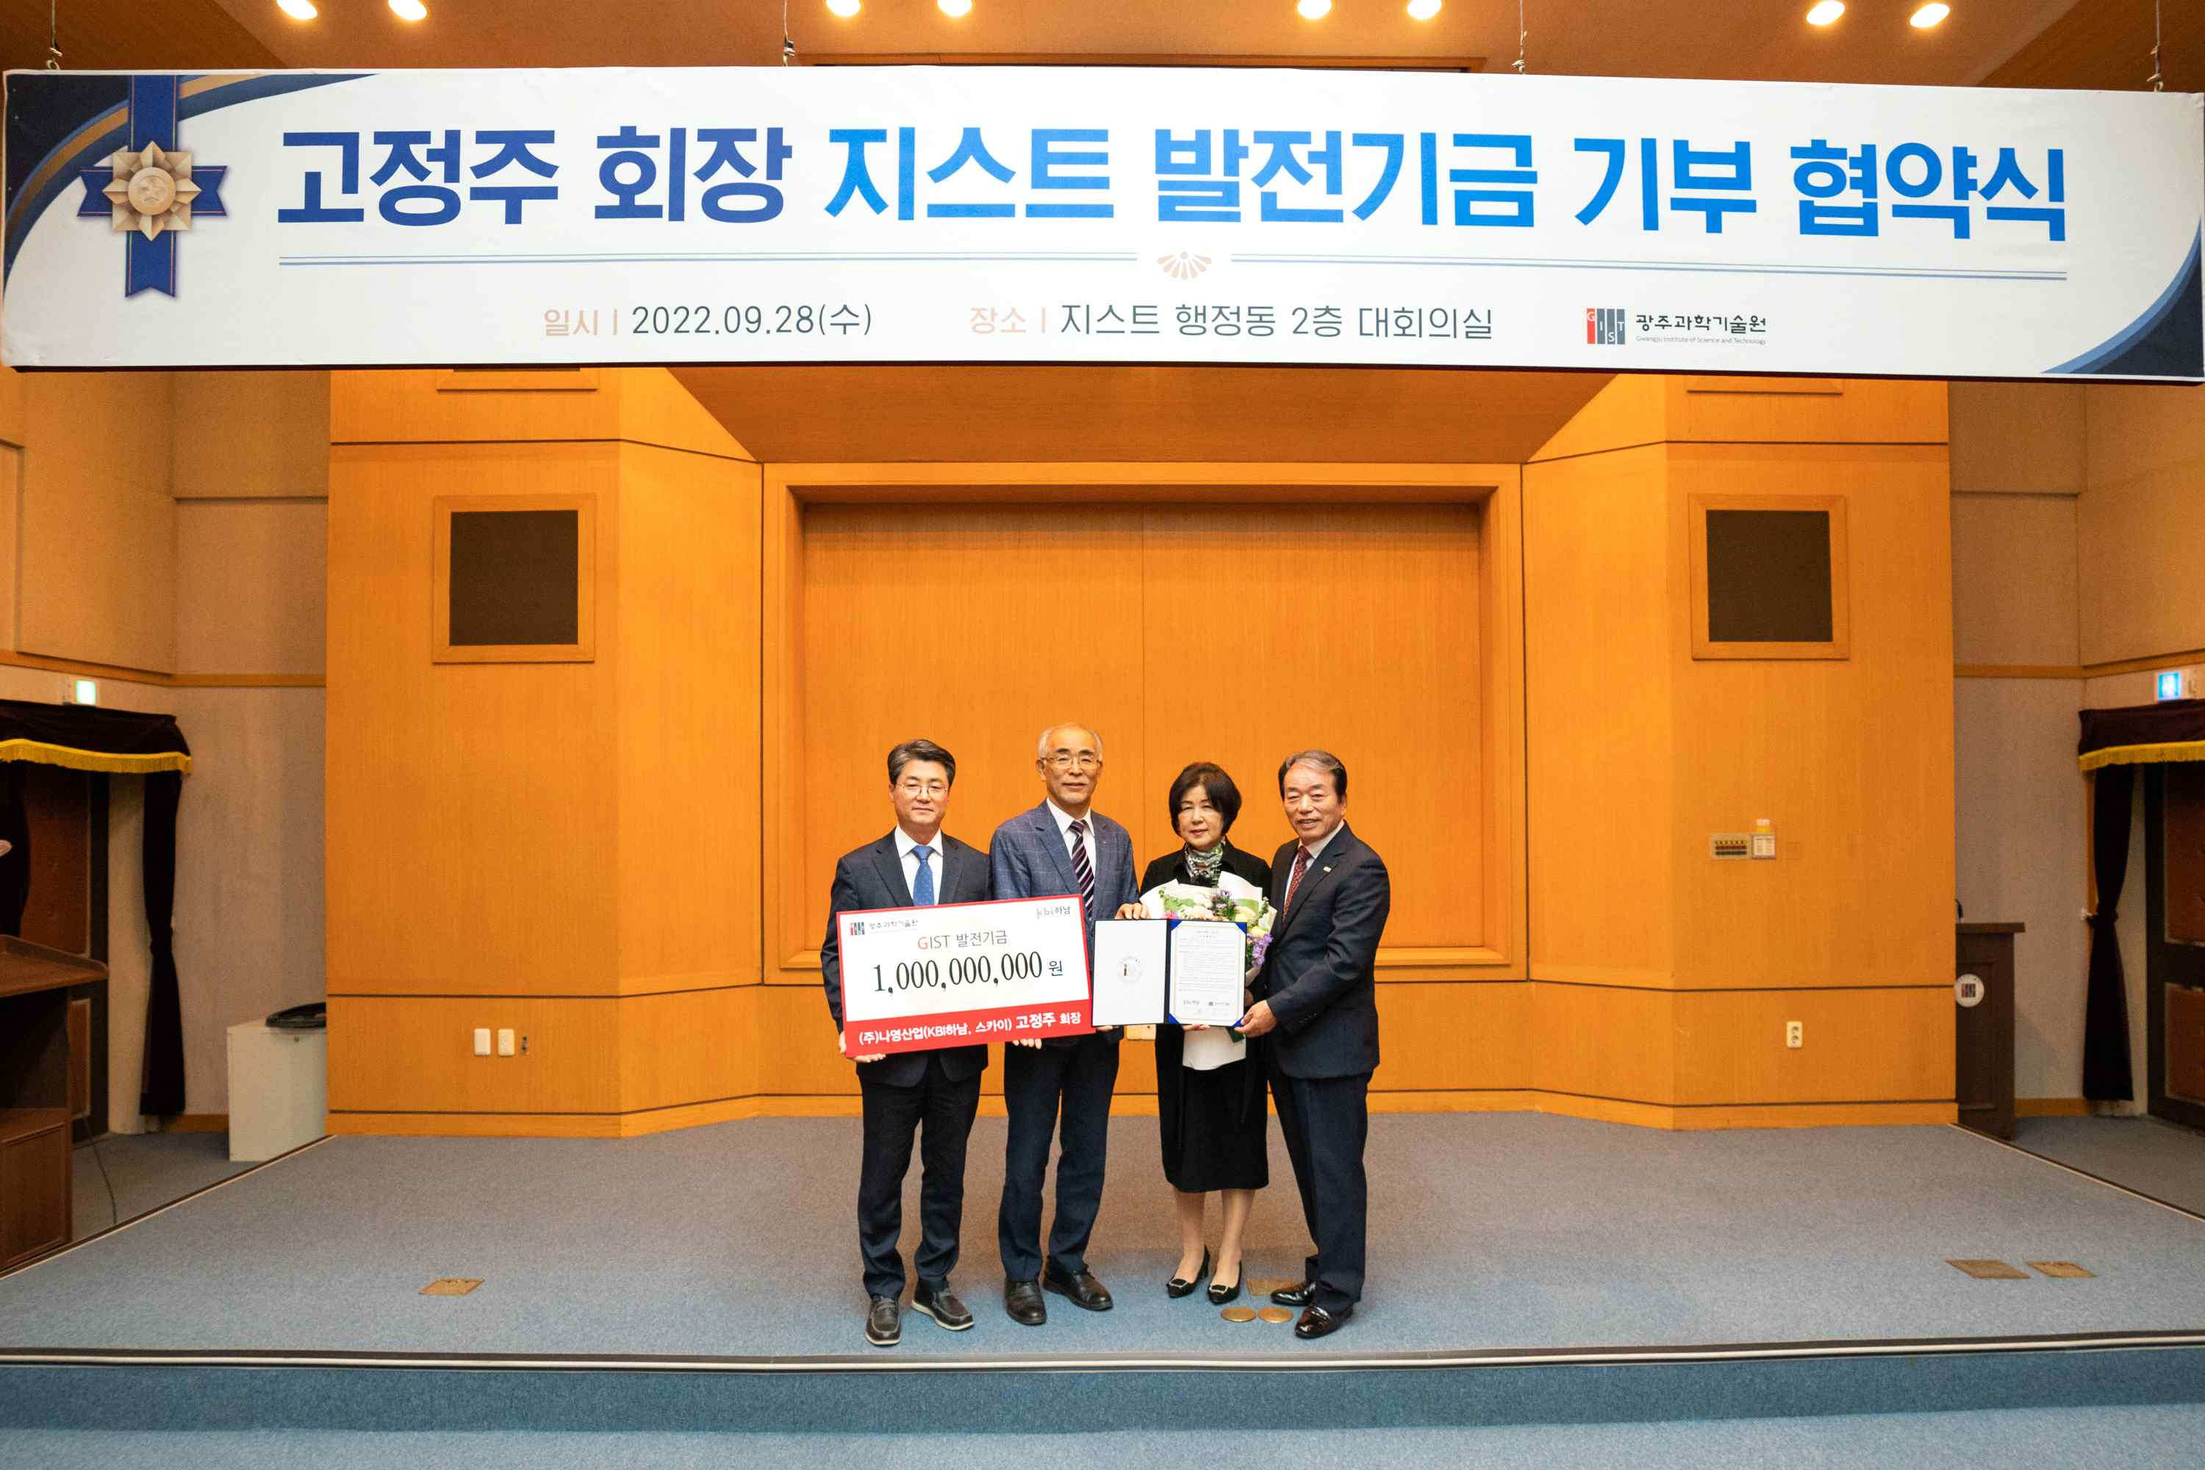
▲ On the afternoon of the 28th (Wednesday), in the conference room on the 2nd floor of the GIST administrative building, KBI Hanam Jung-joo Koh is taking a commemorative photo after signing a donation agreement and depositing the development fund with GIST. (From left) Gist Jeon Chang-deok, head Yeon Gu, Ki-seon Kim, president of GIST, and KBI Hanam Chairman Ko Jung-joo couple.
(From left) GIST Research Director Chang-Duk Jun, President Kiseon Kim, KBI Hanam Chairman Jung-joo Koh and his wife

GIST (Gwangju Institute of Science and Technology, President Kiseon Kim) Jung-joo Koh, chairman of the Korea Development Foundation and chairman of KBI Hanam, a knowledge industry center established jointly by government and private capital for the first time in Gwangju Metropolitan City, donated KRW 1 billion to GIST as a development fund.

Since GIST was established in 1993, this was the first time that an individual has donated KRW 1 billion in development funds, excluding companies.

Chairman Jung-joo Koh said, "While running a company, I realized that the development of science and technology and nurturing of excellent human resources are of the utmost importance in order for Korea, which lacks resources, to become an economic powerhouse. Please use it for the establishment of the (tentative name) ‘GIST Welfare Club’ for the members so that GIST can play a major role in nurturing future scientific experts."

After establishing Asung Corporation in 1982, Chairman Koh served as the chairman of the Samsung Partners Association, contributing greatly to the development of the local industry as a metal processing company for white appliances.

With the belief that nurturing young entrepreneurs in the region is urgently needed for regional development, the first knowledge industry center supported by the Ministry of Trade, Industry and Energy, 'KBI Hanam,' was built, and a strong network such as the integration of the same industry and cooperative projects between different industries. It is developing the Hanam Industrial Complex in Gwangju Metropolitan City into a nationwide startup revitalization and youth startup base.

President Kiseon Kim said, "GIST will do its best to foster world-class science and technology experts and will make efforts to ensure that all members cherish and practice Chairman Jung-joo Koh's wish for GIST. I sincerely thank the chairman for being a catalyst for GIST to take a leap forward."

GIST Research Institute Director Chang-Duk Jun said, "Starting with this development fund donation agreement ceremony, this will serve GIST as an opportunity to cooperate with the local community and accompany them toward the future."

On the afternoon of September 28 (Wednesday), Chairman Jung-joo Koh's signing ceremony for donation of development funds was held in the conference room on the 2nd floor of the administrative building in the presence of GIST officials, including President Kiseon Kim, Research Director Chang-Duk Jun, the board of directors of the GIST Development Foundation, and the family of Chairman Ko Jung-joo.



