A wall of obstacles that transcends science and technology! Korea Culture Technology Institute, Seoul Exhibition Commentary Service Demonstration

- 3D motion correction technology applied and introduced in October at the Pai Chai Hakdang History Museum, aiming to upgrade the service

- Sign language translation such as <Azalea Flower>, verification of the disabled experience group, etc... “Improvement of the cultural living environment for the disabled”

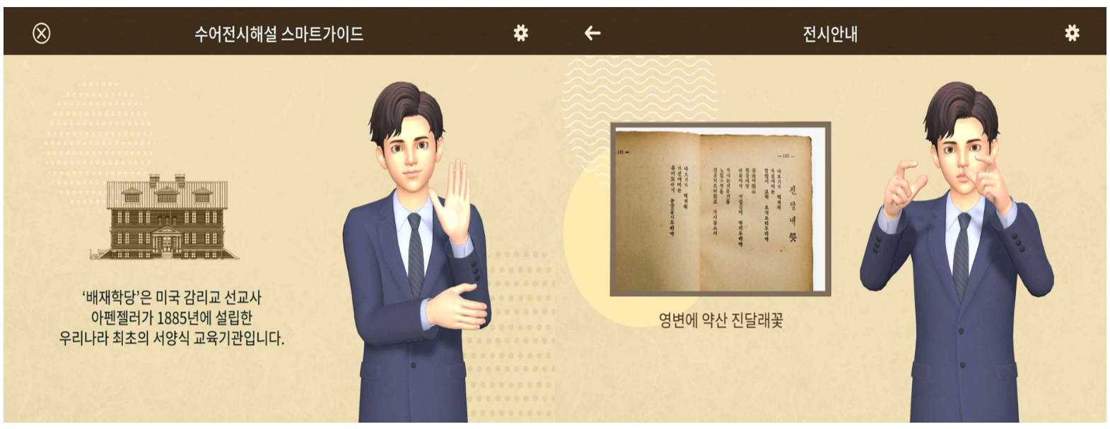▲ Sign language translation verification service for exhibition explanation at the Pai Chai Hakdang History Museum: The 'Smart Guide for Sign Language Exhibition Interpretation' for the hearing impaired, jointly developed by GIST Korea Culture Technology Institute, etc. Azalea Flower (right) is delivered in sign language.

By applying the ‘3D motion correction technology’ developed by GIST (Gwangju Institute of Science and Technology, President Kiseon Kim), hearing impaired people can enjoy the works displayed in the museum without discomfort while viewing sign language* commentary videos.

GIST Korea Culture Technology Institute* (Director Moongu Jeon, hereinafter CT Research Center) is held at the Paichae Hakdang History Museum (Director Kim Jong-heon) located in Jung-gu, Seoul from October 4 (Tuesday) to October 29 (Sat), and the development of intelligent exhibition commentary text/Korean language conversion technology' demonstration service was announced.

* Sign Language: A language in which hearing impaired people convey meaning through the movement of their hands.

* Korea Research Institute for Culture Technology (KRICT)

Recently, a service that converts speech into text for the hearing impaired has become common, but there is still a lack of service that converts the first language of the hearing impaired into Korean sign language. Moreover, as the existing sign language translation service is focused on areas necessary for daily life, the services for the hearing impaired to enjoy cultural life are insufficient.

To lower the barriers to entry into the cultural life of the deaf and to realize a high-quality cultural life, the CT Research Institute has established a Korean sign language data collection platform to translate commentary in major cultural infrastructures such as museums, art galleries, and exhibition halls into Korean sign language. They will develop 3D motion correction technology for the advancement of sign language implementation and will conduct a demonstration service at the Paichai Hakdang History Museum in October.

‘Pai Chai Hakdang History Museum’ was called ‘Pai Chai Hakdang’, the first Western-style educational institution in Korea established in 1885 by Appenzeller, a Methodist missionary in the United States. Currently, it has been created as a space to illuminate the modern history of Korea in various aspects such as education, religion, politics, society, and culture, and many visitors are looking for it.

Hearing-impaired visitors to the Pai Chai Hakdang History Museum can borrow a device for sign language translation experience. If the device recognizes the QR code attached to the exhibition commentary, an avatar will be provided with a service that translates it into Korean sign language.

In the permanent exhibition space on the first and second floors of the museum, you can experience a sign language conversion service for a total of 13 exhibits, starting with the sign language commentary of ‘the first modern educational institution, Pai Chai Hakdang’. There is also a service experience space that translates the audio commentary of the exhibition commentator into sign language.

In particular, in this demonstration service, Kim So-wol's representative work, 'Azalea Flower', was implemented as a sign language translation service for the hearing impaired through advanced technology to implement avatar sign language, so that they can experience the charm of poetry vividly on the spot.

CT Research Center was selected as the lead research institute in the ‘Policy Designated Project to Support Cultural Technology Research Organizations’ hosted by the Ministry of Culture, Sports and Tourism in April 2020. During this time, they developed a technology that converts exhibition explanations and announcements of cultural infrastructure into text and Korean sign language animations.

The CT Research Institute has been cooperating with Chonnam National University (President Seong-taek Jeong), a joint research institute, Wichis Co., Ltd. (CEO Go Mia), and the consigned research institute, Korea Deaf Association Gwangju Association (Chairman Sang-Wan Kim), for this technology development. In 2020, they signed a business agreement with the Welfare Center for the Disabled in Gwangju (Director Mi-ran Kim) and have been working hard to implement advanced services based on a practical understanding of sign language through the consultation and professional manpower of the sign language interpreting team at the welfare center.

To verify the excellence of the research results, the CT Research Center plans to conduct usability evaluations by forming an experience group for the hearing impaired during this demonstration service period. After the demonstration service of the Pai Chai Hakdang History Museum, the Gwangju National Museum (Director Lee Su-mi) will provide an additionally expanded sign language exhibition commentary service to the hearing impaired.

CT Research Center Director Moongu Jeon said, "This demonstration service at the Pai Chai Hakdang History Museum aims to lower the barriers to entry into cultural life and to implement practical services so that hearing impaired people can enjoy cultural life without discomfort. It is expected that through the advanced sign language service of the CT Research Center, even the hearing impaired can enjoy culture without being marginalized."

CT Research Center is a cultural technology research institute established in GIST in accordance with Article 17-5 of the Culture Industry Promotion Act (designation of the cultural technology research institution belonging to the Ministry of Culture, Sports and Tourism). It is carrying out a number of projects such as realistic content, AI-based art convergence creation, and media façade mapping technology.



