Why did Asian and African water experts gather in Songdo, Incheon?

- Hosted by GIST IERI-CTCN Cooperation Liaison Office
- Sharing water problems and solutions by country, such as improving water quality... “Contribute to solving water problems with science and technology”

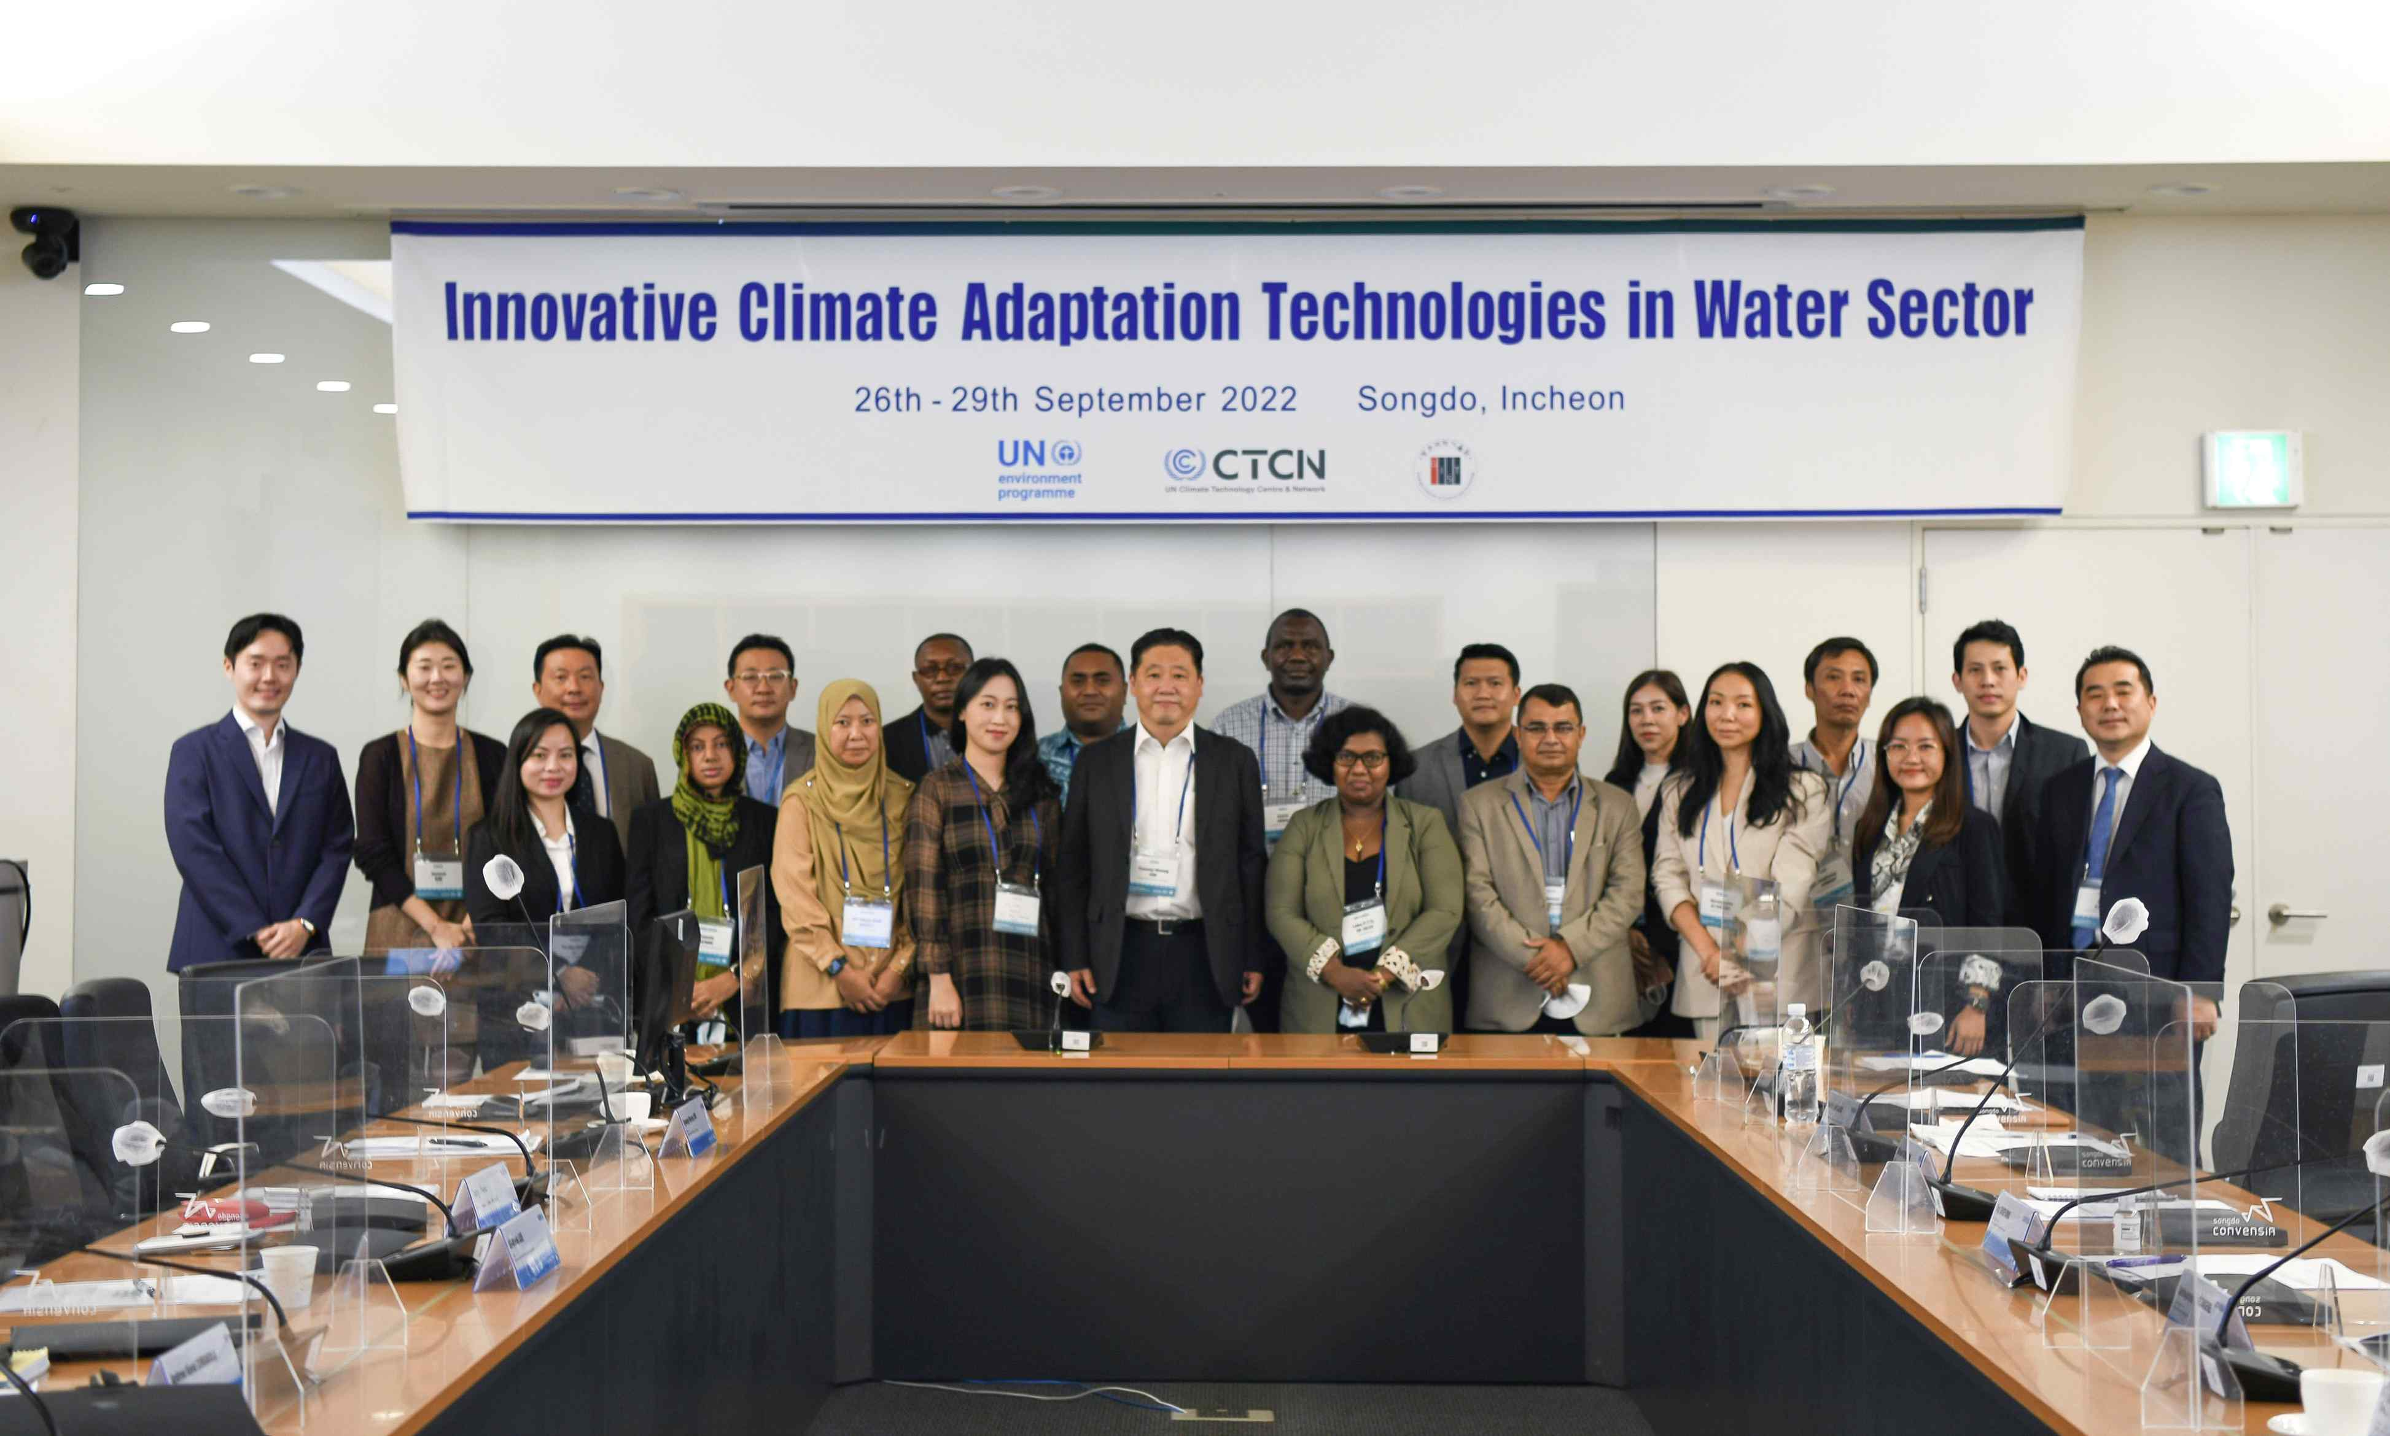
▲ Participants are taking a group photo at the opening ceremony of the ‘Innovative Climate Adaptation Technology Capacity Building Program in the Water Field’ hosted by the Climate Technology Center and Network (CTCN) Cooperation Liaison Office of the United Nations Framework Convention on Climate Change and hosted by the GIST International Environmental Research Institute.

GIST (Gwangju Institute of Science and Technology, President Kiseon Kim) invited climate technology cooperation experts from the Asia-Pacific region and African countries to Korea to operate an education program to strengthen their professionalism and work competency.

GIST International Environmental Research Institute (IERI, Director Kyoung-Woong Kim) held a capacity-building program for 18 water experts from 15 countries* including Thailand, Malaysia and Kenya from September 26th (Mon) to 29th at Songdo Korn Bensia, Incheon.

* 15 countries: Cambodia, Laos, Malaysia, Thailand, Vietnam, Bangladesh, Sri Lanka, Maldives, Mongolia, Nepal, Fiji, Namibia, Kenya, Zambia, and Tanzania

In this capacity building program, 22 experts from domestic and foreign related fields were invited as speakers to address the overall water sector, including ▴ water supply ▴ water quality improvement ▴ response to climate crisis in the water sector, from a technical, policy, and financial perspective. Participants will participate in activities such as ▴ presenting their own water problems ▴ listening to lectures and discussing solutions through group discussions ▴ discussing potential cooperative projects ▴ participating in technology matching events ▴ visiting on-site water purification and water reuse facilities.

On July 19, the International Environmental Research Institute was selected as the host organization for the 'Innovative Climate Adaptation Technology Capacity Building Program in the Water Field' hosted by the United Nations Framework Convention on Climate Change Climate Technology Center Network (CTCN)* Cooperation Liaison Office*. The invitational capacity building program was jointly operated with the CTCN Cooperation Liaison Office.

The International Environmental Research Institute signed an operating agreement of about KRW 140 million with the United Nations Environment Program (UNEP) to operate the program, and this event will be held for the first time since the CTCN Cooperation Liaison Office was established with the active invitation of Korea. It is significant in that it is a capacity-building program for civil servants and experts in charge of climate technology cooperation.

* Climate Technology Center and Network (CTCN): To support projects to promote the development and transfer of energy-efficient, low-carbon and climate-resilient climate technologies based on the needs of developing countries, the 2013 United Nations Framework Convention on Climate Change is based on international organizations. GIST is the 200th network member institution.

* CTCN Partnerships and Liaison Office (PALO, Partnerships and Liaison Office): Opened on the 23rd floor of G-tower in Songdo, Incheon on July 21 this year for the purpose of cooperation in climate technology R&D and demonstration and strengthening partnership with the Green Climate Fund (GCF). office. The establishment agreement was signed on September 27, '21, and an administrative and financial agreement was concluded on October 7, '21, and a total of KRW 12.5 billion (Ministry of Science and ICT each year, KRW 2 billion, Incheon City provided 500 million won).

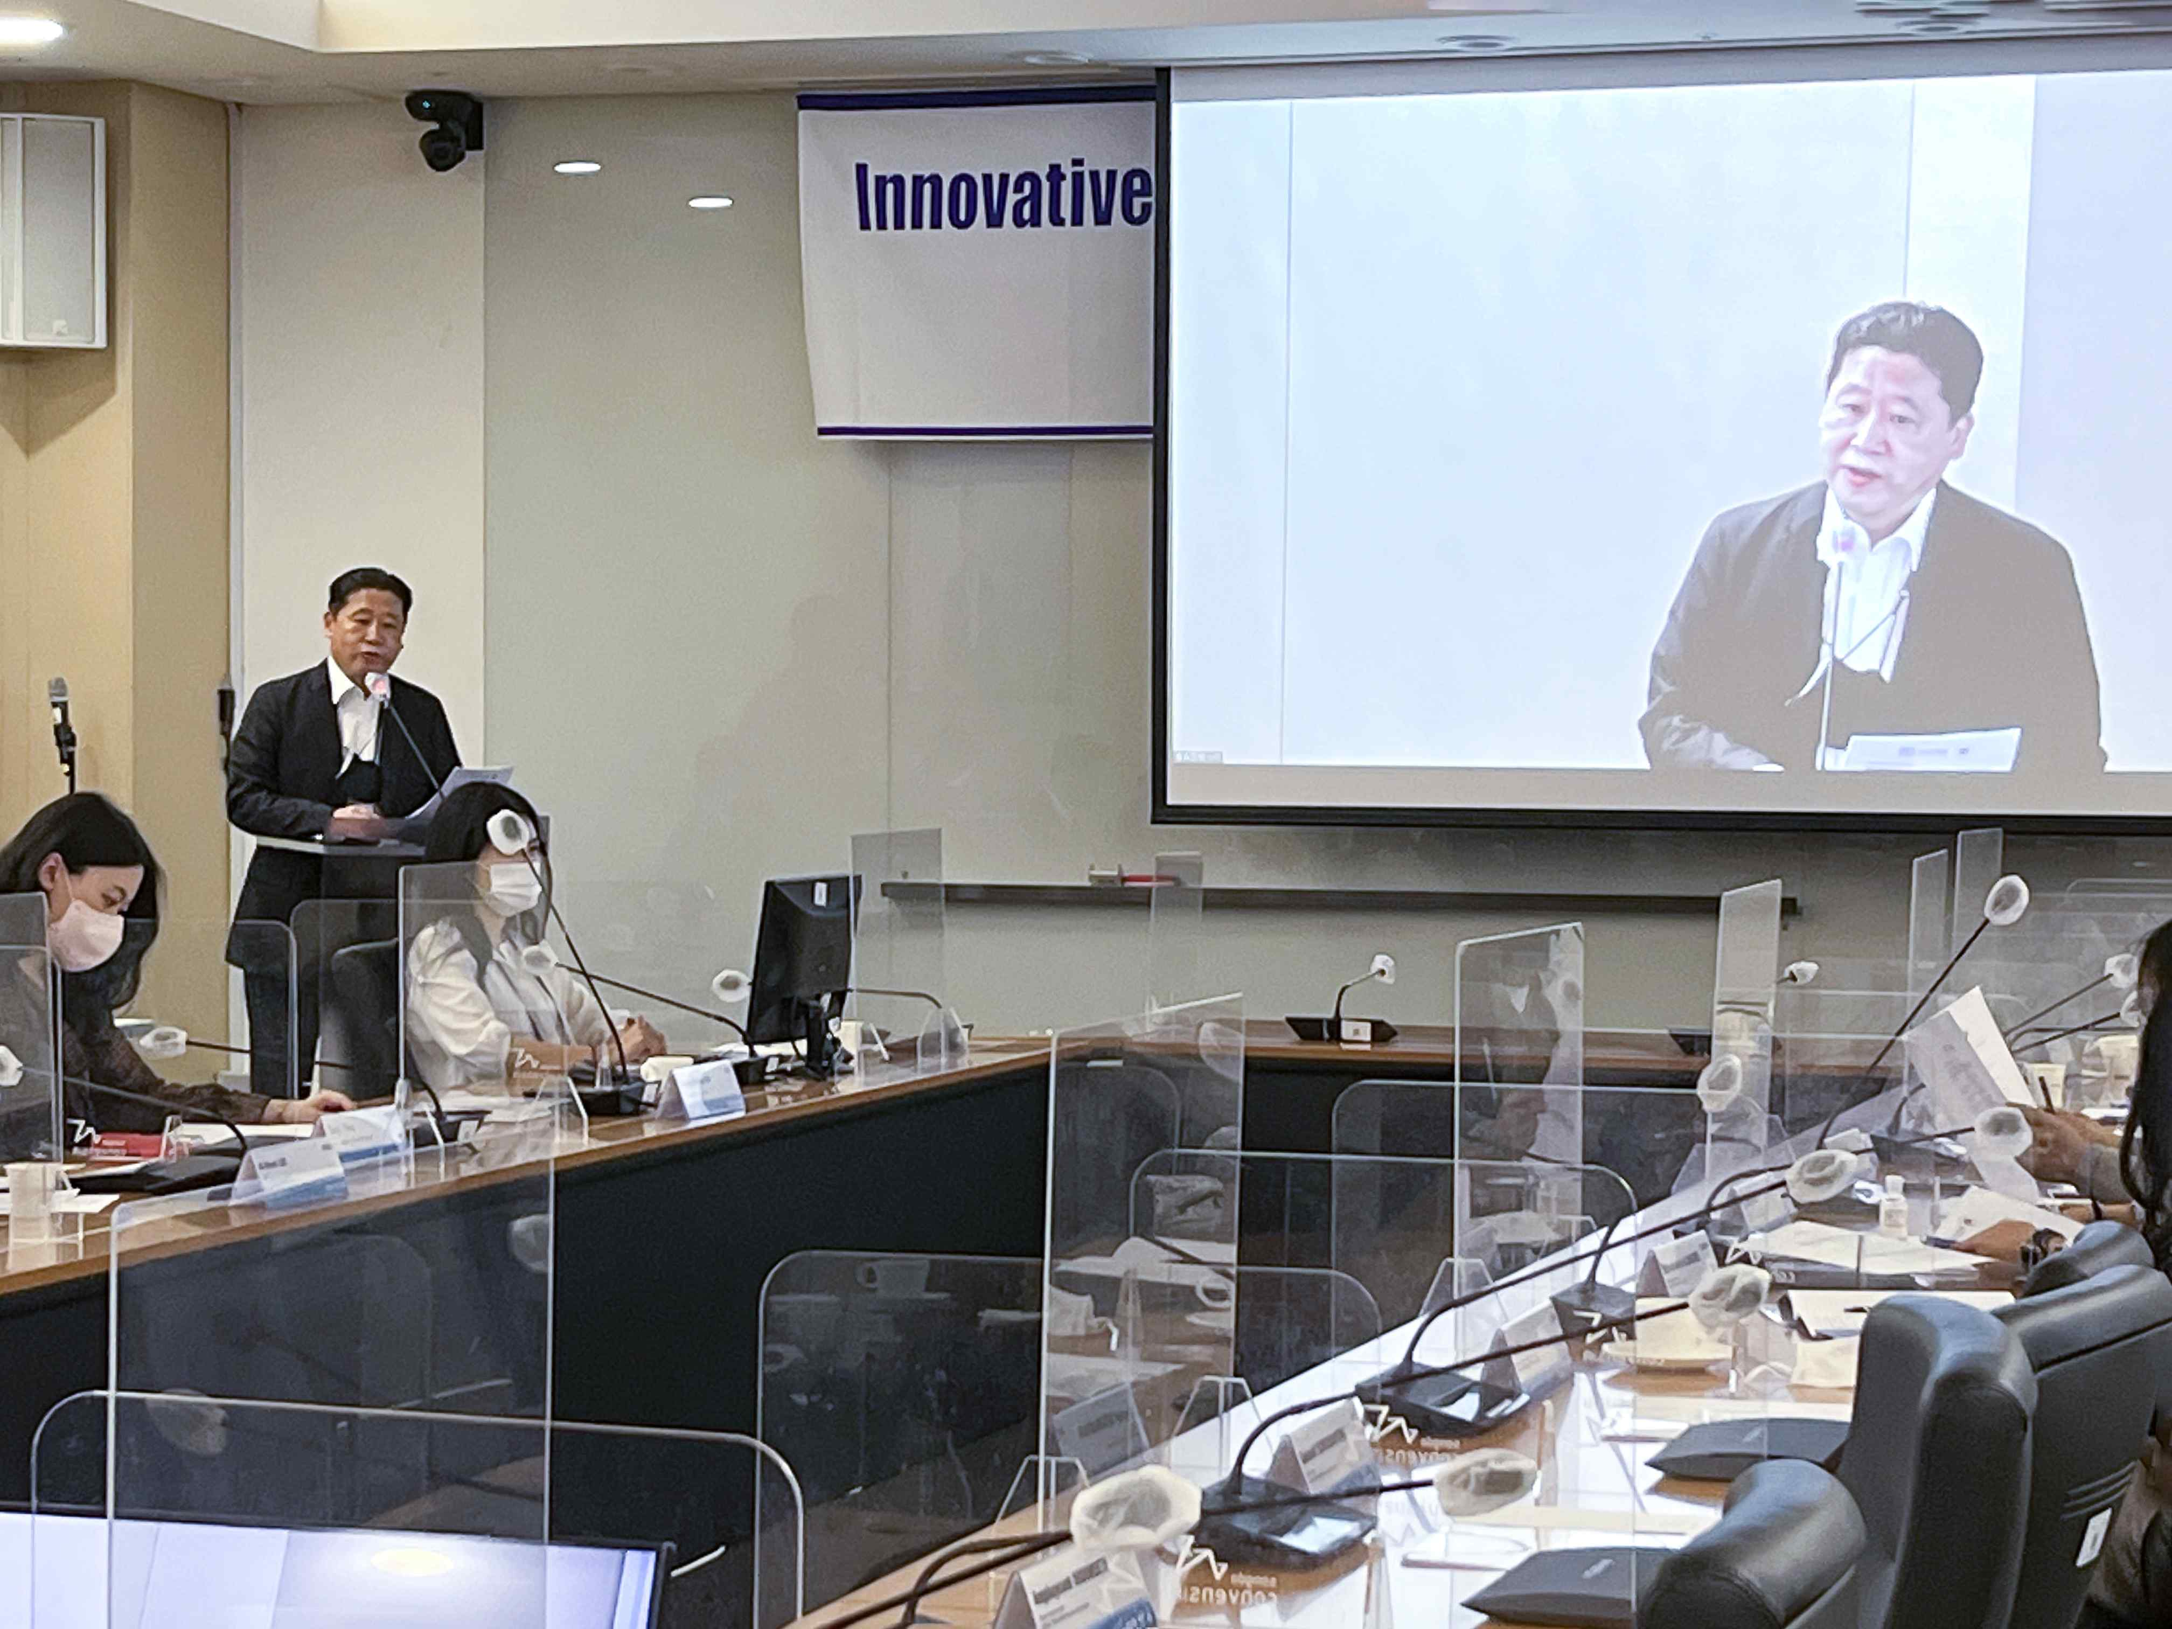
▲ Hosted by the United Nations Framework Convention on Climate Change Climate Technology Center and Network (CTCN) Cooperation Liaison Office. GIST International Environmental Research Institute (IERI, Director Kyoung-Woong Kim is giving the opening remarks at the ‘Water Field Innovative Climate Adaptation Technology Capability Reinforcement Program’ hosted by the GIST International Environmental Research Institute.

Director Kyoung-Woong Kim said, "Recently, as the International Environmental Research Institute actively participated in the free CTCN technology support project using a water purifying device with the Cambodian government, a capacity-building program was started.
In cooperation with the CTCN Cooperation Liaison Office, this is expected to be of practical help in resolving water problems in Asia-Pacific and Africa and responding to climate change."

Meanwhile, GIST International Environmental Research Institute has been working on international research and development to solve environmental problems in developing countries since its establishment in 2001 for the purpose of establishing the UN University Research Center. This has contributed greatly to nurturing environmental experts and reinforcing competence, and is continuing related activities.

Since 2014, we have been actively conducting international development cooperation activities in the water sector through the United Nations Development Program (K-UNDP) project, etc., and since 2016, through the UNFCCC technology mechanism, international climate technology cooperation and climate change Actively participating in the response.



