"In the digital economy era, grab the 'attention' of consumers!" GIST Academy held breakfast forum in September

– Division of Liberal Arts and Sciences Professor Dae-Cheong Ha emphasizes the economic value of the ‘attention’ ability in accordance with the development of the digital economy

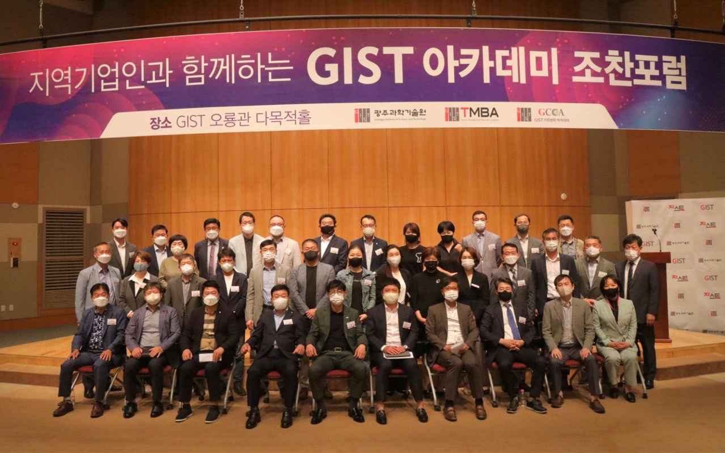
▲ Commemorative photo of GIST Academy is holding a breakfast forum in September at Oryong Hall

GIST (Gwangju Institute of Science and Technology, President Kiseon Kim) Academy held a September breakfast forum under the theme of 'YouTube recommendation algorithm and the economy of the state' at Oryong Hall on September 26 (Mon) with about 60 representative companies from Gwangju and Jeollanam-do in attendance.

Prior to the lecture, Division of Liberal Arts and Sciences Professor Professor Dae-Cheong Ha, who was the speaker of the forum, said that user attention is the main source of revenue for digital companies, and in order to secure the attention of limited users as much as possible, large companies such as YouTube, Facebook, and Netflix He explained that digital companies are competing fiercely.

Professor Dae-Cheong Ha said that with the development of the digital economy, human attention has become a scarce and valuable economic resource. He stressed that what and how to pay attention is largely a result of interactions with digital technology rather than personal choices.

In addition, Professor Dae-Cheong Ha explains 'excited attention' as the opposite of 'deep attention', and 'excited attention' can pay attention to a given task only for a short period of time, and instead allows multitasking to perform multiple tasks at the same time. He ended the lecture by suggesting the possibility that the distraction of the user's attention is the beginning of a new change in the state economy era.

The GIST Academy operates the Techno Management Business Academy (opened in 2010) and the Climate Change Academy (opened in 2016) as non-degree programs. The “GIST Academy Breakfast Forum” is held on the last Monday of every month, inviting experts from various fields as lecturers for alumni and local business executives.

The GIST Academy is contributing to the vitalization of the local economy and industry-university cooperation by helping managers in each field to deeply understand changes in the corporate environment and global business strategies and form a wide human network through lectures by the best experts in Korea.



