GIST – KAIST – Kwangwoon University Student Union Team, ‘Defense Technology’ Startup Competition Grand Prize

– Awarded the first prize, the Defense Acquisition Program Administration Award, for the idea of ‘reinforcing job training using mixed reality technology’

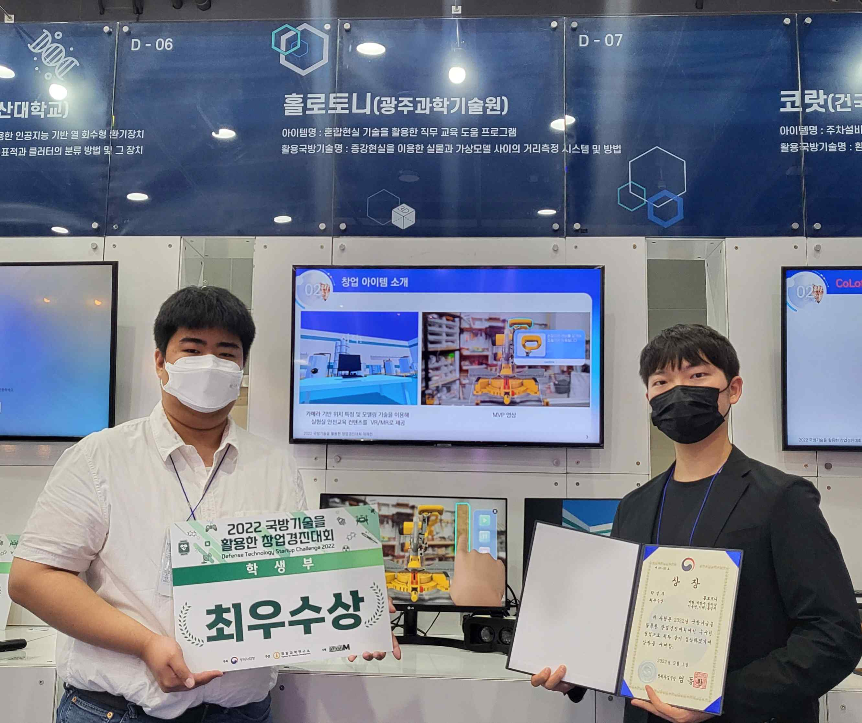
▲ The Holotony team led by Hyun Park won the top prize in the student division at the 2022 Startup Contest using defense technology (right)

The combined team of GIST-KAIST-Kwangwoon University students won the top prize in the student division at the <2022 Startup Contest using Defense Technology>, which competes for ideas for start-up and commercialization using defense technology.

Hosted by the Defense Acquisition Program Administration and the Defense Science Research Institute, the <Entrepreneurship Contest using Defense Technology> is a contest to propose commercialization ideas (techniques) that can be applied to new products or industries using defense technologies registered in the Defense Technology Trading Market*. It is divided into a student section and a general section.

* Defense Technology Trading Market website: http://techmart.dtaq.re.kr

GIST (Gwangju Institute of Science and Technology, President Kiseon Kim) The <Holotony> team, which consists of 6 students from 3 universities, including Hyun Park (2nd year, team leader) of the School of Electrical Engineering and Computer Science, offers a 'job training help program using mixed reality technology'. It was proposed as an idea and received the first prize in the student division.

The ‘job training help program using mixed reality technology’ announced by the Holotony team is an idea to reinforce job training by using the latest technology related to virtual reality, mixed reality (MR).

MR is a concept created by complementing VR and AR, and is a technology that allows users to interact with graphics by overlaying a virtual layer on the real world when wearing a head mounted display (HMD) device.

Currently, laboratory safety education at universities is conducted only through video education, but the Holotoni team is researching ways to improve the quality of education by developing it as MR content.

The Holotony team was selected as the top student in the student division and won the Defense Acquisition Program Administration Award and will receive support such as △ waiver of start-up technology fee △ qualification to participate in the inter-ministerial Entrepreneurship Contest (Challenge 2022! K-Startup) △ technology commercialization programs and customized startup accelerators.

GIST student Hyun Park, who led the Holotony team, said, "While participating in the competition, I was able to materialize the contents of business items and business models by receiving user research, prototyping, customer discovery, and verification training. Thanks to GIST's various start-up programs, I have broadened my horizons, and as I gained confidence from winning this competition, I plan to continue implementing more specific business ideas."

The <Entrepreneurship Contest using Defense Technology> has been held since 2014 to lay the foundation for activating the transfer of defense technology to the private sector and to find ways to utilize defense technology from various perspectives to create a domestic startup culture and to discover defense technology suitable for start-ups. is being held. This year's competition was held as one of the major events of the recently held <6th National Defense Science and Technology Festival>.



