GIST faculty and staff donated 120 million to the Development Fund

– Fund for the construction of a welfare center as a space for the coexistence of members and local residents

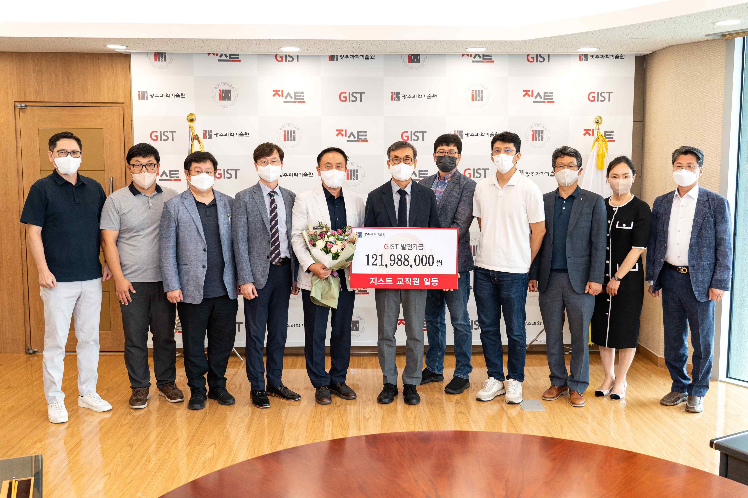
▲ On the afternoon of the 13th (Tuesday), GIST held the 'GIST Faculty Development Fund Donation Ceremony' event in the 5th floor of the Administration Building in the President's Office with the participation of 11 donors, including Vice President for Academic Affairs Raekil Park and GIST Research Institute Director Chang-Duk Jun. (From left) Dean of Academic Affairs Sang-Don Kim, Professor Sunjae Lee, Professor Tae Kim, Professor Jae Gwan Kim, former GIST Professor Sang-hyuk Lim, Vice President Raekil Park, Professor Young-Soo Jun, Professor Ji-Hwan Park, Director Yeung Lak Lee, Section of Public Affairs Chief Hyo Jung Kim, and GIST Research Institute Director Chang-Duk Jun

GIST (Gwangju Institute of Science and Technology, President Kiseon Kim) faculty members donated 120 million won to the school development fund for the construction of the school welfare center.

GIST announced that on the afternoon of September 13 (Tuesday), 10 GIST faculty and staff donors, including Vice President for Academic Affairs Raekil Park and GIST Research Institute Director Chang-Duk Jun, were in attendance at the 5th floor of the administrative building in the Administrative Building, and held a donation ceremony for the Development Fund.

As the representative donor, GIST Research Institute Director Chang-Duk Jun (Professor of Life Sciences) said, "With a pure heart for the development of GIST, this donation will be used to promote the construction of a welfare center as a space where all GIST members and local residents such as professors, staff, and students can coexist."

Vice President for Academic Affairs Raekil Park said, "This donation to the Development Fund is even more meaningful as it contains the hearts of members to create a GIST of harmony and trust to be one step closer to the local community. We would like to express our gratitude to the faculty and staff for the development of the school, and the donated funds will serve as a solid foundation for GIST to leap forward."



