GIST receives 30 million won donation from Omega INC CEO Ki-seok Koh

– To nurture talented students and contribute to regional development

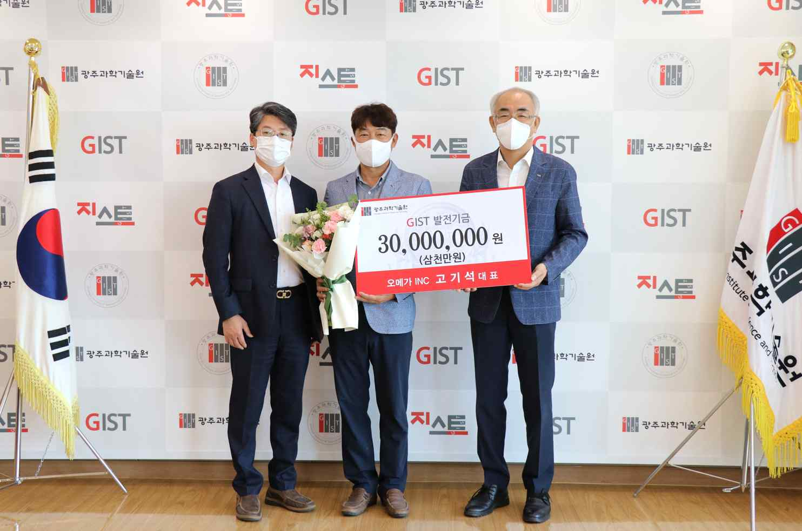
▲ Commemorative photo of Omega INC CEO Ki-seok Koh donating to the GIST Development Fund. (From left) Dean of International and Public Affairs Chang-Duk Jun, Omega INC CEO Ki-seok Koh, and President Kiseon Kim

GIST (Gwangju Institute of Science and Technology, President Kiseon Kim) recently announced that Omega INC CEO Ki-seok Koh donated 30 million won to the GIST Development Fund.

Omega INC is an interior remodeling company located in Buk-gu, Gwangju, specializing in custom furniture and interior design, and it has grown into a company with the highest level of design and delivery capabilities by accumulating expertise in the field for more than 15 years. As CEO, Koh is interested in children and scientific development, and he has been continuously volunteering, sharing, anddonating to various local organizations and groups.

CEO Ki-seok Koh said, "At GIST, where a lot of talented people are nurtured for the development of national science and technology, they have built a regional core infrastructure, and I donated with the hope that excellent research results will contribute to regional development."

President Kim said, "I thank you very much for your interest and donation for the development of GIST, and the precious donation will be used diligently for nurturing excellent scientific specialists and for regional development."

The donation by CEO Ki-seok Koh is expected to be used for comprehensive school development, such as improving the quality of GIST's education and for research and building infrastructure.



