GIST awards honorary doctorate degree in engineering to Nayoung Industrial Co., Ltd. Chairman Jung-joo Koh

- As the chairman of the GIST Development Foundation, he contributed to the establishment of a science and technology infrastructure and the training of talented specialists

- Contributed to the development of local industries and economic revitalization through the management of representative mid-sized enterprises and investment in knowledge industry centers

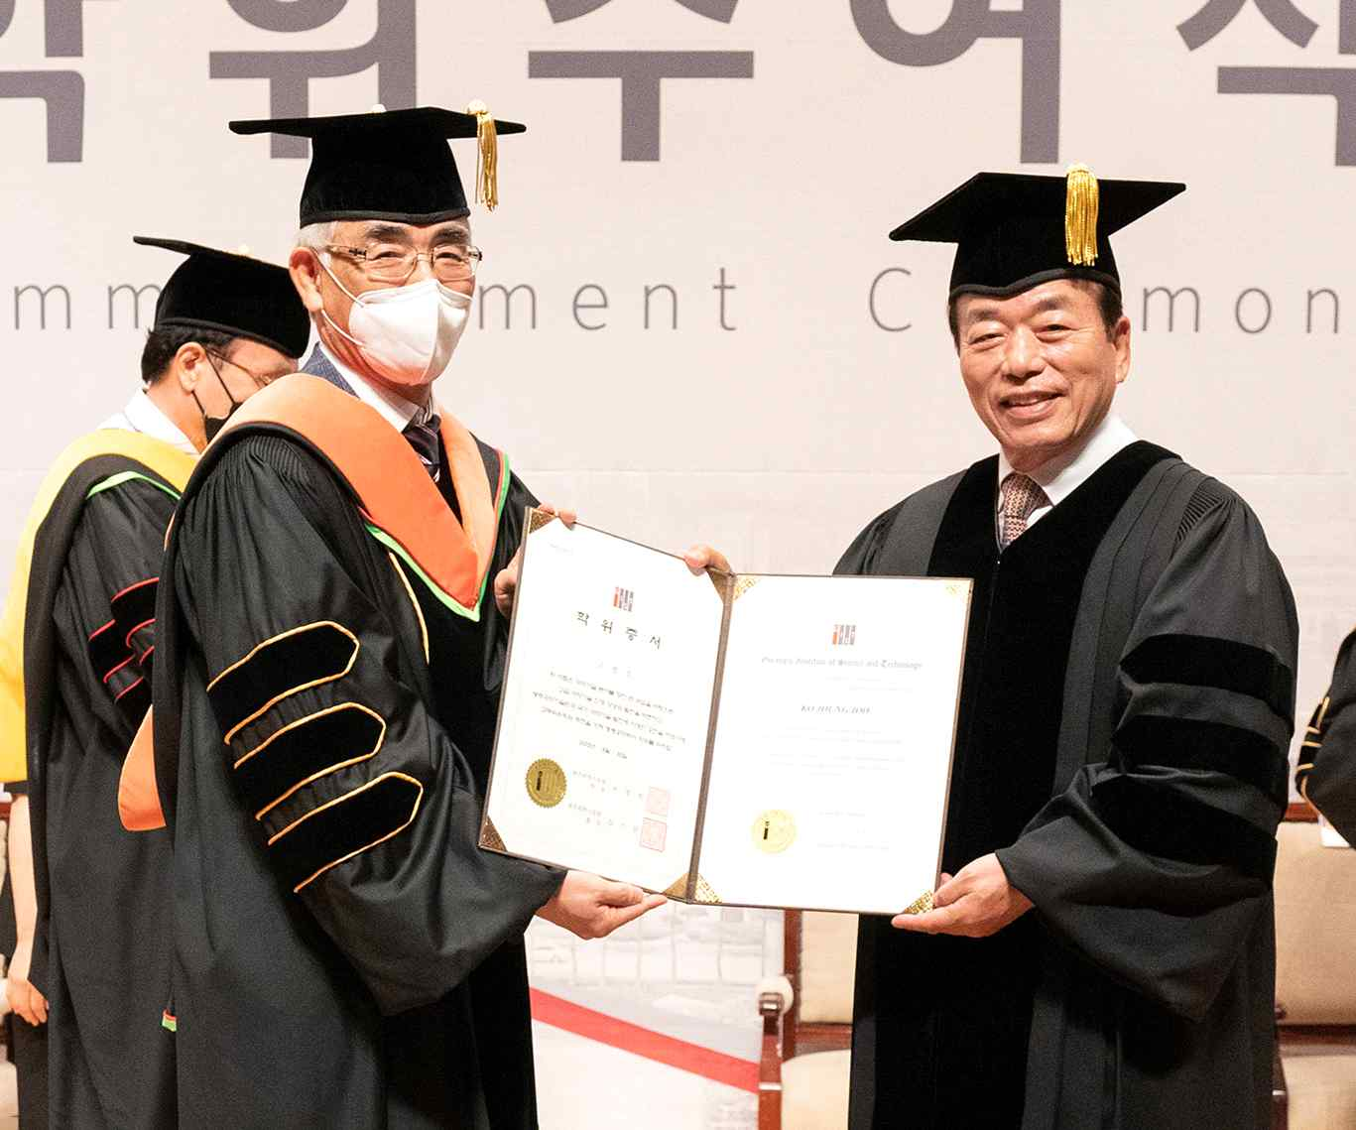
▲ On the afternoon of August 30 (Tuesday), GIST held an honorary doctorate award ceremony at Oryong Hall for Chairman Jung-joo Koh. (From left) GIST President Kiseon Kim and Nayoung Industrial Co., Ltd. Chairman Jung-joo Koh

GIST (Gwangju Institute of Science and Technology, President Kiseon Kim) conferred an honorary doctoral degree in engineering to Nayoung Industrial Co., Ltd. Chairman Jung-joo Koh.

GIST held an honorary doctoral degree conferment ceremony for Chairman Koh on the afternoon of August 30 (Tuesday) at GIST Oryonggwan in the presence of 200 people and key officials, including President Kiseon Kim, the board of directors for the GIST Development Foundation, GIST Academy President Yong-beom Lee, and Chairman Koh's family and friends.

GIST said, "Chairman Jung-joo Koh, as a regional entrepreneur, is an entrepreneur who has contributed to the economic development of the nation's industry and the region by running Nayoung Industrial Co., Ltd. He has also served as the chairman of the GIST Development Foundation since 2019, and he has greatly contributed to the establishment of GIST's education and research infrastructure and fostered outstanding specialists."

In particular, Chairman Koh participated as a private investor in 'KBI Hanam', a knowledge industry center promoted by both the government and private capital for the first time in Gwangju Metropolitan City to improve the infrastructure of the old Gwangju Hanam Industrial Complex and to provide R&D buildings, production buildings, and dormitories. By building a modern complex hub to support young entrepreneurs, the company is sparing no investment in strengthening the competitiveness of industrial complexes and developing local industries.

‘KBI Hanam’ has built a strong network such as the agglomeration of the same industry and cooperative projects between different industries to build a perfect business infrastructure as a high value-added innovation landmark in an industrial complex, and this is expected to serve as a growth engine for the future of Gwangju and Hanam Industrial Complex, which is playing the role of revitalizing start-ups and incubating young entrepreneurs.

In addition, Chairman Jung-joo Koh served as a model as an entrepreneur who fulfills social responsibilities for the local economy and industry through △ book donations △ delivery of smart devices and masks to 20 schools in the Gurye area △ providing Koh’s Jongmoon Scholarship △ supporting GIST Volunteer Club's 'Yeominrak' activities, etc. △ through continuous contribution activities for the underprivileged.

In recognition of his achievements and contributions, Chairman Koh has won several awards, including the Presidential Commendation of Merit for Small and Medium Enterprises, the Presidential Commendation of the National Quality Management Competition, the Gwangju Citizens' Grand Prize, and the Invention Award.

Chairman Jung-joo Koh, who was awarded an honorary doctorate in engineering, said, "I'm very happy to be here today to receive such an honor. I think this will give me an opportunity to contribute to the development of the school and the local community with more love for GIST more than anyone else, and I will do my best to make a positive impact with a great sense of responsibility."

President Kiseon Kim said, "Chairman Koh is a model entrepreneur representing the region in both name and reality, and he is an entrepreneur who serves as a model for our GIST scientists, engineers, and students. With a deep sesense of respect, I am very happy and honored to conferred an honorary doctorate in engineering to Chairman Koh, who has shown great enthusiasm for GIST and regional development."



