GIST-Hanwha Co., Ltd. to jointly develop laser anti-aircraft weapons!

- Concluded business agreements to promote cooperation such as commissioned research, consortium R&D, and prior research

- Achievements of cooperation in the defense laser field for the past 10 years... “Advancement of defense science and contribution to future weapon development”

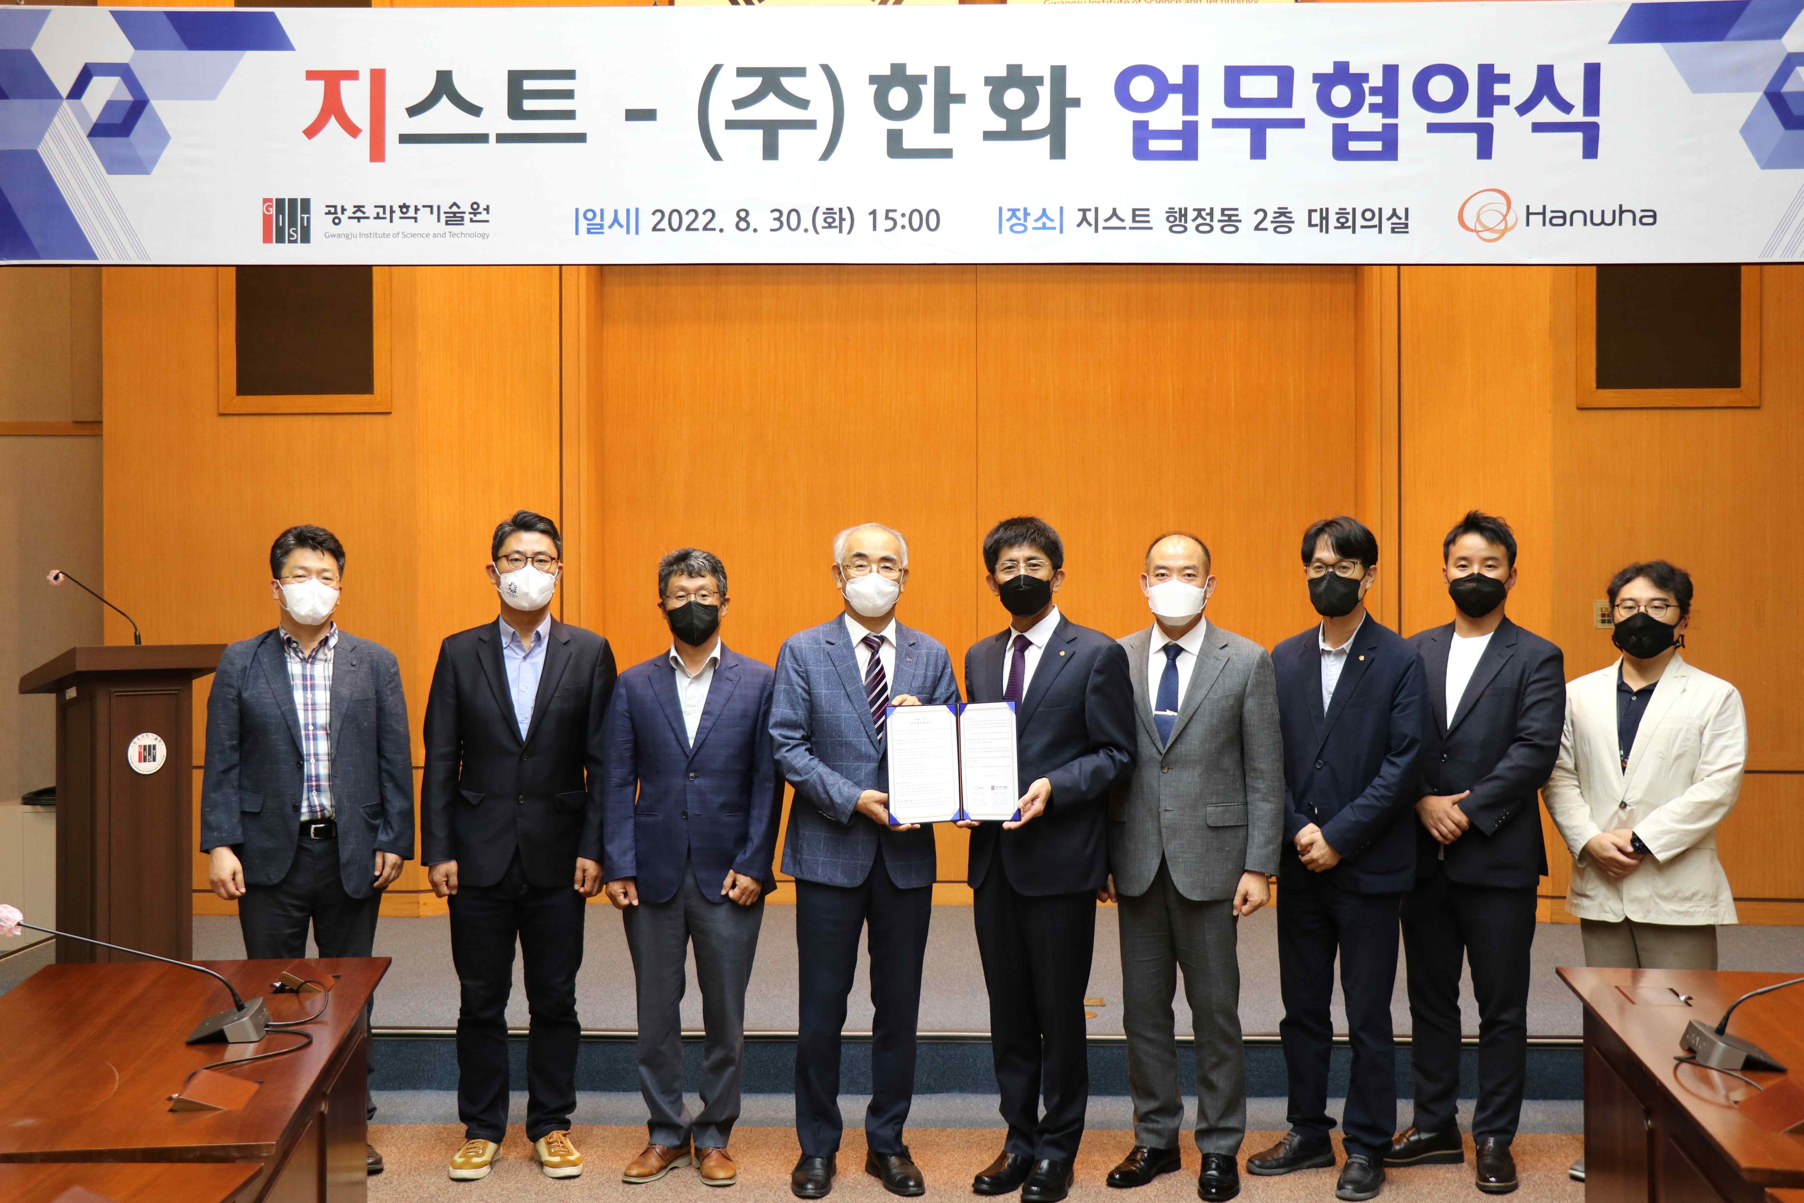
▲ GIST and Hanwha Corporation signed an MoU for cooperation in the joint development of laser weapons
(From left) GIST Advanced Photonics Research Institute Senior Researcher Woojin Shin, Director of Research Chang Lyoul Lee, Director Yeung Lak Lee, President Kiseon Kim, Hanwha CEO Seung-Mo Kim, Vice President of Defense Business Division Young-Kwan Ryu, Director of Laser Business Division Joon-Yong Cho, Deputy Manager of Laser Business Division Boo-Won Chun, Head of Laser Development Team 1 Seol Lim

GIST (Gwangju Institute of Science and Technology, President Kiseon Kim) signed a business agreement (MoU) to secure laser anti-aircraft weapons and related application technologies with Hanwha Co., Ltd. (Defense Division CEO Seung-Mo Kim), a leading defense company in Korea.

With this agreement, GIST and Hanwha will ▴ consign joint research and development through consortium ▴ perform studies aimed at discovering and securing specific technologies with high technological risk to secure business opportunities ▴ identify leading research projects for collaborative research ▴ promote exchange of research personnel and joint use of research facilities.

GIST and Hanwha Co., Ltd., which have been continuously cooperating in the field of laser technology since 2012, developed high-power fiber laser technology for defense and has been conducting research on localization of parts and equipment for the fiber laser field.

GIST President Kiseon Kim said, "Through this agreement with Hanwha, we will contribute to the advancement of defense science through mutual cooperation in laser and optics, which are the core of future defense technology."

Hanwha Co., Ltd. Defense Division CEO Seung-Mo Kim said, "We plan to continue R&D on laser technology together with GIST for the early deployment of future weapons."

The signing ceremony was held on the afternoon of August 30 at the GIST Administrative Building with important officials in attendance, including GIST Advanced Photonics Research Institute Senior Researcher Woojin Shin, Director of Research Chang Lyoul Lee, Director Yeung Lak Lee, President Kiseon Kim, Hanwha CEO Seung-Mo Kim, Vice President of Defense Business Division Young-Kwan Ryu, Director of Laser Business Division Joon-Yong Cho, Deputy Manager of Laser Business Division Boo-Won Chun, Head of Laser Development Team 1 Seol Lim.



