"Prepare for a healthy 100-year-old era with a special lecture at the Senior-Friendly Industry Support Center!"

- Hosting ‘100-year-old health project lecture’ for seniors once a month until November

- Expected to foster health welfare and related industries by providing information on prevention of geriatric diseases and dementia

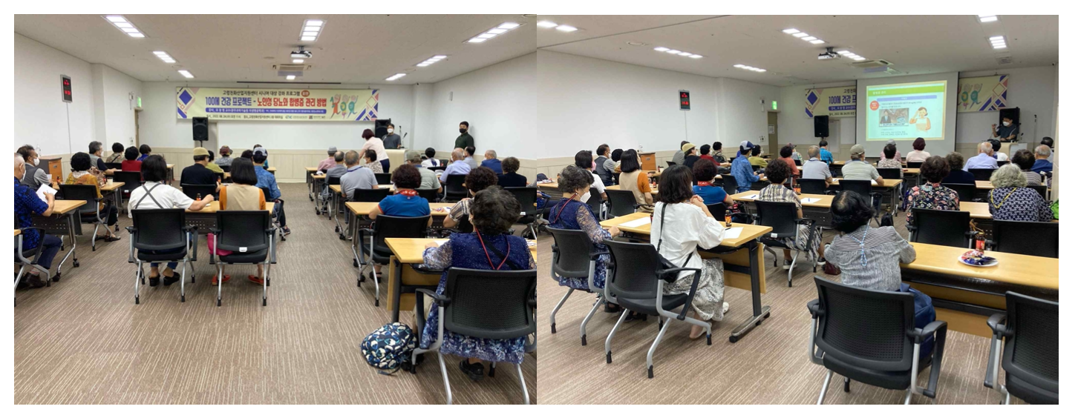▲ Prof. Chang-Myung Oh (GIST Department of Biomedical Science and Engineering), who is the center director of the GIST Senior-Friendly Industry Support Center, is giving a lecture on the topic of ‘Geriatric Diabetes and Complications Management Methods.’

GIST (Gwangju Institute of Science and Technology, President Kiseon Kim)GIST Senior-Friendly Industry Support Center (Director Chang-Myung Oh, Department of Biomedical Science and Engineering professor) is holding a series of special lectures to help Gwangju seniors prepare for a healthy ‘100-year-old era.’

The Senior-Friendly Industry Support Center (hereafter the Center) announced that it would hold a <100 Years Old Health Project Lecture> once a month on the topics of geriatric diseases, emergencies, dementia, and health exercise from August to November.

In the first special lecture held on the morning of August 24 (Wednesday), Prof. Chang-Myung Oh (GIST Department of Biomedical Science and Engineering), who is in charge of the Center, gave a lecture on the topic of 'Geriatric Diabetes and Management of Complications.'

In the lecture, Professor Oh explained how to control blood sugar and exercise to manage diabetes and complications, and conducted a question-and-answer session with 40 participants about health management.

The Center will move forward with health-related lectures to be held once a month △ (September) Response to emergency situations for the elderly (Seongdo Lee, Director, Department of Emergency Medicine, Gwangju Veterans Hospital) △ (October) Dementia Prevention Campaign (Rowan Kang of Seung-hwa Co., Ltd.) △ (November) Elderly Health Care Exercise (Trainer Ji-hwan Hwang).

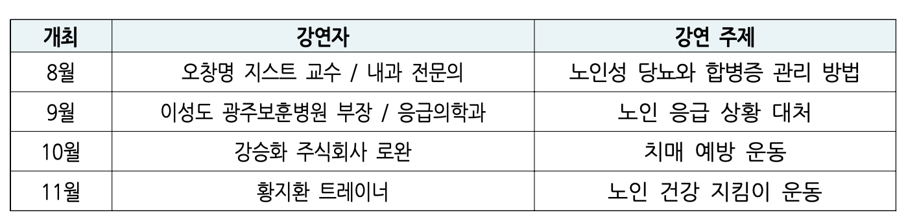

Center Director Chang-Myung Oh said, "With this series of lectures as an opportunity, we expect that we will be able to check the health status and main interests of senior citizens in Gwangju. Based on this, we plan to explore the direction of the aging-friendly industry and actively develop projects that provide useful health information to citizens to prepare for an aging society."

Anyone can participate in this series of lectures for free, and course registration and related information can be found on the Senior-friendly Industry Support Center website (www.gstc.or.kr). (Related inquiries: 070-7710-4905)



