GIST hosts the 2022
Creative Convergence Contest

- College students who returned to school to develop table tennis robots and algorithms competed fiercely for two months

- Held annually to foster talents in convergence technology fields such as artificial intelligence and next-generation energy-based technologies

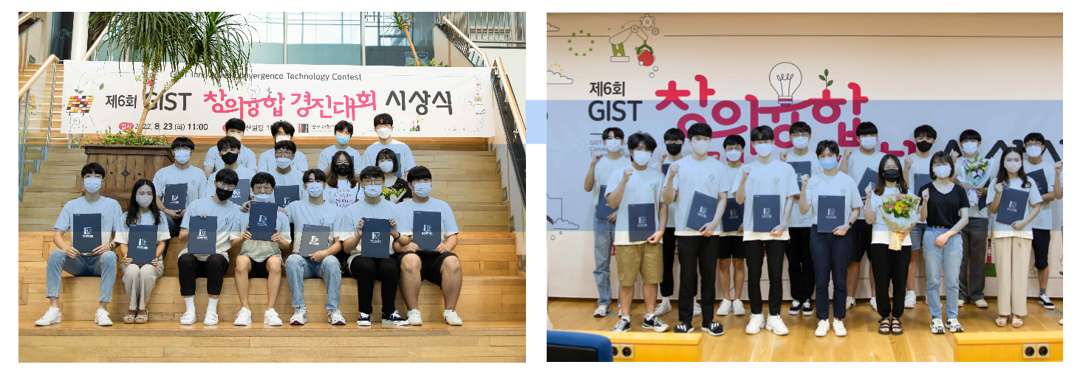▲ Students who participated in the 6th GIST Creative Convergence Contest
are taking a commemorative photo after the awards ceremony.

GIST (Gwangju Institute of Science and Technology, President Kiseon Kim) Institute of Integrated Technology (Director Je Ha Ryu) held the “6th Creative Convergence Contest” in August to nurture talented people with creative and convergent thinking required in the era of the 4th Industrial Revolution. The awards ceremony was held on the 23rd (Tuesday) and the two-month competition schedule was successfully completed.

The “Creative Convergence Contest,” which started in 2017 and celebrated its 6th anniversary this year, was held in the field of convergence technology corresponding to the era of the 4th Industrial Revolution, such as artificial intelligence, intelligent robot, virtual environments, healthcare, and next-generation energy-based technology. It is held every year to discover talented students, and it provides an opportunity to foster cooperation and group creativity by conducting joint research in a team of 3 to 4 participating students.

In particular, the professors and graduate students of the GIST Convergence Technology Institute serve as mentors for each team and provide practical help such as on-site guidance and advice, establishing a place for the students to express their infinite creativity and realize innovative ideas.

This year's competition, in which 24 undergraduates from Korean universities formed seven teams competed for about two months from the end of June, was divided into two tracks: the Table Tennis Robot Contest and the Campus Energy Management System (EMS)* Development Contest. After returning from summer vacation, the students participated in the competition for two months, immersing themselves in the development of innovative table tennis robots and algorithms.

* EMS: Energy Management System

The 'Table Tennis Robot Contest' was conducted in a way that competed for rankings by performing challenging tasks, in which the ping-pong robot hit the ping-pong ball coming out of a ping-pong machine and by participating students playing ping-pong against the robot.

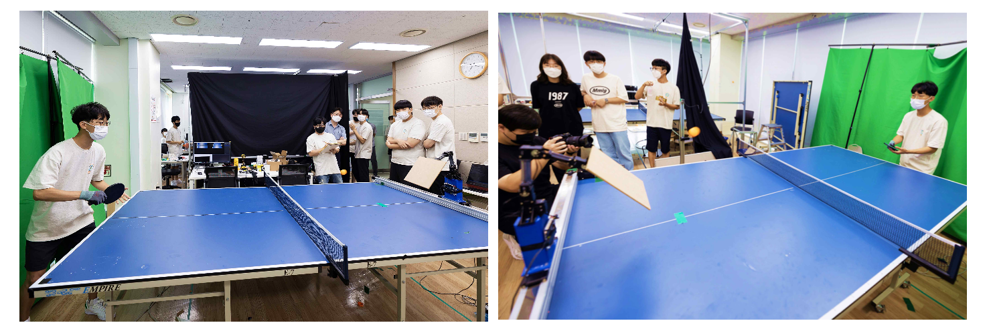▲ Students from the participating team who challenged the 'Table Tennis Robot Contest' section of the 6th Gist Creative Convergence Contest are playing a game with the table tennis robot.

The ‘Campus EMS Development Contest’ is a contest to develop a load prediction algorithm, a solar power generation amount prediction algorithm, and an electricity rate minimization algorithm based on the data provided by the organizer, and the ranking by was determined by calculating the electricity cost used.

The winner of this year's competition was the 'Zipingi' team consisting of students majoring in mechanical engineering (Jeong-Woo Lee, Hyun-Beom Shin, and Han-Seok Han) in the GIST undergraduate program for their <Development of a table tennis robot using computer vision and robot reinforcement learning> in the 'Table Tennis Robot Contest' section. They won a cultural gift certificate worth 2.5 million won.

The first prize was awarded to the 'Cat Decided by the Cat' team in the 'Table Tennis Robot Contest' category and the 'Today's Weather' team from the 'Campus EMS Development Contest' category. Team 'CP' in 'Table Tennis Robot Contest' and 'MySolar' Team in 'Campus EMS Development Contest' won the prizes.

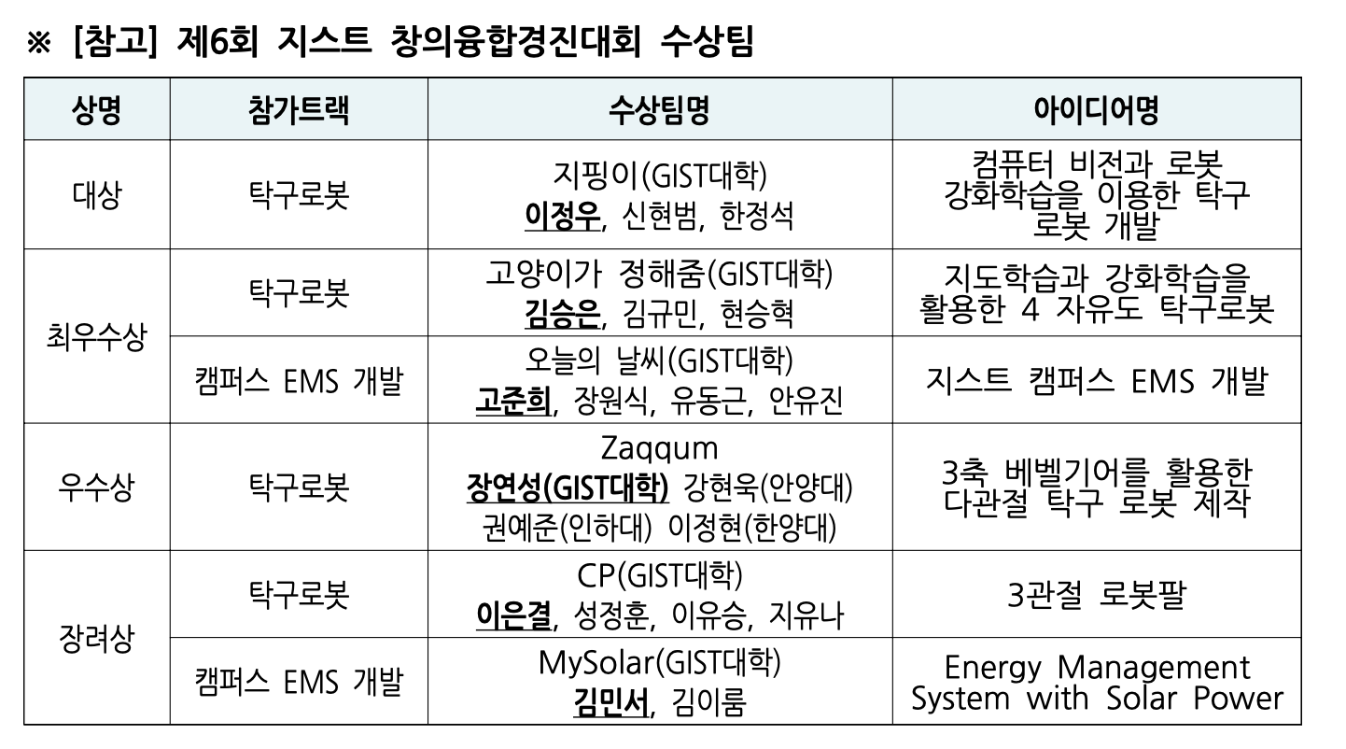

Institute of Integrated Technology Professor Jung Won Yoon, who served as the head of the contest, said, "This event was held in the form of a contest using a convergence research theme that combines artificial intelligence and hardware (robot), and the enthusiasm and interest of the students was very high. The Creative Convergence Contest will be able to provide a new educational platform that can nurture convergence specialists with a challenging spirit necessary for the era of the 4th Industrial Revolution."



