Cooperation in establishing standards for intelligent service robots

- 9 companies signed business agreements with GIST Senior-friendly Industry Support Center... “Robot Industry Innovation Efforts”
- Expect a great synergy effect on the growth of the aging-friendly industry and the robot industry due to digital transformation

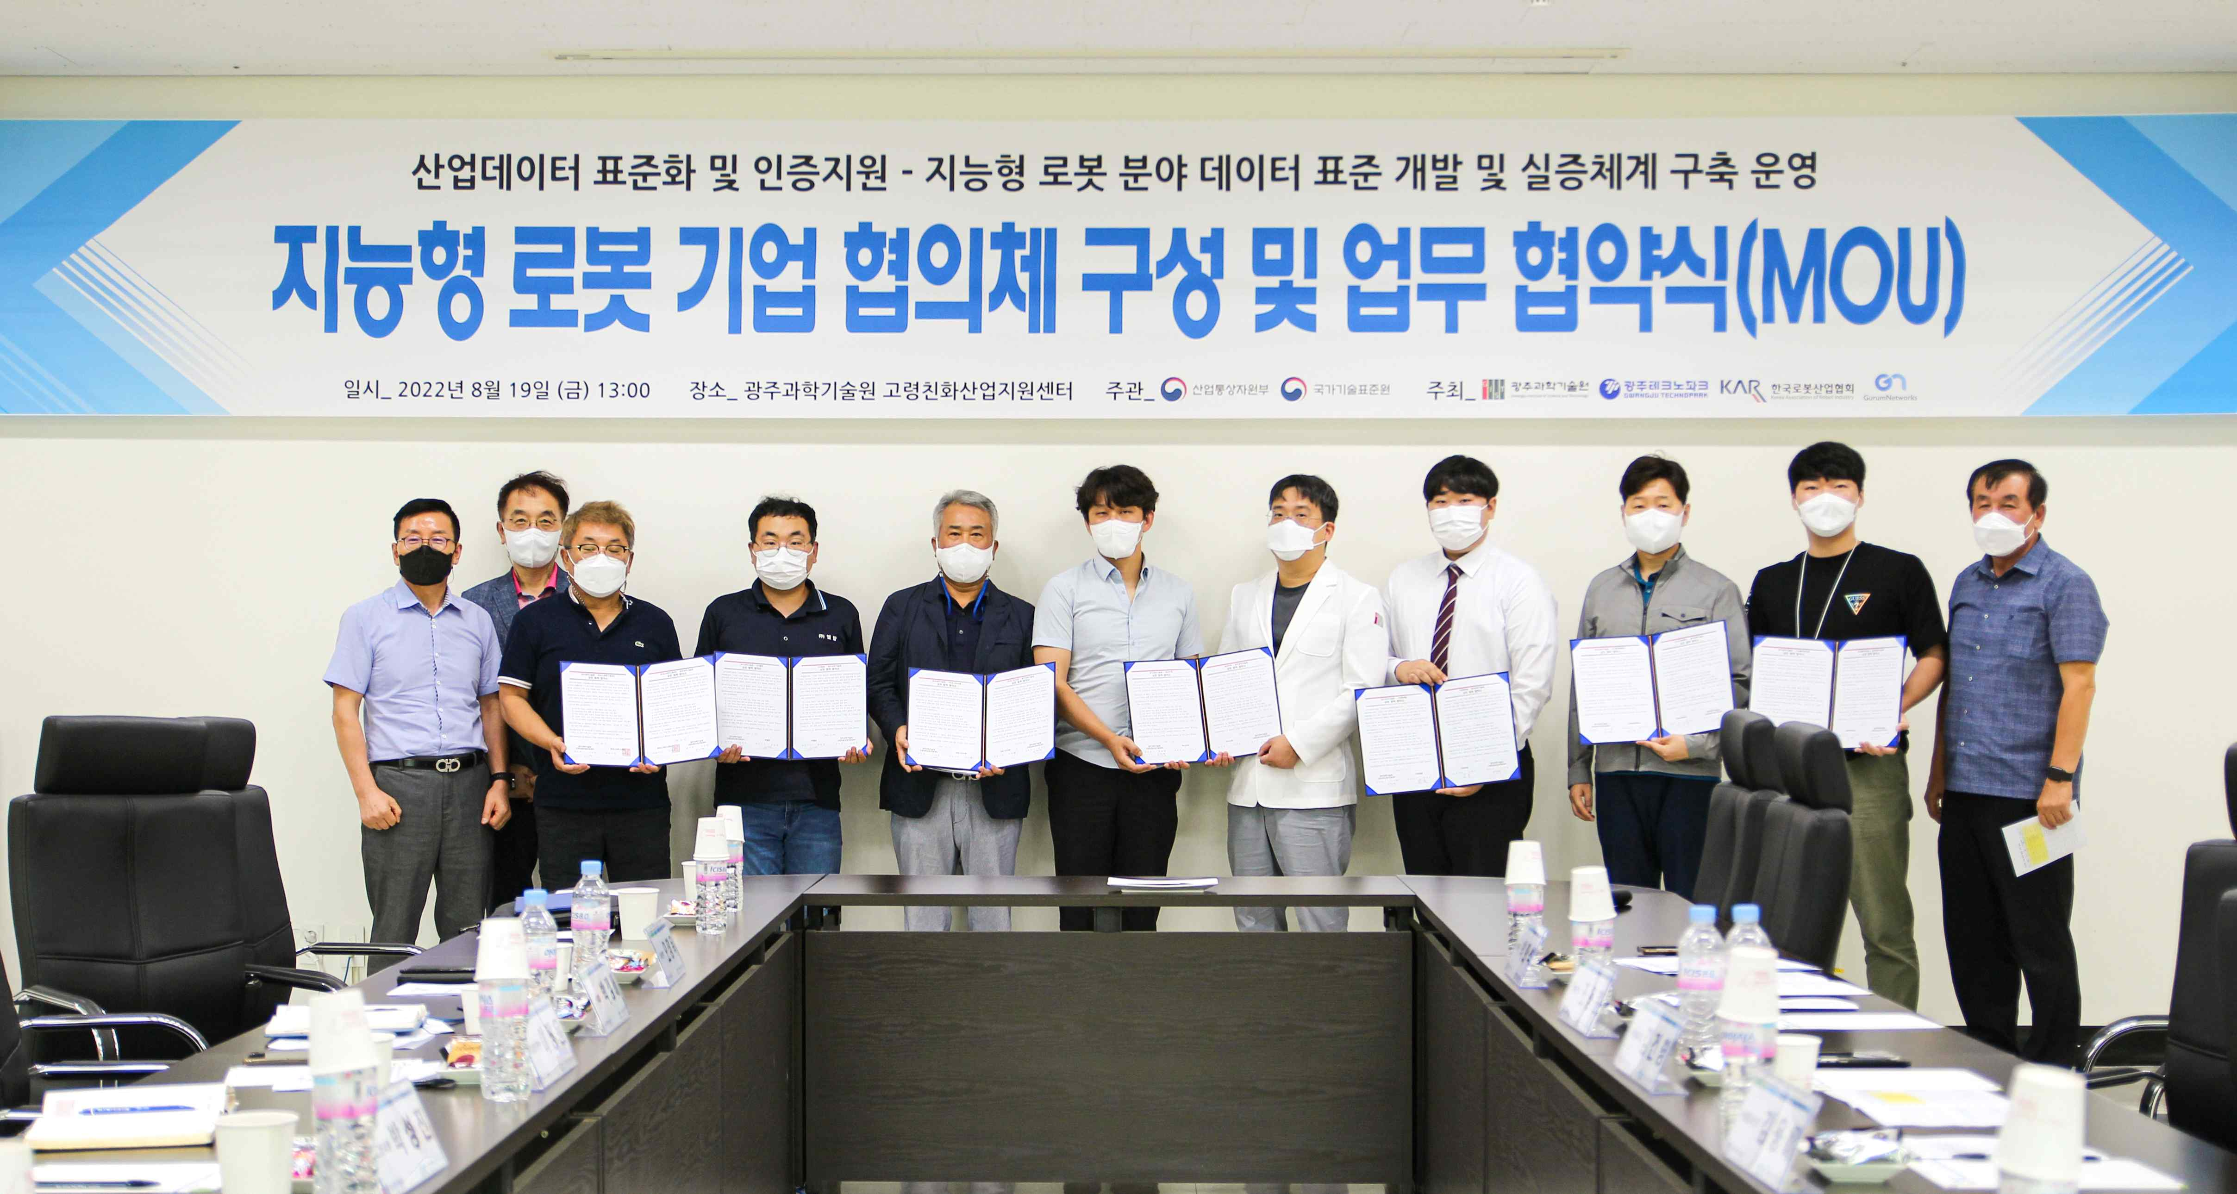
▲ Group photo of the intelligent robot company council formation and business agreement ceremony
(From left) Representatives and working groups of companies related to intelligent service robots Ltop Co., Ltd., Login Seokwang Co., Ltd., Hi-Track, GIST Senior-friendly Industry Support Center Director Chang-Myung Oh, Manntel Co., Ltd., Cybermedic Co., Ltd., and Avirtual Co., Ltd.

GIST (Gwangju Institute of Science and Technology, President Kiseon Kim) Senior-friendly Industry Support Center (Director Chang-Myung Oh) announced on August 19 (Fri) that a business agreement was signed with nine domestic companies* developing and producing intelligent service robots to cooperate and establish standards.

* 9 companies that develop and produce intelligent service robots: Login Seokwang Co., Ltd., Manntel Co., Ltd., Samyoung System Co., Ltd., Cybermedic Co., Ltd., Circulus Co., Ltd., Avirtual Co., Ltd., Ltop Co., Ltd., Hi-Track, Korea Smart Drone Co., Ltd.

This business agreement is to carry out the 'industrial data standardization and certification support project' of the Ministry of Trade, Industry and Energy, where four institutions (companies)* including GIST and Gwangju Technopark were selected. Through this agreement, the center and nine companies will cooperate on ▴ intelligent service robot industry related technology development ▴ cooperation in securing industrial data and support for data standard development ▴ deducing essential elements for securing interoperability between different models ▴ support for empirical evaluation.

* four institutions (companies): GIST, Gwangju Techno Park, Korea Robot Industry Association, Cloud Networks Co., Ltd.

The ‘industrial data standardization and certification support project’ in which the center participates is a project that lays the foundation for establishing data standards in the field of intelligent robots, collects data for standard development, checks interoperability, and conducts empirical evaluations. It will be carried out with the support of 2.4 billion won from the national treasury for four years from this year.

Director Chang-Myung Oh said, "The GIST Senior-friendly Industry Support Center is seeking corporate support and R&D from various perspectives to foster local specialized industries such as healthcare industry and precision medical business, as well as aging-friendly industries. With this business agreement as an opportunity, we will establish a multi-faceted mutual cooperation system by sharing human and material infrastructure owned by the center and the companies along with the ongoing life care robot demonstration projects."

In addition, he said, "We expect that this will create a great synergy effect in the growth of the aging-friendly industry and the robot industry following the digital transformation."



