GIST holds degree conferment ceremony for the second half of 2022

– On the afternoon of August 19. (Fri), a total of 164 students were awarded degrees and was held simultaneously both online and offline were held to reduce the impact of COVID-19

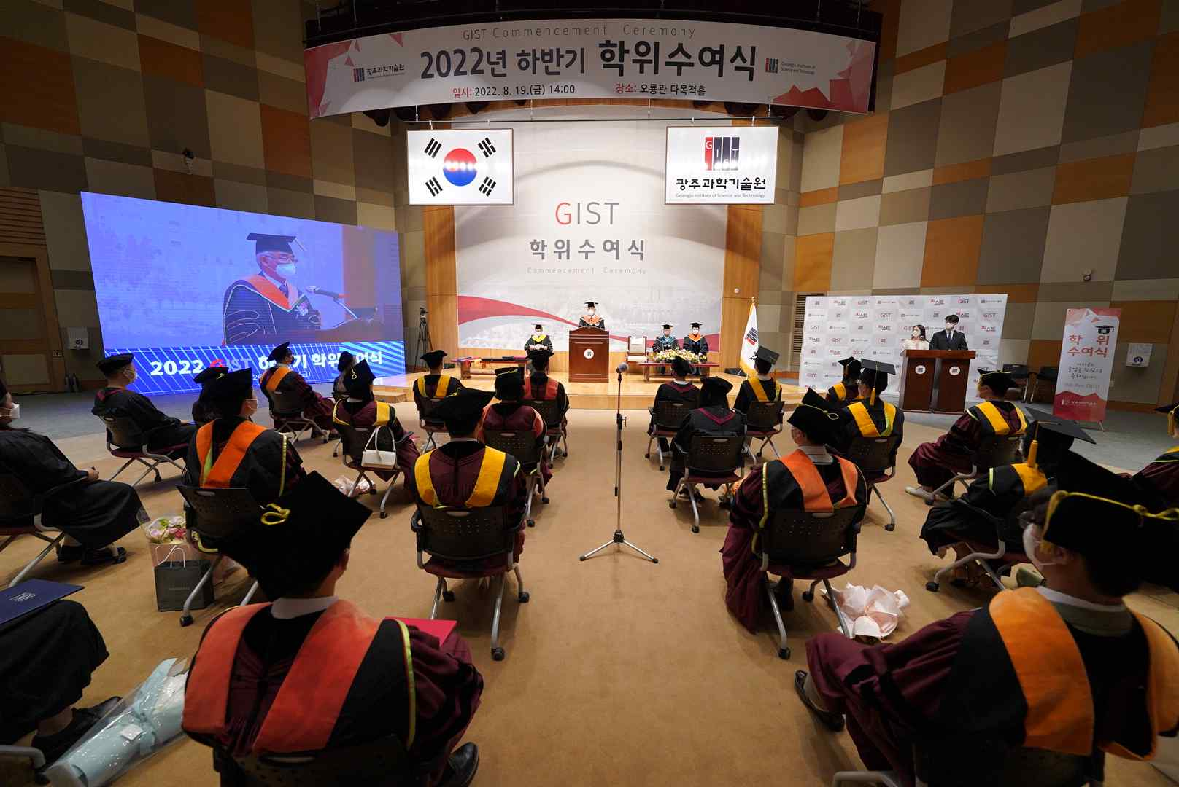

GIST (Gwangju Institute of Science and Technology, President Kiseon Kim) conferred degrees during the ‘second half of 2022 degree conferment ceremony’ at Oryong Hall on August 19 in the presence of 50 people, including representatives of graduates.

At the graduation ceremony that day, a total of 164 students including 54 doctoral students, 62 master's students, and 48 bachelor's students were awarded their degrees.

To prevent the spread of COVID-19, a video containing messages from teachers and students was produced and viewed, and representatives of graduates were selected through lottery and reduced the number of participants at the event.

Degree recipients and parents who could not attend the event were able to watch the graduation ceremony in real time through YouTube streaming.

On this day, 54 doctoral degree recipients published an average of about 6 papers per person in SCI (Science Citation Index) listed academic journals during their enrollment period.

In particular, among doctoral graduates, Dr. Haesol Kim (advisor: Professor Sanghan Lee) published a total of 13 SCI-level papers in excellent academic journals during his time in school, and among them, he published two papers in the best journal in the field of chemistry (Journal of the American Chemical Society). In recognition of his research activities and three patents, he received the 'Excellent Research Award' at the graduation ceremony.

The 'Future Talent Award' was awarded to Department of Chemistry student Min-Jun Kim (Advisor: Professor Jin Hee Ahn), who is walking the path of a challenging entrepreneur, starting Cloud Stone Co., Ltd. while attending GIST College and operating the delivery app service 'Baedal Geek', and expanding the service to about 10 major universities in Korea.

Meanwhile, at this degree conferment ceremony, the first 7 graduates for the first master's degree were produced at the AI Graduate School, which was established in 2019, with the goal of nurturing global AI innovative talents linking education, research, and start-ups.

At the graduation ceremony, President Kiseon Kim said, "I wish good fortune and endless development for the 164 people who have lived at the GIST campus for the past several years and have challenged themselves towards their goals and dreams. I hope that they will become heart-warming scientists and engineers who will contribute to the development of national science and technology with the competence and pride obtained from GIST."

Since its establishment in 1993, GIST has produced a total of 7,448 high-level scientific and technological personnel, including 4,707 masters, 1,035 bachelors, and 1,706 Ph.D.



