GIST to participate in 2022 Korea Science Festival

- A city-type science festival held under the theme of ‘Festival Earth’ in Seongsu-dong, Seoul from August 18 to August 21.
- School of Earth Science and Environmental Engineering Professors Kyoung-Woong Kim and Jaeyoung Lee operated an exhibition and experience booth for outstanding achievements in the environment field

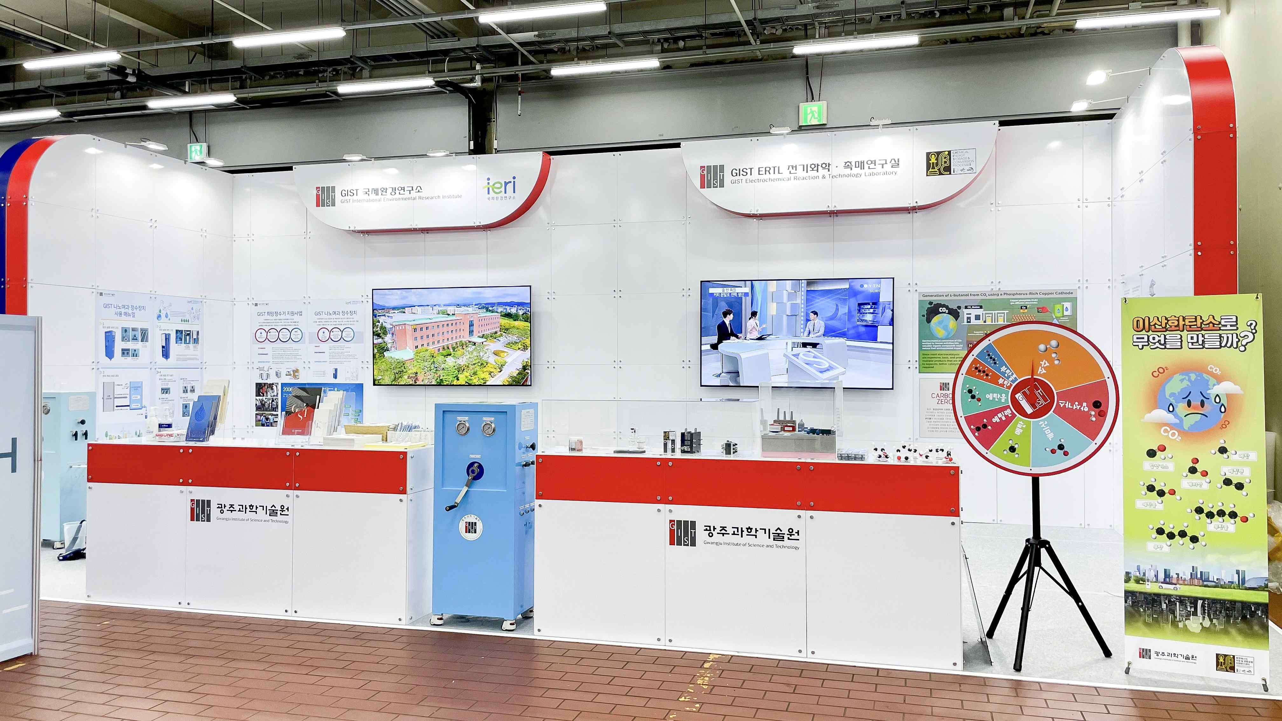
▲ ‘2022 Korea Science Festival’ GIST Booth

GIST (Gwangju Institute of Science and Technology, President Kiseon Kim) participated in the <2022 Korea Science Festival>, a science and technology fair hosted by the Ministry of Science and ICT and co-organized by the Korea Foundation for Science and Creativity and the Science and Culture Private Council, to present outstanding research achievements to the public in the environmental field.

<2022 Korea Science Festival> is a festival-type event that communicates with the public under the slogan of ‘Festival Earth’ on various scientific issues necessary for a sustainable earth. It will be held from August 18 (Thu) to 21 (Sun) at S Factory and nearby streets in Seongsu-dong, Seoul.

GIST prepared a space on the first floor of S Factory D building, to operate an experience booth where the general public who visits the site can experience firsthand: 1 GIST nanofiltration water purification device (International Environmental Research Institute Director and School of Earth Science and Environmental Engineering Kyoung-Woong Kim, and 2 Exhibiting contents about the carbon dioxide recycling process for carbon neutrality (School of Earth Science and Environmental Engineering Professor Jaeyoung Lee Lee, School of Earth and Environmental Engineering).

1 'GIST Nanofiltration Water Purification Device' is a manpower-driven nanofiltration water purification device that can purify water by human power without a separate power source in developing countries where the supply of drinking water and electricity is not smooth. Turns bacteria-contaminated water into clean, safe drinking water.

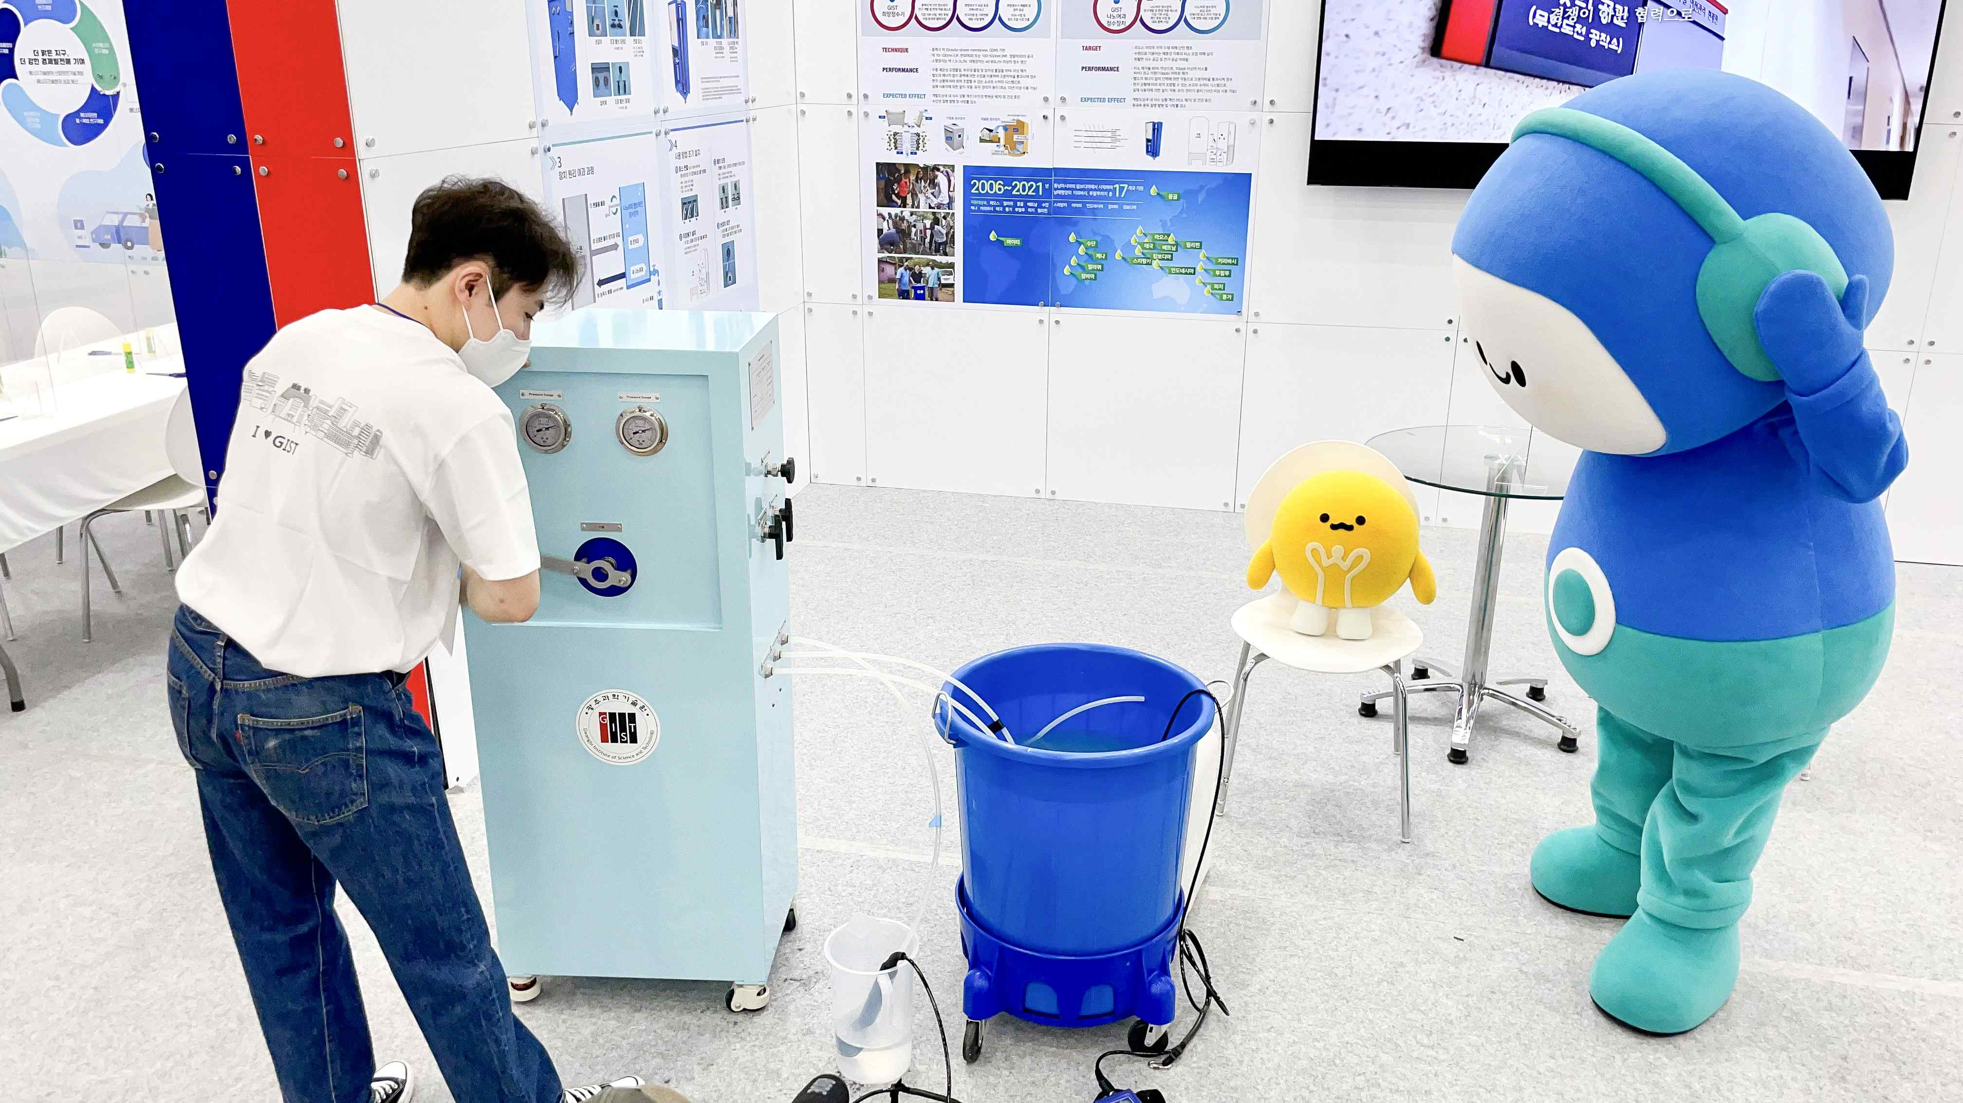
▲ GIST is introducing the nanofiltration water purification device to Diro and Rano, the characters of the 2022 Korean Science Festival.

The nanofiltration water purification device exhibited at this event uses manpower to purify contaminated water by passing it through a polymer nanofiltration membrane. Anyone who visits the booth can immediately see that polluted water is purified into clean water in front of their eyes by simply holding the handle of the water purifier and turning it.

GIST International Environmental Research Institute has been conducting the 'Hope Water Purifier' project since 2006 to supply water treatment equipment using a Gravity-Driven Membrane, which was developed to support developing countries that lack drinking water. Based on this, a water purification system that filters arsenic and heavy metals has been developed using nanofiltration technology without additional energy supply.

2 At the booth of ‘CO2 Recycling Process for Carbon Neutrality’, chemical raw materials that can be produced by recycling carbon dioxide, the main culprit of global warming, were introduced. Materials (catalysts, membranes) and reactors used in the recycling process are presented.

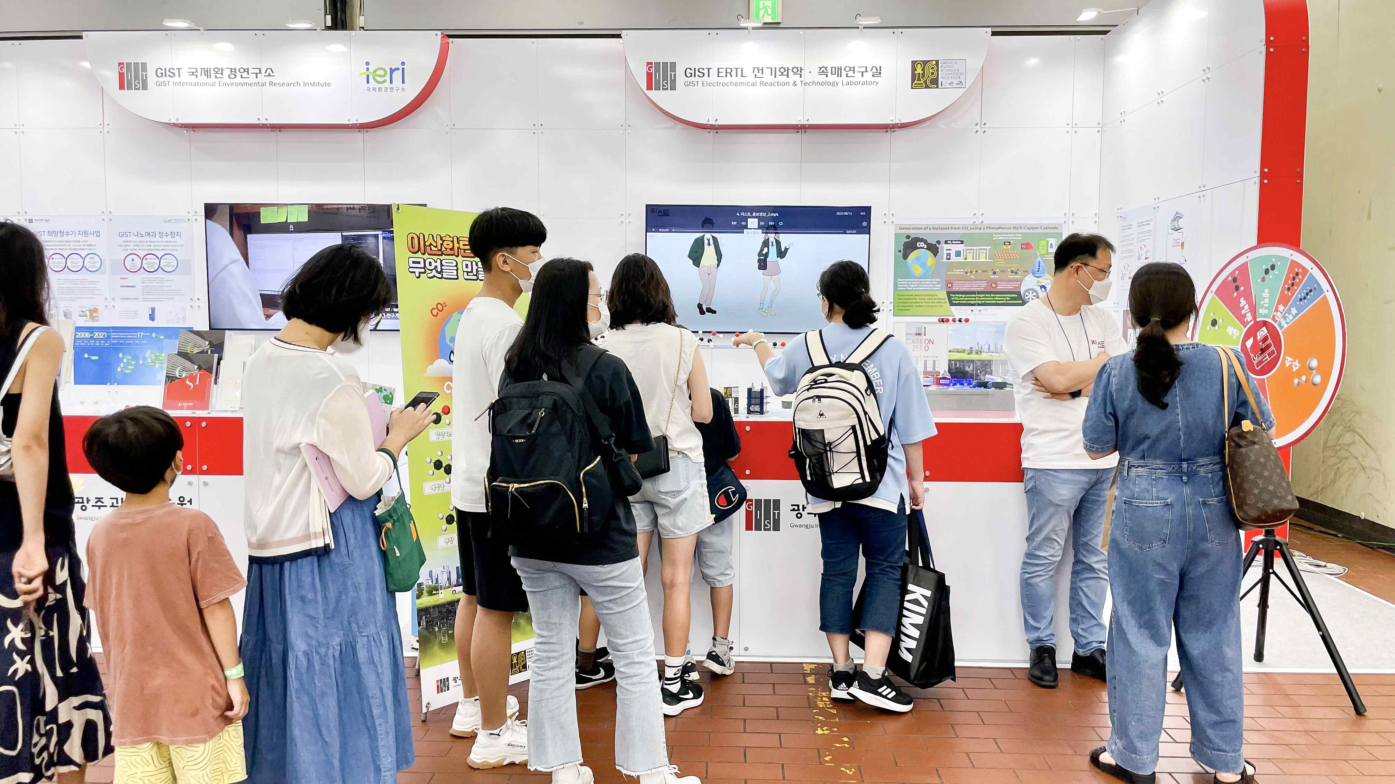
▲ GIST is introducing a carbon dioxide recycling process at the 2022 Korea Science Festival.

The booth shows that high value-added organic compounds can be secured by using carbon dioxide, a substance that causes global warming, and that this technology can quickly enter a carbon-neutral society. In addition, it is expected to present the direction of future technology to visitors through the possibility of using it as an eco-friendly vehicle and industrial fuel.

Office of international and Public Affairs Dean Chang-Duk Jun said, "I am very happy to be able to introduce GIST's excellent research results to the public in an easy and fun way as the science festival, which had not been held for two years due to COVID-19, is being held again. We will do our best in research and development to solve environmental problems and contribute to the improvement of people's quality of life with GIST's science and technology."

Meanwhile, under the theme of ‘Earth’, government-funded research institutes, universities, corporations, entertainers, YouTubers, and star scientists will participate in this event to present various R&D achievements and scientific and cultural contents.



