GIST Climate Change Academy members establish a development fund to the Royal Phnom Penh University in Cambodia

- Donation of fund for environmental engineering and development promoted by GIST International Environmental Research Institute
- “I hope it will serve as a foundation for fostering environmental experts and strengthening international cooperation between Korea and Cambodia”

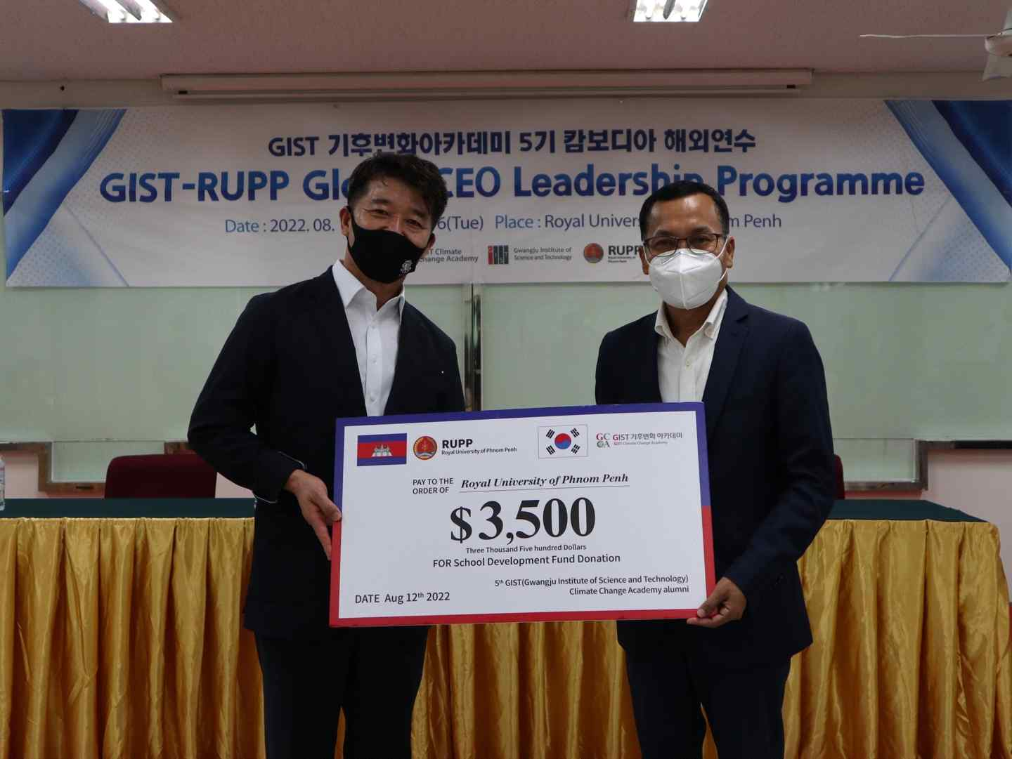
▲ The 5th GIST Climate Change Academy (GCCA) members donated development funds to the Department of Environmental Engineering, Royal University of Phnom Penh, Cambodia, and held a donation ceremony on August 12 (Fri). (From left) Chairman Seok-Jong Kim of the 5th GCCA Wonwoo Association (CEO of Nam-Ah Food), President Chet Chealy at the Royal University of Phnom Penh

GIST (Gwangju Institute of Science and Technology, President Kiseon Kim) Climate Change Academy (GCCA*) 5th Wonwoo Association (Chairman: Seok-Jong Kim, CEO of Boys Foods) contributed to the Royal University of Phnom Penh of Cambodia (RUPP)** to fund the development of the University’s Department of Environmental Engineering (approximately $3,500 / 5 million won) was donated.

* GCCA: GIST Climate Change Academy

** RUPP: Royal University of Phnom Penh

The donation ceremony was held on August 12 (Fri) at the Royal University of Phnom Penh in Phnom Penh, the capital of Cambodia, with President H.E. Rector Dr. Chet Chealy, GIST International Environmental Research Institute Director Kyoung-Woong Kim, and Korea International Cooperation Agency (KOICA) Cambodia Office Vice President Kwang-wook Kim and was held in the presence in the presence of officials and related parties of the 5th Climate Change Academy.

On this day, the participants planted a commemorative tree and installed a sign next to the Art Performance Building, which the Department of Environmental Engineering is planning to use as an exclusive building, to commemorate the opening of the Climate Change Academy leadership program at the Royal University of Phnom Penh along with the donation of the development fund.

At the donation ceremony that day, Chairman Seok-Jong Kim said, "We appreciated the infinite growth potential of the Royal University of Phnom Penh and decided to donate the development fund with a heart to support the growth and development of students. I hope that the GIST Climate Change Academy will contribute to responding to global issues as well as local communities."

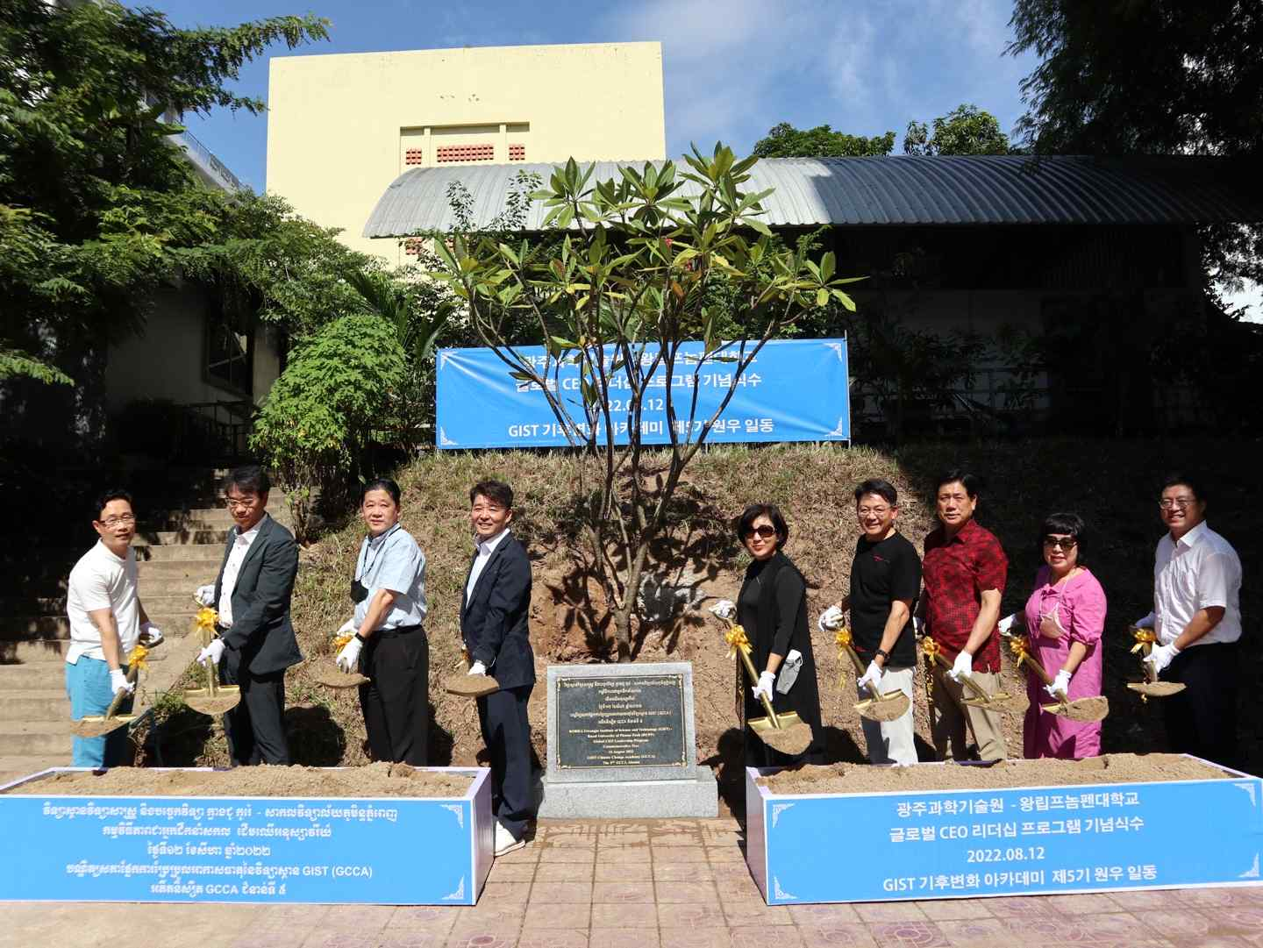
▲ GIST Climate Change Academy (GCCA) 5th member Wonwoo and Chairman Seok-Jong Kim are installing a commemorative planting tree and a sign next to the Art Performance Building, which is planned to be used as a dedicated building for the Department of Environmental Engineering at the Royal University of Phnom Penh in Cambodia.

GIST International Environmental Research Institute Director and School of Earth Sciences and Environmental Engineering Professor Kyung-Woong Kim said, "It is very meaningful to hold this event as the GIST International Environmental Research Institute opened the Department of Environmental Engineering at the Royal Phnom Penh University. The fund raised by the 5th Climate Change academy is fostering world-class students. It is hoped that this will serve as a small grain of wheat in strengthening international cooperation between Korea and Cambodia."

GIST International Environmental Research Institute continues its related activities for international R&D cooperation to solve environmental problems in developing countries, nurtures environmental experts, and strengthens capacity. With the support of the Korea International Cooperation Agency (KOICA), the representative institution for development cooperation in Korea, the project to open bachelor's and master's programs in environmental engineering at the Royal University of Phnom Penh in Cambodia is being promoted from this year.

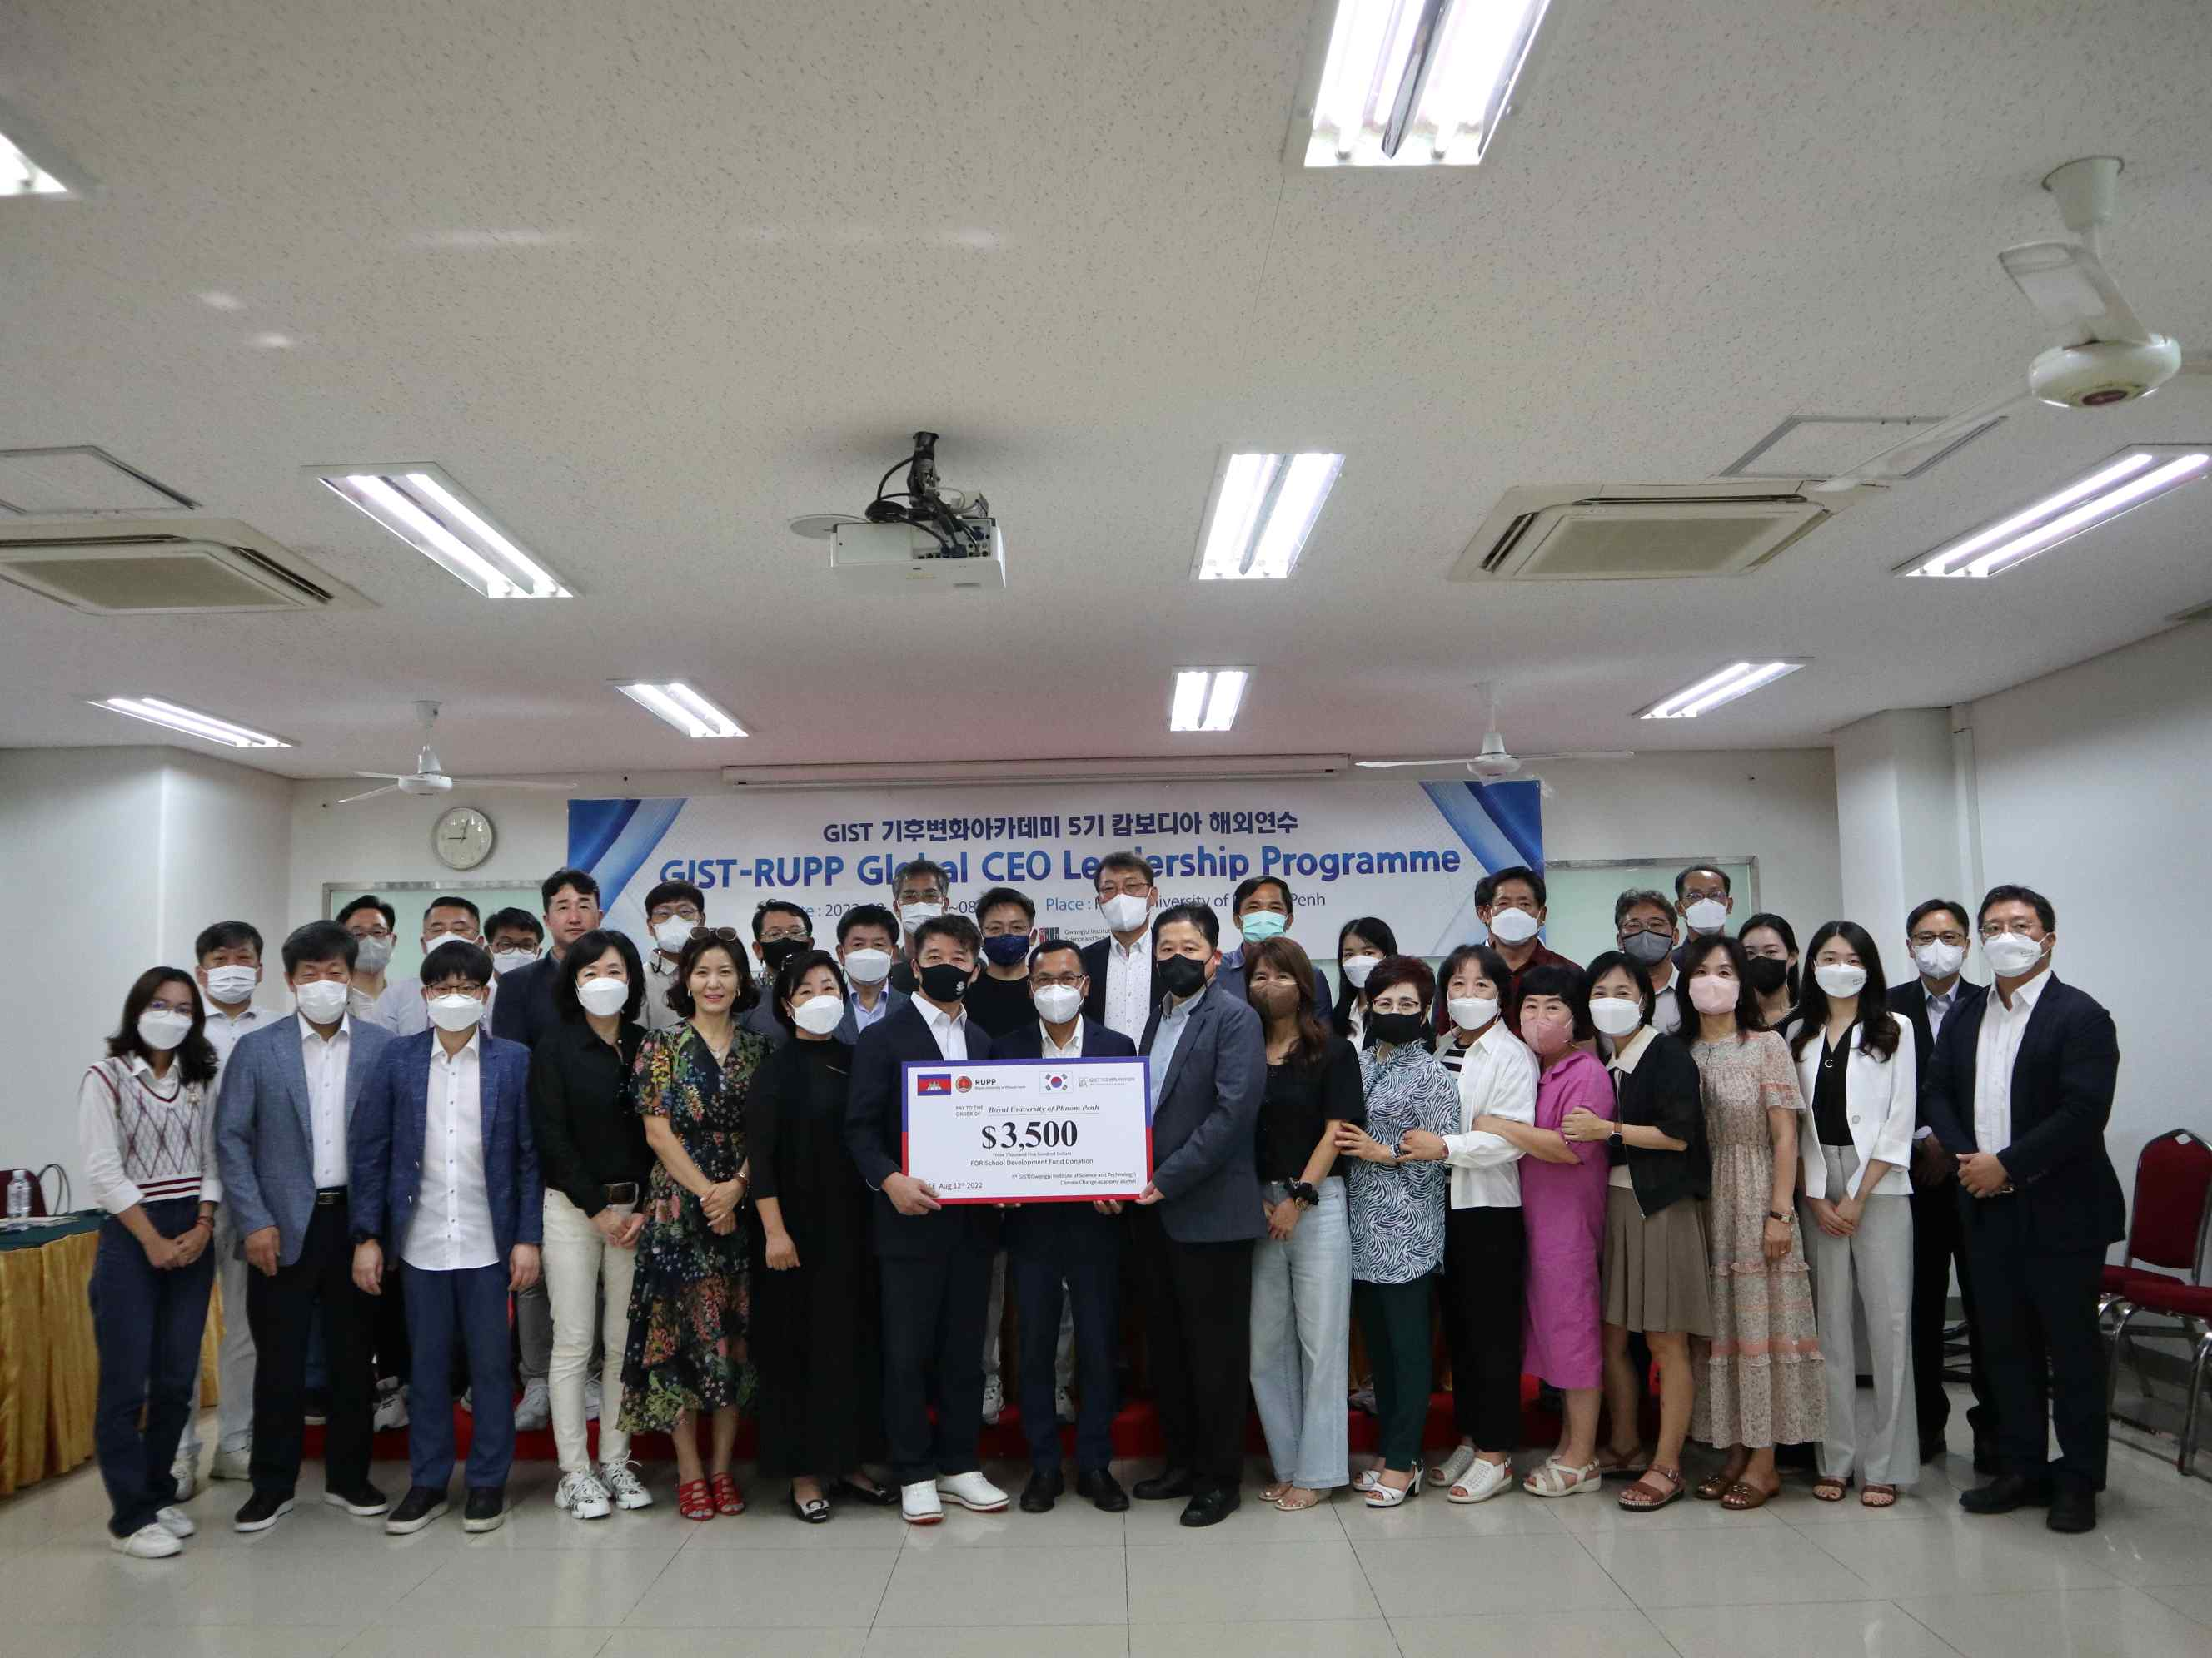
▲ At the Royal University of Phnom Penh on August 12 (Friday), President Chet Chealy, GIST International Environmental Research Institute Director Kyung-Woong Kim, and members of the 5th GCCA group are taking a commemorative photo in the presence of attendees.



