<Science Camp with GIST> help to help young people explore science and engineering career paths

- Invitation of 50 students from Daegu Gyeongam Middle School and Jeonju Jeonbuk Girls’ High School, campus tour, laboratory experience, special lectures by professors, etc.
- Great response to customized programs...“Continued activities of social contribution groups to close the gap in career experience”

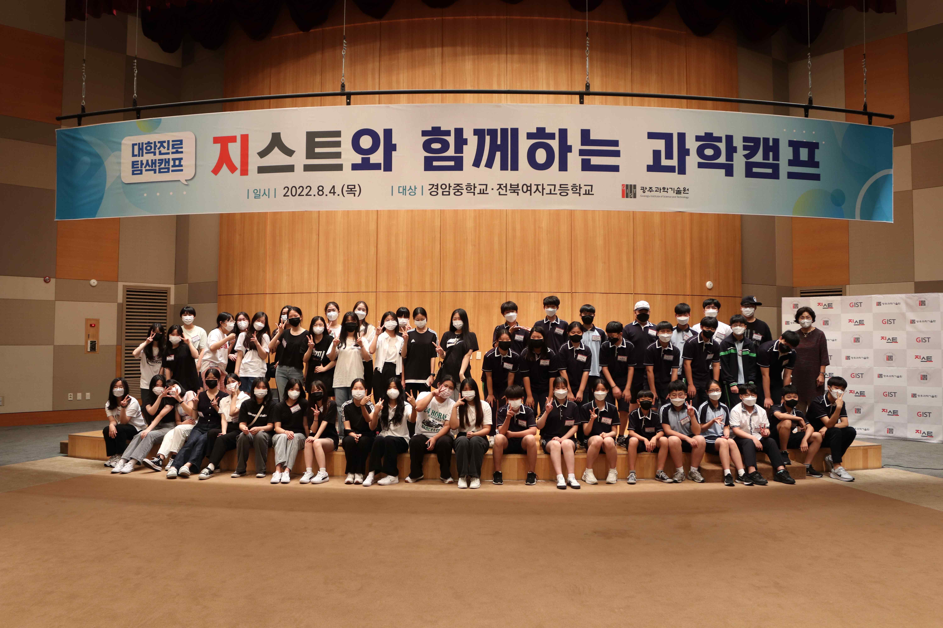
▲ Students and teachers from Jeonbuk Girls' High School and Gyeongam Middle School who participated in <Science Camp with Gist> are taking a commemorative photo. (Left - Jeonbuk Girls' High School, right - Gyeongam Middle School)

GIST (Gwangju Institute of Science and Technology, President Kiseon Kim) held the <Science Camp with GIST> by inviting 52 middle and high school students from Yeong and Honam to the campus to spread a sound science culture and provide opportunities to explore various science and engineering career paths.

<Science Camp with GIST> is one of the social contribution programs hosted by GIST. It invites middle and high school students to the GIST campus to help them explore their career paths by allowing them to directly experience science at the university's education and research sites and experience creative research activities.

This science camp was held on the 4th for 24 students from Daegu Gyeongam Middle School and 28 students from Jeonju Jeonbuk Girls' High School and was well-received by the participating students and teachers for its fruitful composition, including △ campus tour △ lab experience △ GIST professor lectures △ science experiments with mentors.

In particular, in this science camp, the contents of the programs for the middle school and high schools were configured differently so that students could participate in the program according to their level.

Students who participated in the science camp took a campus tour, followed by the Korea Institute of Culture and Technology. They visited GIST's representative laboratories, such as the Intelligent Medical Robot Lab and Advanced Optical Technology Research Center and had time to listen to the research contents and tour the experimental lab.

Next, to increase the interest and interest of students △ GIST Department of Physics and Photon Science Professor Keun-Young Kim lectured on the theme of 'Einstein's Legacy: Black Holes, Gravitational Waves, and General Relativity', and School of Earth Science and Environmental Engineering Professor Joon Ha Kim lectured on the theme of 'The Great Transition (MoT Conversion) and Five Future Industries'.

In addition, during a science experiment with mentors from the social contribution group <PIUM>, which is composed of GIST students, the middle school students ‘create obstacle-avoiding self-driving cars’ and had a time to satisfy their scientific curiosity by making and experiencing it with their own hands through the ‘Vitamin C Clock Reaction’ experiment.

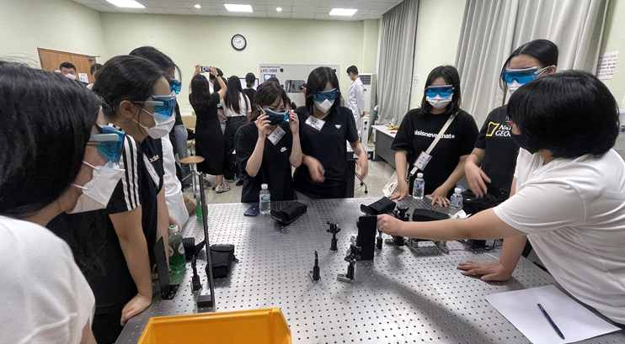
▲ Students from Jeonbuk Girls' High School are practicing the characteristics and phenomena of light (light overlapping phenomenon, wavefront measurement, etc.) at the 'High Light Technology Research Center'.

Jeonghyeon Lee, a 3rd year student at Gyeongam Middle School who participated in the camp, said, "It was a good time to experience various engineering technologies and to get information about the entrance exam. In particular, during the last career special lecture, I was able to review my life goals once again."

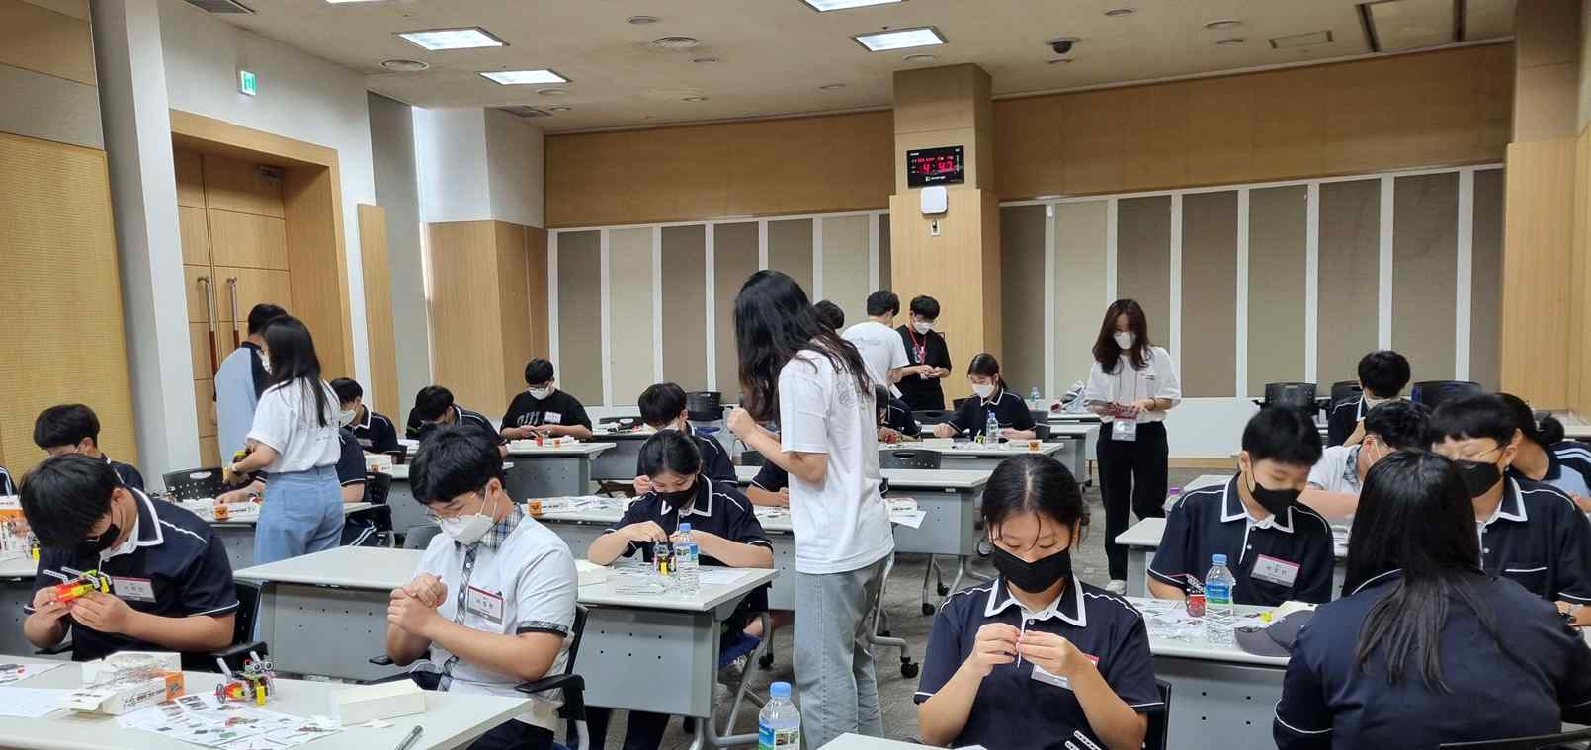
▲ Students from Gyeongam Middle School are working on ‘Making Self-Driving Cars’ together with ‘PIUM’, a social contribution group of GIST.

Jinki Lee, a teacher who led the students of Jeonbuk Girls' High School, said, "It seems to have been a good opportunity for students with various experiential activities that are difficult to experience normally with a substantial program. It was a science camp that wanted to give the best in all aspects, including customized program operation. Thank you to everyone who worked hard for the camp despite the hot weather."

Dean of International and Public Affairs Chang-Duk Jun said, "GIST's social contribution group <PIUM> plans to continue conducting science and engineering career experience programs for middle and high school students in order to bridge the gap in students' learning and career experience and to nurture future science and engineering talents."





