Gifted chemistry students gathered at GIST <2022 Korea Chemistry Olympiad Seasonal School> Completion

- 70 nationally gifted chemistry students, received online and GIST Seo Chemistry theory and experiment training for 2 weeks
- Outstanding students who will be finally selected will participate in the International Olympiad next July as national representatives

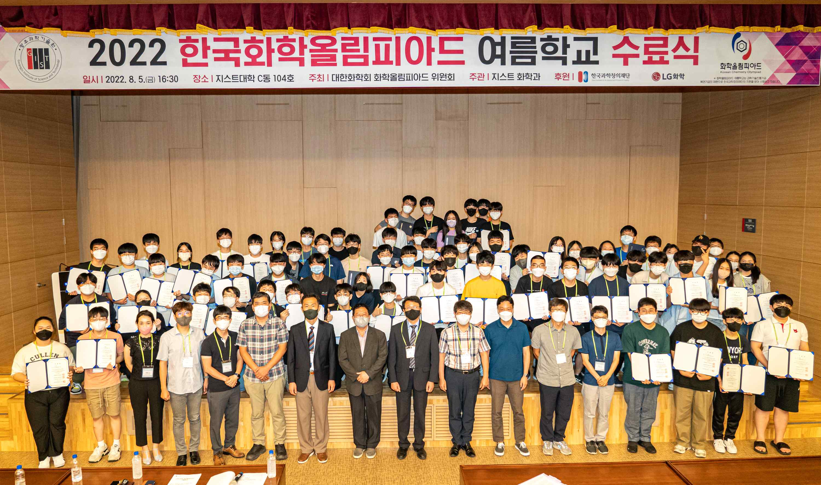
▲ After the <2022 Korean Chemistry Olympiad Seasonal School> finished all schedules, on August 5 (Fri) 4:30 pm in GIST College Building C, Chairman Shin Seok-min of the Korean Chemical Society and Chairman Bong-jin Moon of the Olympiad. A graduation ceremony was held in the presence of GIST Department of Chemistry faculty, 70 students, and parents.

Gifted chemistry students from all over the country participated, and the <2022 Korea Chemistry Olympiad Summer School>, which was held online at GIST (Gwangju Institute of Science and Technology, President Kiseon Kim) for the past two weeks, completed all schedules and held a graduation ceremony on August 5 (Friday).

The graduation ceremony was held at 4:30 pm on the same day in GIST College Building C, and it was held in the presence of GIST Chemistry Department faculty, 70 participating students, and parents.

<Korea Chemistry Olympiad Seasonal School> is operated twice a year (summer and winter) to discover gifted chemistry early and to nurture future chemistry research leaders.

This summer school was hosted by the Chemistry Olympiad Committee of the Korean Chemical Society with the support of the Korea Foundation for Science and Creativity and LG Chem, and hosted by the GIST Chemistry Department, and was held online and offline for two weeks from July 25th to August 5th.

51 high school students selected from all over the country participated in real-time online lectures, and 19 high school sophomores took part in theoretical and experimental education in GIST Department of Chemistry classrooms and laboratories while staying for two weeks at GIST.

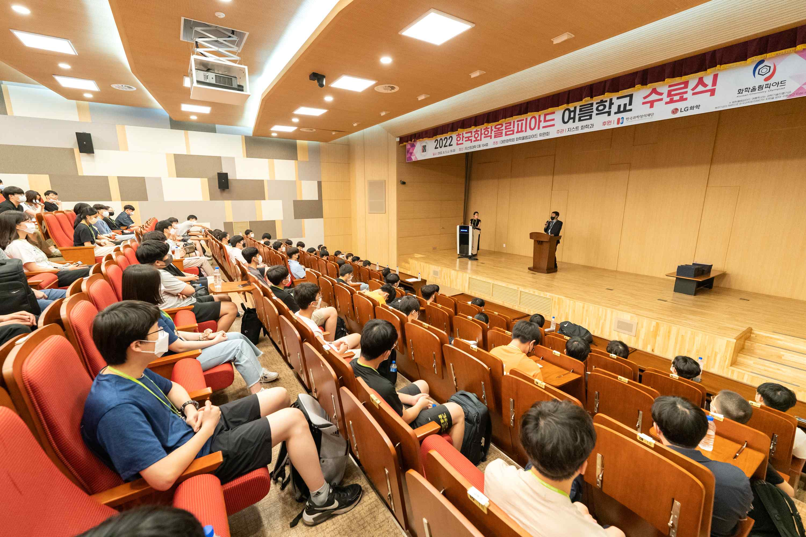
Students who will be finally selected (early 2023) through this year's selection process will participate in the <International Chemistry Olympiad> scheduled to be held in Zurich, Switzerland in July 2023 as the national team.

<International Chemistry Olympiad> is a competition where middle and high school students from all over the world compete in their chemistry skills. Since Korea first participated in the 24th Congress held in 1992, it has been consistently achieving good results.

GIST Department of Chemistry Professor Junhyeok Seo, who served as the principal of this year's Korea Chemistry Olympiad Summer School, said, "Although the pandemic is continuing, I am proud of the students who successfully completed summer school while complying with quarantine rules. It is expected that these students will become leaders who will lead the future of chemistry in Korea."



