JoongAng TCC Rental CEO Hyung-yong Jung donated 50 million won for development fund

– The 5th Climate Change Academy (GCCA) alumn Hyung-yong Jung CEO of Jungang TCC Rental Co., Ltd., donated 50 million won to GIST

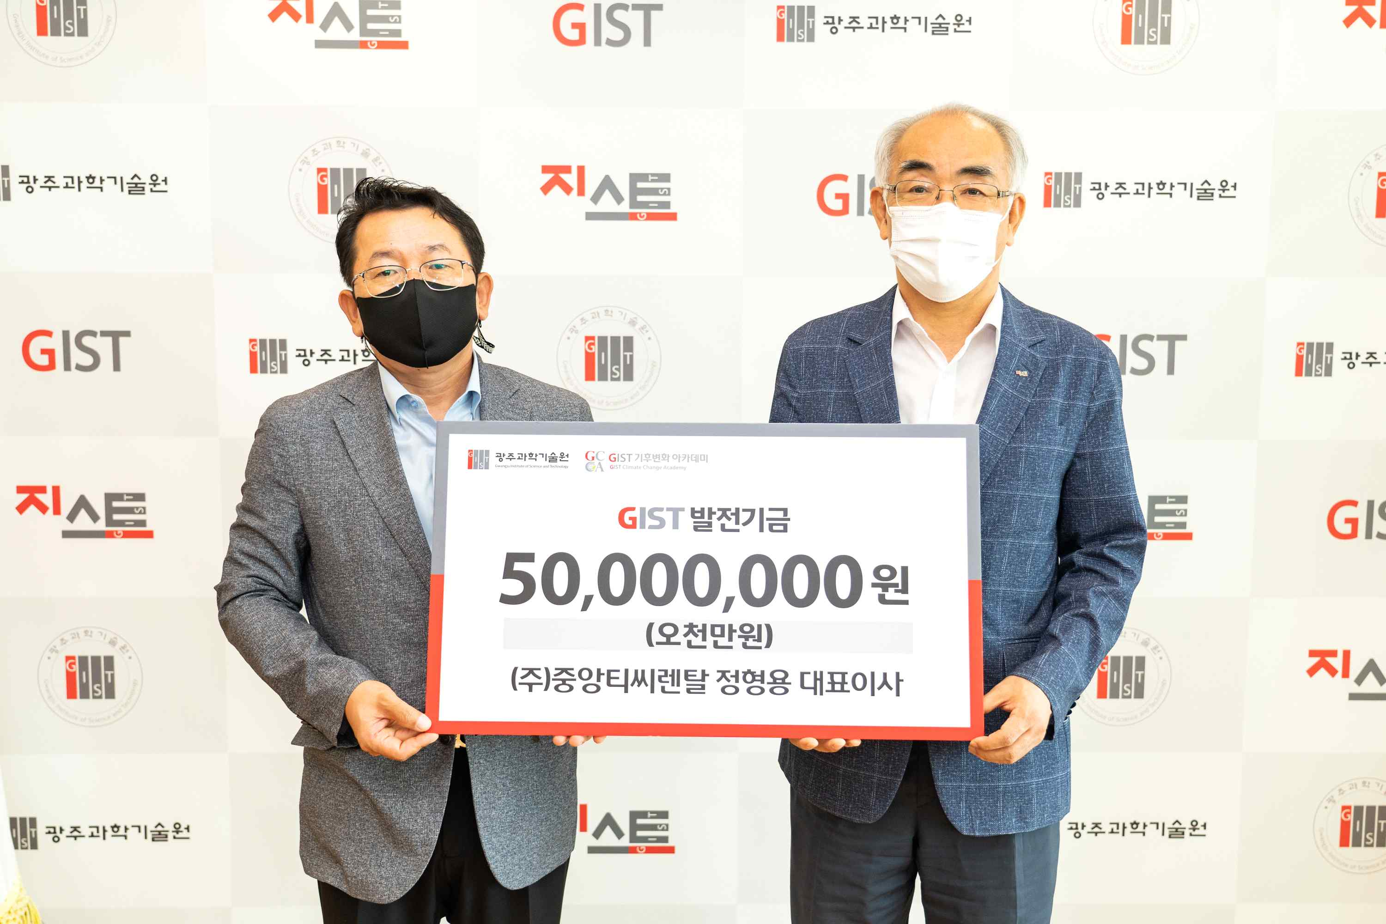
▲ GIST Climate Change Academy (GCCA) 5th class alum Hyung-yong Jung (right) CEO of JoongAng TC Rental Co., Ltd., donated 50 million won to the GIST Development Fund, which was received by GIST President Kiseon Kim, (left).

GIST Climate Change Academy (GCCA) 5th class alum Hyung-yong Jung CEO of JoongAng TC Rental Co., Ltd., donated 50 million won to the GIST (Gwangju Institute of Science and Technology, President Kiseon Kim) Development Fund.

Jungang TCC Rental, a building construction company located in Gwangju, is a mid-sized company that installs, dismantles, and leases construction equipment necessary for building completion, and develops autonomous and safe operation systems. It registered a patent for the tower crane autonomous safe operation system in 2022 and is providing various services so that construction sites can be operated safely and efficiently.

CEO Hyung-yong Jung said, "As an alumni of the academy, I donated the development fund in the hope that GIST’s excellent research achievements will contribute to regional development by creating an optimal environment for talented people to focus on research and establishing the local AI core infrastructure."

President Kiseon Kim said, "We would like to thank you for your donations for the development of the school and the region despite the difficult times, and we will use the precious donations for the promotion of research achievements and regional development of GIST researchers and students. We will do our best to support education and research so that GIST can establish itself as a global university and focus on nurturing outstanding talent."

GIST Academy operates two courses: GIST Techno Management Business Academymy (opened in 2010) and GIST Climate Change Academy (opened in 2016). It is contributing to the vitalization of the local economy and industry-university cooperation by helping students learn global management strategies and form a wide human network.



