GIST, two book selected as 'National Academy of Sciences Excellent Academic Books'

- Co-authored by Professor Sung-Min Hong, <Introduction to Computational Electronics> ...Introduction for graduate students and researchers in the relevant field
- Professor Choi Won-il's translation <How do aging and language affect you?>... "It's good to prepare for a healthy old age"

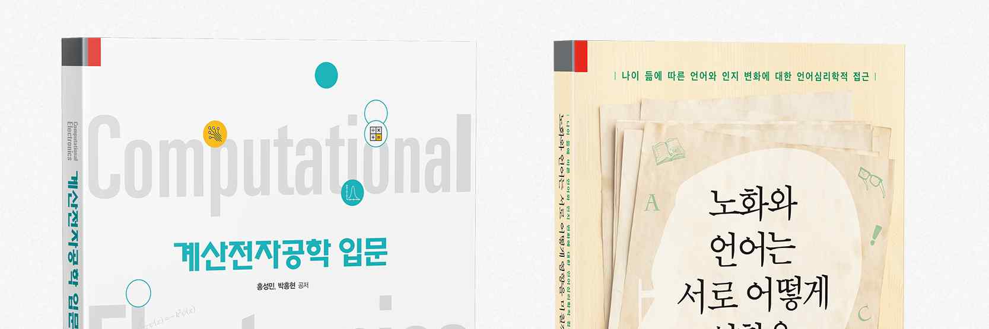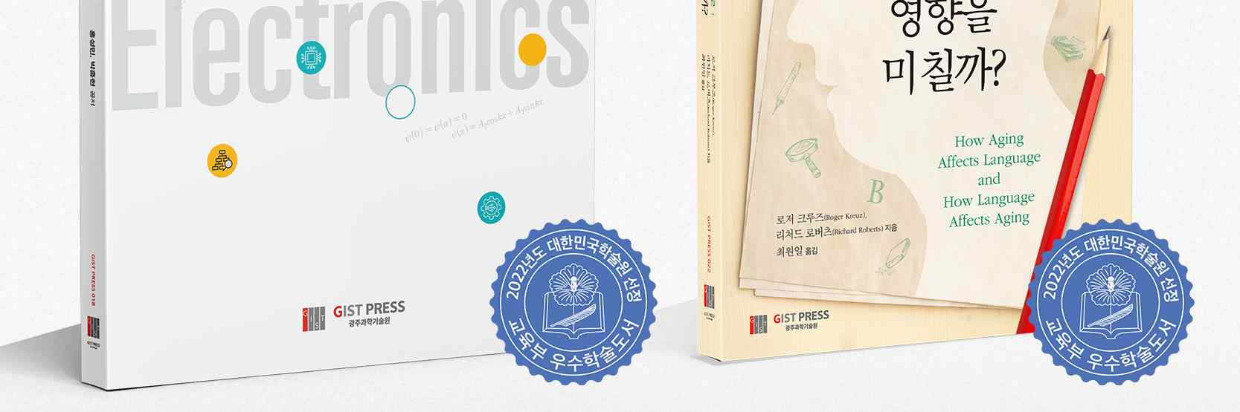
▲ (From left) Covers of <Introduction to Computational Electronics> and <How do aging and language affect you?> of GIST PRESS, selected as an excellent academic book in 2022

Two books published by GIST PRESS, a publisher of GIST (Gwangju Institute of Science and Technology, President Kiseon Kim), were selected as 'National Academy of Sciences Excellent Academic Books' in 2022.

The selected books are <Introduction to Computational Electronics> co-authored by School of Electrical Engineering and Computer Science Professor Sung-Min Hong and published in July 2021, and a translation of Division of Liberal Arts and Sciences Professor Wonil Choi <How Aging and Language Affects?> published in December of the same year.

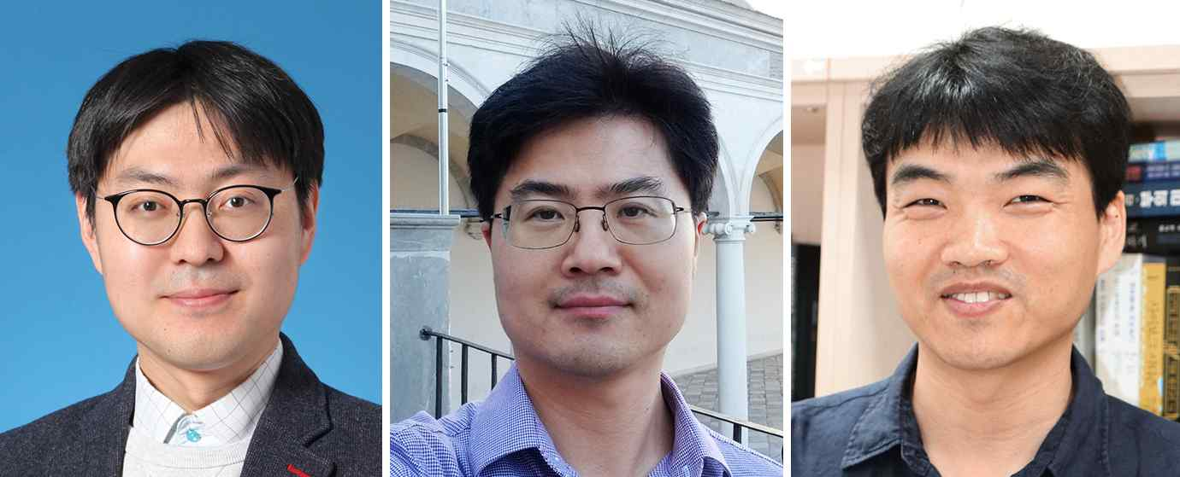
▲ (From left) Professor Sung-Min Hong, Dr. Hong-hyeon Park (Samsung Semiconductor Inc), and Professor Wonil Choi

<Introduction to Computational Electronics>, written by Professor Sung-Min Hong and Dr. Hong-hyeon Park (Samsung Semiconductor Inc.), is an excellent academic book in the field of natural sciences and is a specialized book for graduate students and researchers in the field.

In <Introduction to Computational Electronics>, important principles used in the field of computational electronics are easily explained, helping researchers to form a basic cognitive framework that can be used in actual research.

In addition, practice codes implemented in MATLAB are included in the appendix along with practical examples for writing numerical analysis programs. It is structured so that researchers can self-evaluate their skills or verify their coding results.

Professor Sung-Min Hong, the co-author, said, "We hope that <Introduction to Computational Electronics> will be a useful introduction and a good guide for researchers who want to study the attractive field of computational electronics."

Professor Wonil Choi's Korean translation of <How do aging and language affect you?> was co-written by Professor Roger Kreuz (Department of Psychology), who studies language psychology at the University of Memphis, USA, and Dr. Richard Roberts, a Ph.D. in cognitive psychology and an incumbent diplomat.

<How do aging and language affect you?> reveals the effect of aging on language and, conversely, the effect of language on aging, especially from a cognitive viewpoint among various perspectives that study the relationship between aging and language.

In addition, the development and use of language while presenting various cases and research results reflecting various cultural contexts. It deals with the interrelationship between language and aging.

Professor Wonil Choi, the translator, said, "I recommend this book to readers who are expecting and preparing for a healthy and meaningful old age or want to expand their knowledge in the field of human language information processing."

'Excellent Academic Books' is a project initiated by the Ministry of Education and the National Academy of Sciences of Korea to revitalize research and writing activities of researchers in basic academic fields and to share and spread research results. 67 humanities, 110 social sciences, 40 Korean studies, 83 natural sciences) were selected as excellent academic books. The selected books will be distributed to major institutions such as universities and research institutes in the second half of this year after a demand survey by the National Academy of Sciences.



