GIST successfully completed education and seminar for prospective entrepreneurs

– Provide various programs to strengthen the capabilities of prospective entrepreneurs and create synergies

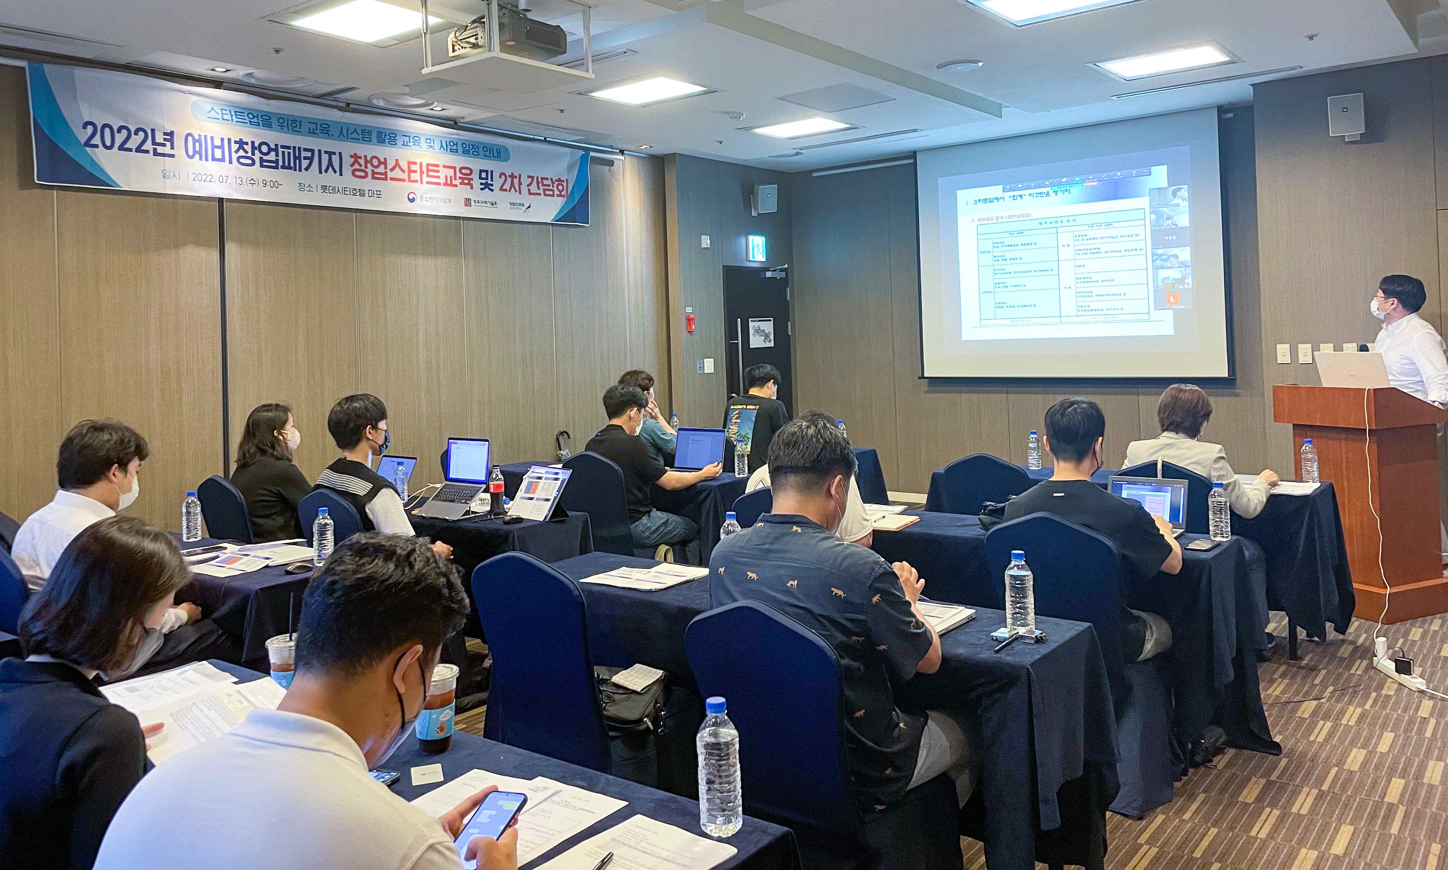
▲ 2022 Pre-Startup Package Specialized Start-up training site photo

'2022 Pre-Startup Package Support Project' jointly hosted by GIST (Gwangju Institute of Science and Technology, President Kiseon Kim), the Honam region and the cooperative organizations Jeonnam, Gwangju, Chungbuk, Bitgaram Creative Economy Innovation Center, Jeonju University, Gwangju Technopark, and Gwangju Regional Tax Office Education and seminar' was successfully completed.

GIST is a pre-startup package specialized field, such as digital, network, artificial intelligence (D.N.A), etc., which utilizes artificial intelligence in the D.N.A field, focusing on the excellence of business items. By evaluating the possibility of commercialization, it is supporting material and human resources to achieve commercialization of start-ups.

‘Startup Startup Education’ was held online and offline on July 13 (Wednesday) for a total of 19 prospective entrepreneurs and GIST College students selected for this year’s preliminary startup package. On July 19th and 20th, ‘financial and credit education’ necessary for start-up commercialization was held non-face-to-face.

The seminar has been well-received by the participants by providing seminars on ▴ financial education and credit management ▴ funding using guarantees ▴ value-added tax, global income tax ▴ how to finance startups.

The 'Preliminary Start-up Package' support project of the Ministry of SMEs and Start-ups is a business that provides practical start-up support such as start-up education and mentoring, market connection, and global expansion, as well as commercialization financial support for the smooth start-up commercialization of prospective founders with innovative technology start-up materials.

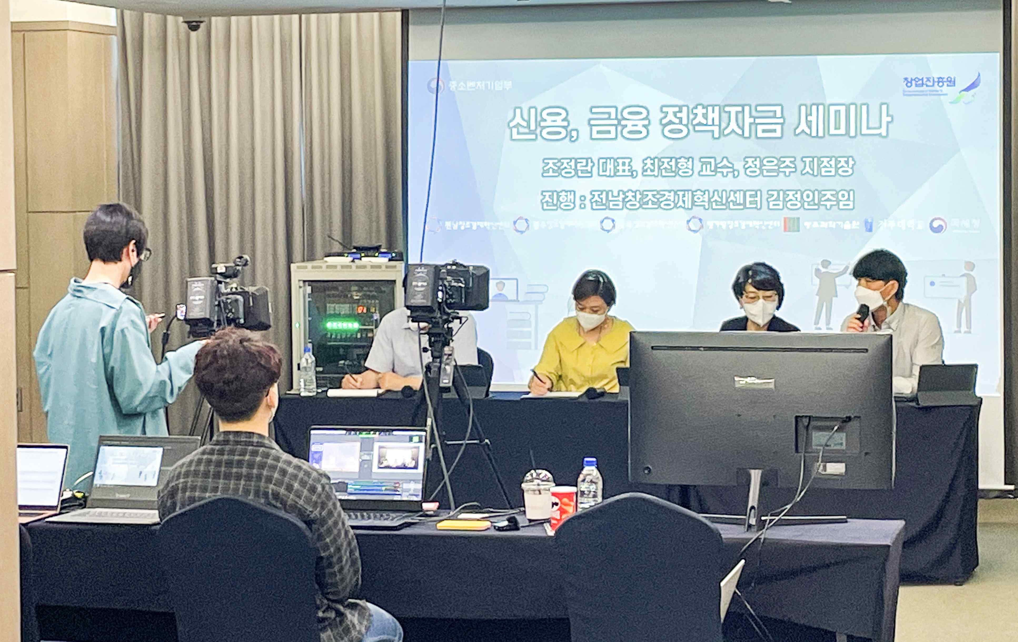
▲ 2022 Preliminary Startup Package Finance and Credit Education and Seminar

An average of 50 million won is provided to prospective founders selected through the evaluation of commercialization funds required for idea discovery, prototype production, intellectual property rights acquisition, and marketing and provides on-line and off-line education and business start-up/management experts as dedicated mentors to provide close support services for the overall start-up activities of prospective entrepreneurs.

GIST Business Incubator Director Byeong-gwan Cho said, "Although it is a difficult time to start a business in the aftermath of COVID-19, we will serve as a guide so that prospective entrepreneurs can quickly succeed in starting a business by reducing trial and error."

Meanwhile, as follow-up training, IR (specialized) training for the 2022 preliminary startup package will be held in mid-September. The program is a startup investment attraction strategy. It will be conducted with information on strategy establishment through investment case analysis and how to write an investment reservation form.



