Gifted chemistry students gathered at GIST despite the heat and coronavirus
<2022 Korea Chemistry Olympiad Summer School> in progress

– 19 chemistry gifted high school students selected from all over the country, staying at GIST for 2 weeks
– High school 1 online, high school 2 face-to-face class... Selected high school 2 students to participate in the International Olympiad

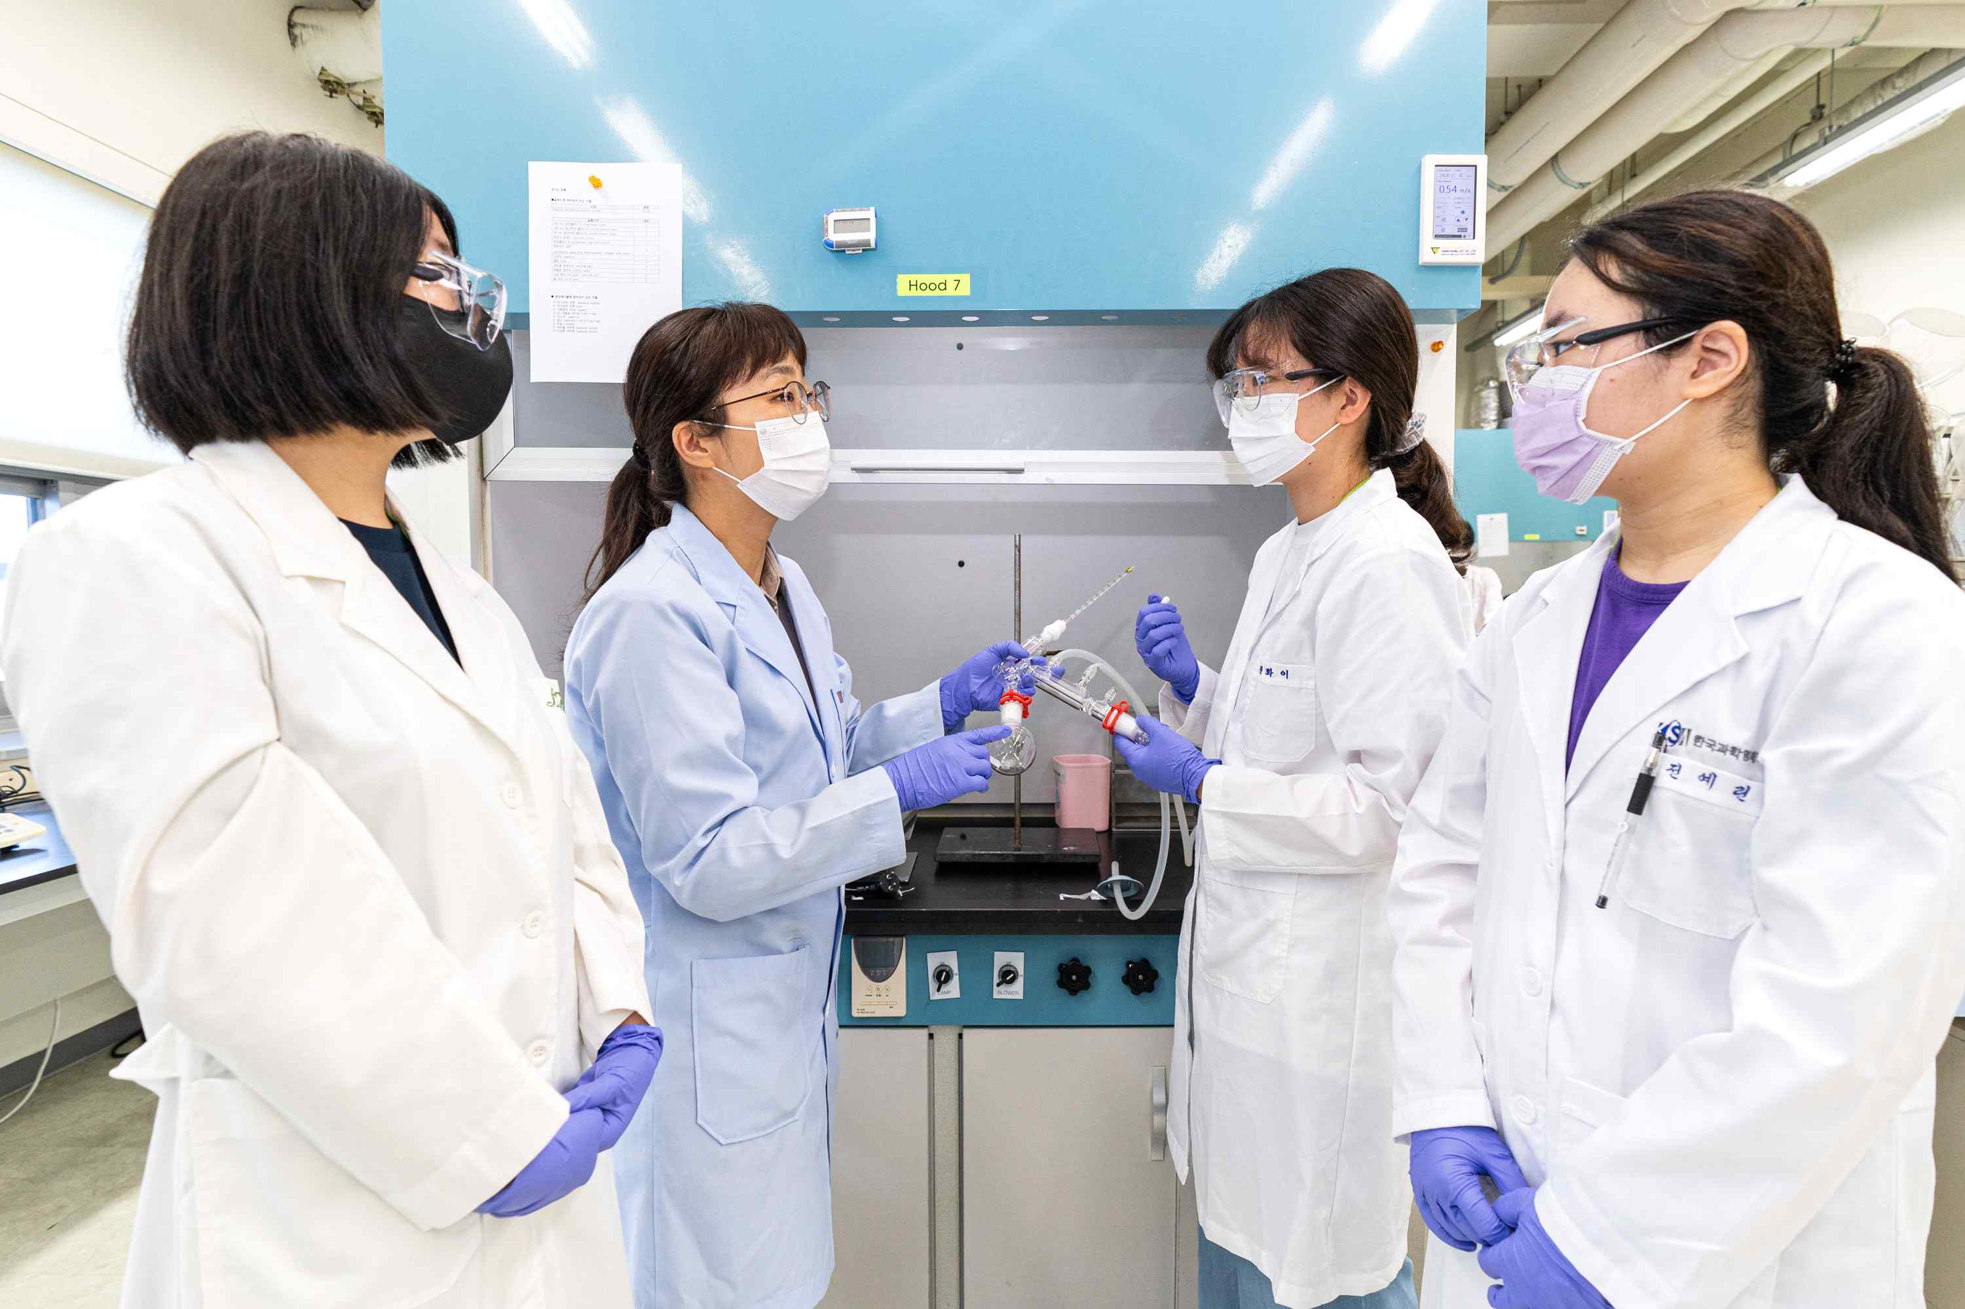
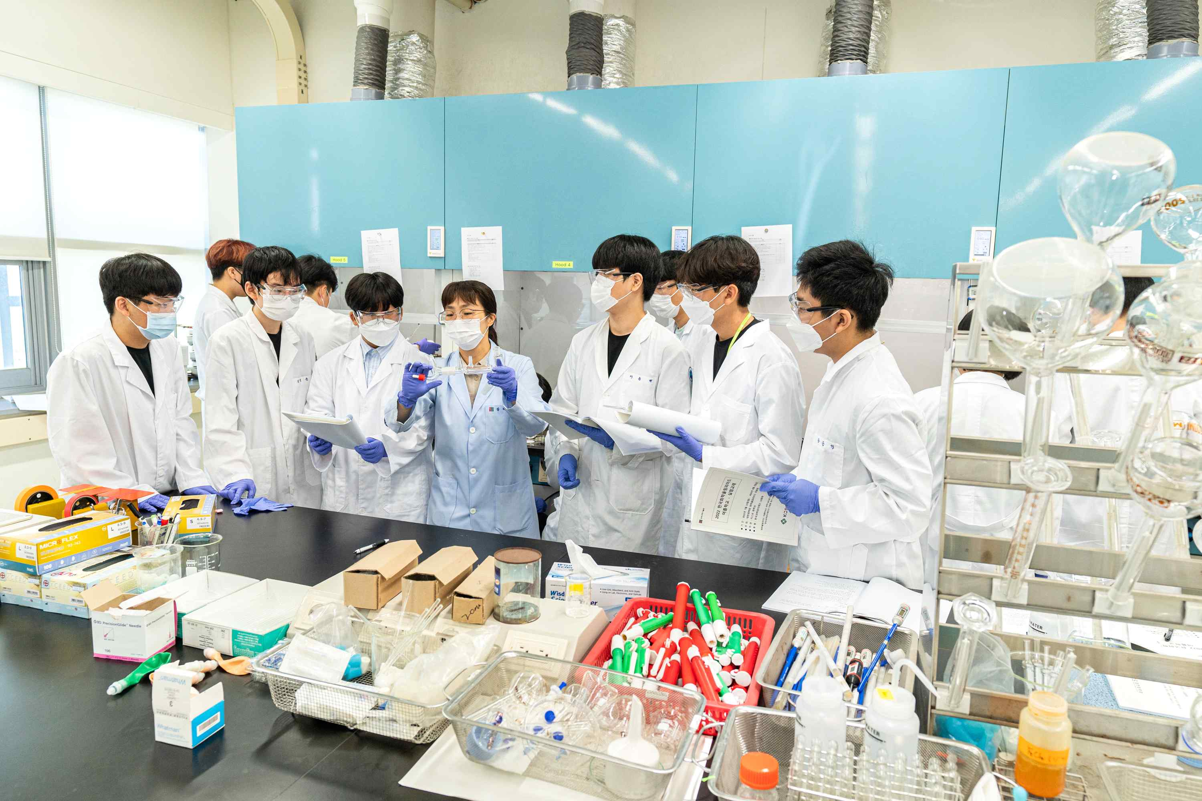

[Photo Description] On the morning of July 27 (Wednesday), in the Chemistry Lab of GIST (Gwangju Institute of Science and Technology), sophomores from high school who participated in the <2022 Korean Chemistry Olympiad Summer School> conducted an experiment on the purification of organic compounds with an experiment instructor. Hosted by the Chemistry Olympiad Committee of the Korean Chemical Society with the support of the Korea Foundation for Science and Creativity and LG Chem, and supervised by the GIST Chemistry Department, this summer school is being held online and offline in parallel* for the first time in two years due to the impact of the COVID-19 pandemic. Among the 19 high school sophomores who stay in the GIST dormitory for two weeks until August 5 and participate in chemical theory lectures and experimental education, those who received excellent evaluations will be selected as the national representatives after the winter school scheduled for the end of this year and will be selected as the national representatives next year to participate in the Olympiad. The International Chemistry Olympiad is a competition in which middle and high school students around the world compete for their chemistry skills.

* (Note) High School 1_Online, High School 2_Offline



