Tips for adjusting to college life from a current professor! <Professor, is this on the exam?> published

– Published by GIST PRESS...A guide for success in college life and a successful life after college
– Co-authored by William & Mary University Professor Dana Johnson and others

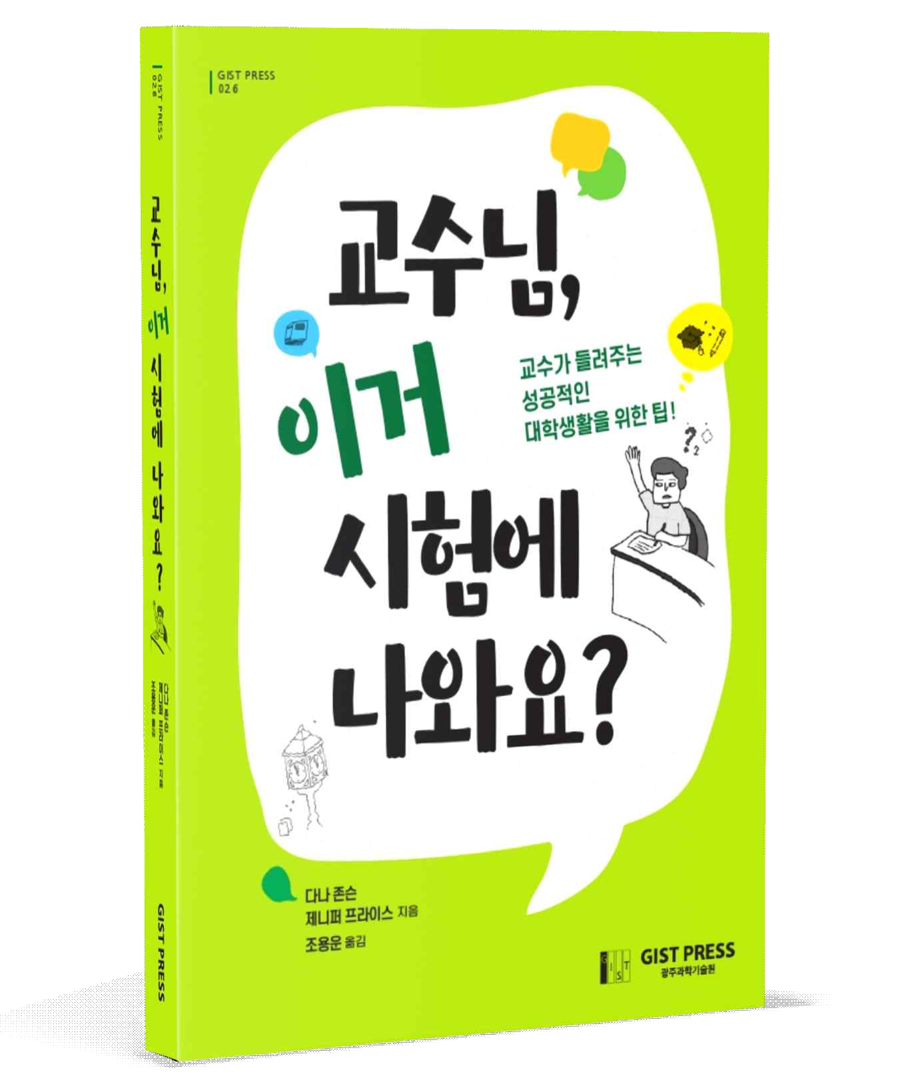
▲ A liberal arts book that resolves vague questions and difficulties about university life published by GIST PRESS <Professor, is this on the exam?>

If college freshmen enter with a good understanding of the unfamiliar higher education system, they can use their four years of time and tens of millions of won in college tuition more efficiently for a successful life.
- <Professor, is this on the exam?>, p.7

'Can I go to the bathroom during university class?', 'I need to get a recommendation from the professor, what should I do?', 'I need to send an email to the professor, but how should I do it?' In addition to these questions that may have been asked, but they are too trivial to ask, a translation has been published that will serve as a useful guide for successful college life.

[GIST PRESS], the publisher of GIST (Gwangju Institute of Science and Technology, President Kiseon Kim) announced on the 21st that it has published <Professor, is this on the exam?>, a liberal arts book for successful college life.

<Professor, is this on the exam?> is a translation of 'Will this be on the exam?', published in 2019 by Princeton University Press, USA, and translated by GIST Executive Administrative Officer Yong-woon Cho. From a university professor's point of view, they give you advice on how to make the most of your college life, how to make the most of your college courses, how to form academic relationships, and how to develop your skills for the future.

One of the authors, Professor Dana T. Johnson, is from the College of William & Mary, renowned for its liberal arts college, the second oldest institution of education in the United States after Harvard University, and taught mathematics for over 30 years. She has twice won the Simon Prize for Excellence, awarded by the university to a professor who has delivered excellent lectures in mathematics.

Jennifer E. Price, who wrote Chapters 7 and 12, is the daughter of Professor Dana Johnson. As a biologist who teaches college students, she has a lot of experience teaching students through online as well as traditional face-to-face lectures.

In Korea, where education is hot, many books are published to get into good universities. There are not many books on how to adapt to a foreign university environment after entering college. In particular, it is even rarer to find a book that contains sincere advice to students from the perspective of a professor in the same educational field.

This book is about △ getting information from the syllabus △ how to effectively prepare for online and offline lectures △ how to communicate smoothly with professors such as using office hours and e-mail etiquette △ practical tips for getting good grades △ how to prepare for your child’s college. It also provides advice for parents who want to help them adjust to life.

The author in the foreword to the book said, "I hope that this book will prepare you well for the challenges you will face in the college course after entering university. It is also hoped that it will be helpful to parents, university professors, admissions officers, high school counselors, and university officials who share the goal of successful college life for students."



