“Contribution to fostering local new industries through AI-based R&D such as Metaverse” inaugural ceremony for two new tasks organized by GIST and others

– GIST, research on building an AI-based metaverse studio by participating in the ‘Project for Opening the Future of the Region’
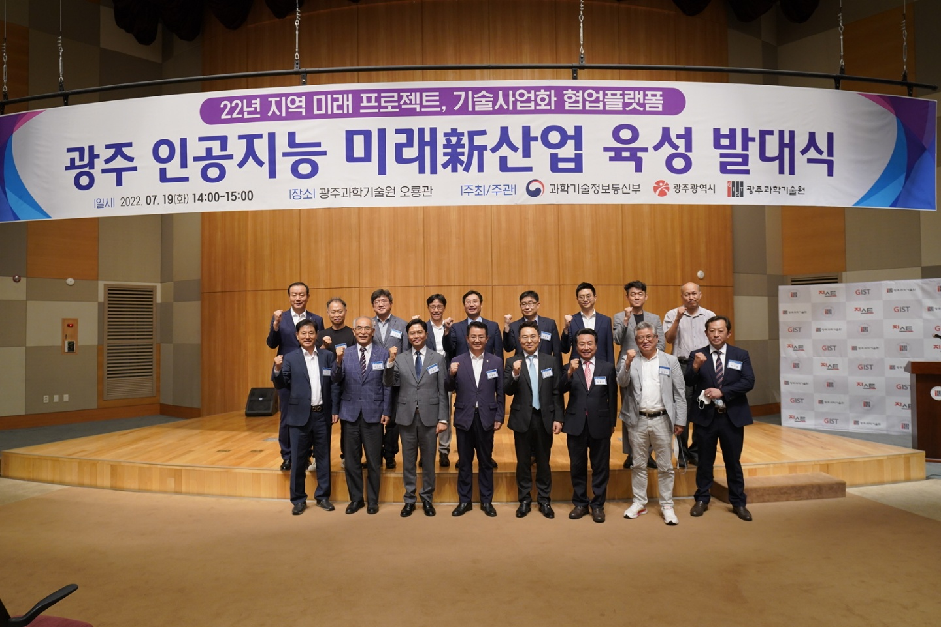
▲ On the afternoon of the 19th (Tuesday), major participants are taking a commemorative photo at GIST Oryong Hall for the Gwangju Artificial Intelligence Future Industry Initiation Ceremony.

In the afternoon of July 19th (Tuesday), the joint launch ceremony of two projects promoted as a new task by GIST (Gwangju Institute of Science and Technology, President Kiseon Kim), etc., to foster new artificial intelligence-based future industries in Gwangju and revitalize the local economy was held at 2 p.m. at GIST Oryong Hall.

Hosted by GIST with support from the Ministry of Science and ICT and Gwangju Metropolitan City, the joint launch ceremony was held for ▴ convergence culture virtual studio for realizing AI-based metaverse hosted by Korea Electronics Technology Research Institute ▴ the development of intelligent digital content production technology and platform construction.

The event was held in the presence of about 60 experts from industry, academia, research and government, including National Assembly member Lee Yong-bin (with the Democratic Party of Korea, Gwangsan Gugap, Gwangju), Kim Gwang-jin, Deputy Mayor of Culture and Economy, Gwangju Metropolitan City, and Ko Seo-gon, head of the R&D policy department of the Ministry of Science and ICT.

GIST (Researcb Director Dukjo Kong) will participate in the <Science and Technology Project to Open the Future of the Region> project as the host organization and will invest a total of KRW 10.4 billion over the next five years (2022-2026) to implement the 'AI-based metaverse'. Researchers in various fields such as artificial intelligence, cultural technology, and audio intelligence will collaborate to create a convergence culture studio.

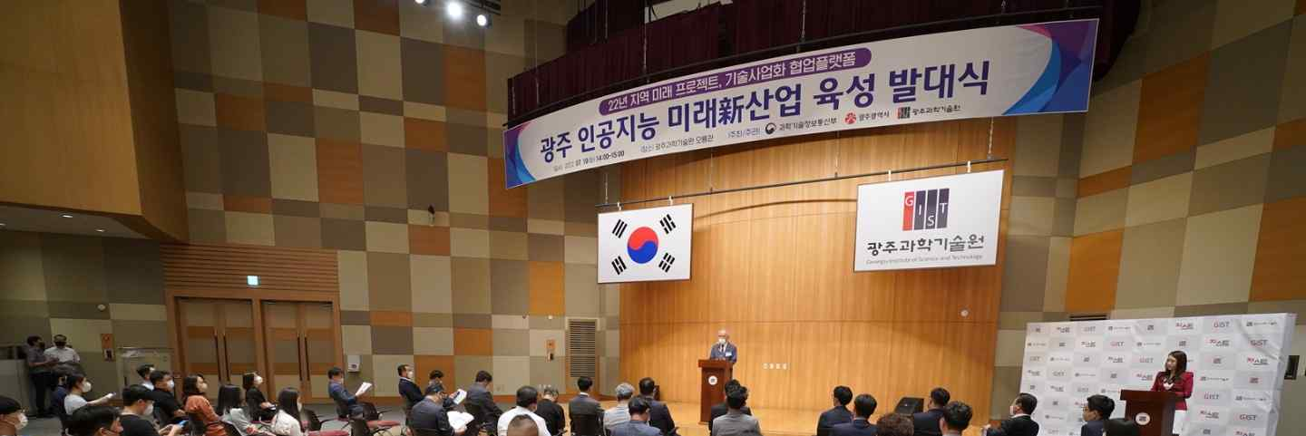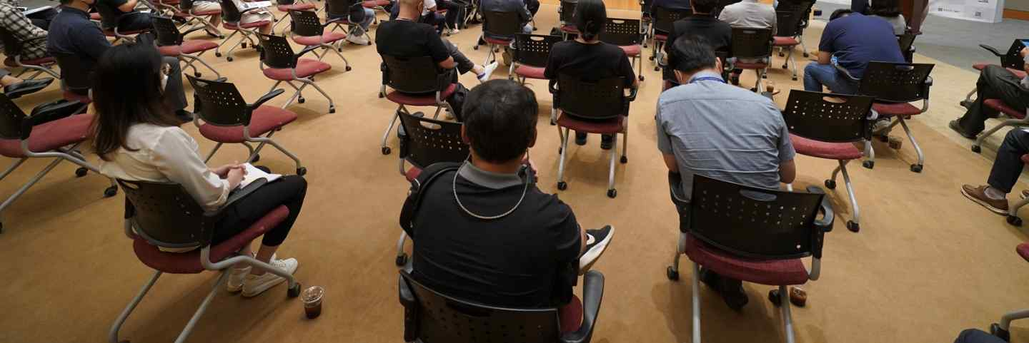
▲ GIST President Kiseon Kim gives a welcome speech at the opening ceremony for the new future artificial intelligence industry in Gwangju held at GIST Oryong Hall on the afternoon of the 19th (Tuesday).

The research team is developing a cutting-edge authoring tool that allows any company or individual wishing to create content on the metaverse to easily implement the background, characters, and voices in the metaverse. They plan to develop a tracking technology that enables human-computer interaction (HCI) and apply it to educational contents using metaverse.

A total of KRW 12.7 billion will be invested for 3 years (2022-2024) for the <Establishment of a technology commercialization collaboration platform> project, which is supervised by the Korea Electronics Research Institute (Research Director Sang-beop Lee) and more than 13 research institutes, including research institutes, participate in the task of 'Building a Platform'.

Building an intelligent digital content production platform ecosystem across planning, production, distribution, and consumption reflecting digital content user demand, and creating and supporting digital content based on artificial intelligence (AI), block chain and non-fungible tokens (NFT) to support the platform and plans to build a foundation for the vitalization of the intelligent digital content industry through technology development and support from companies and prospective founders.

After the launching ceremony, participants conducted an on-site tour to "HPC-AI public infrastructure" built in the largest domestic educational institution and "K-digital platform" to cultivate working-level talent with basic digital capabilities.

GIST Presiden Kiseon Kim said, "GIST will advance its R&D and start-up capabilities in the AI field by linking the national strategic industries such as semiconductors with the regional core industries that provide local jobs based on its unique research capabilities and artificial intelligence infrastructure. Furthermore, we will spare no effort to provide support at the institutional level so that we can lead the national AI research and contribute to the creation of new industries in the region."



