Nepalese embassy in Korea visits GIST

– Tour of major research institutes and discussion of exchanges with students and researchers from their home countries

- Contribute to attracting excellent foreign students in cooperation with the embassy

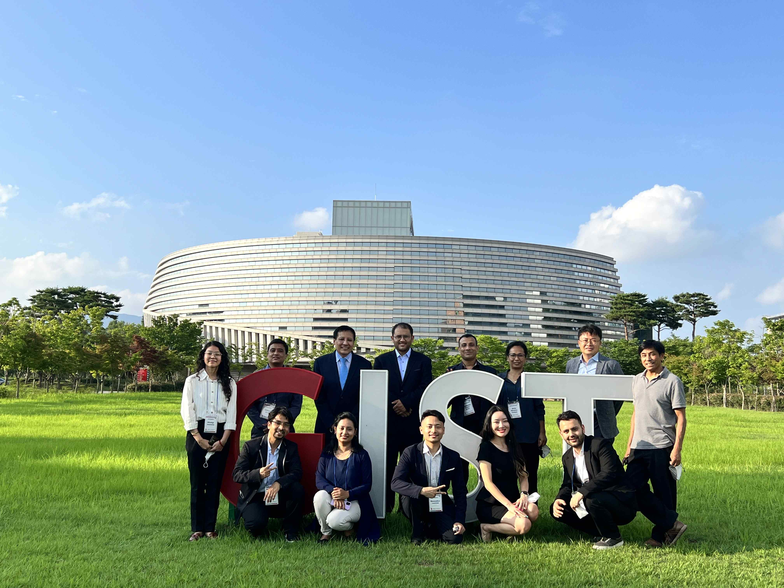
▲ Group photo of the Nepalese Embassy in Korea

The Nepalese Embassy in Korea, including the Nepalese Ambassador to Korea Ram Singh Thapa, visited GIST (Gwangju Institute of Science and Technology, President Kiseon Kim) on Friday, the 8th.

A meeting was held in College Building A in the presence of officials from the admissions team and others, including the Nepalese ambassador to Korea (Ram Singh Thapa), secretary (Sangam Kharee), and 8 Nepalis (3 masters, 3 doctoral, 2 researchers).

After the meeting, the Nepalese embassy in Korea visited the IBS Ultrashort Photon Beam Special Research Building, where Nepalese students are participating in the research, and toured the ultrashort ultra-strong laser facility.

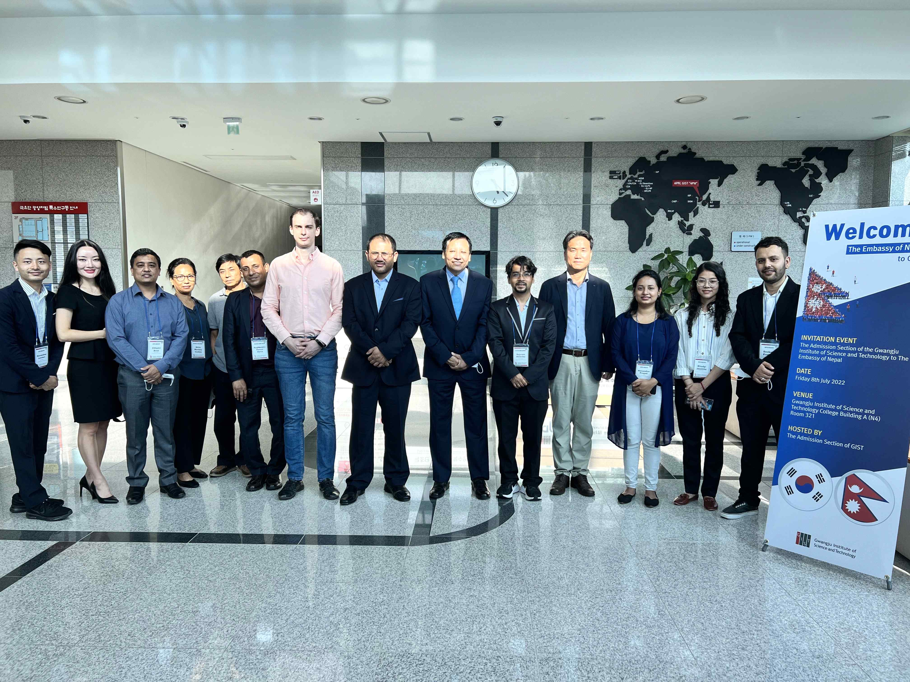
▲ Group photo of visiting IBS Ultrashort Photon Beam Special Research Building

This visit was made in the form of a visit from the Nepalese embassy, who wanted to directly check the excellent educational and research environment of GIST during an admissions briefing session for the embassy in Korea since last March.

The Admissions Team is preparing the foundation for cooperation with embassy observations to attract outstanding foreign talents such as government-invited scholarship students (GKS) by ▴ the formation of networks with excellent universities in Nepal and the international student community in Korea ▴ constant publicity is expected through domestic and overseas contact networks.

The admissions team is actively promoting publicity to attract excellent talents from various countries, such as participating in international study abroad fairs, holding an admissions briefing session at embassies in Korea, operating an ambassador program, social media promotion, and video production.

As a result of various public relations activities, the recent increase in the number of foreign applicants and registrants has led to the admission of excellent students of various nationalities.

Dean of Student Affairs and Admissions Keun-Young Kim said, "GIST selects excellent foreign students for the undergraduate program through various admissions promotions based on its experience in successfully operating graduate school entrance examinations for foreigners. I hope that students will be able to contribute to the advancement of science and technology and the promotion of friendship between the two countries by successfully conducting education and research at GIST."



