“A prototype? Market test? The school will support you!” 2022 'Sprint for Start-up' mock start-up program begins

– GIST's representative start-up support project that verifies the possibility of student start-up ideas without conditions

– Expert advice on design, technology, legal, marketing, etc. for 6 months until December

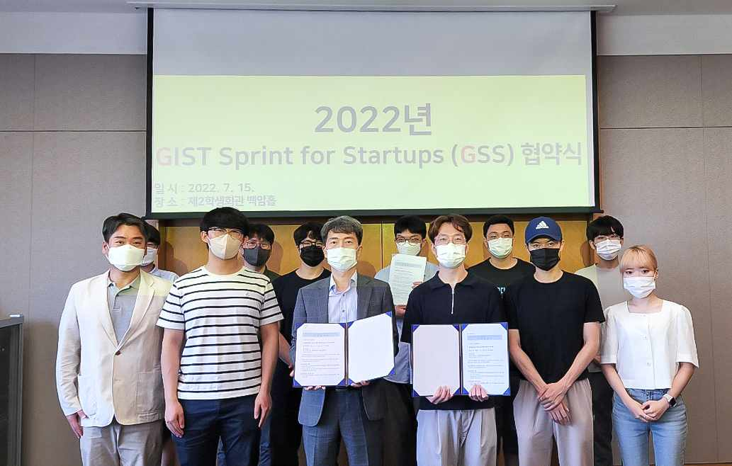
▲ The GIST Business Incubator held an signing ceremony for the ‘GIST Sprint for Start-up (GSS)’ program to inspire a healthy start-up culture and verify various start-up ideas on the 15th (Fri) at the 2nd GIST Student Center.

GIST’s representative start-up support program “GIST Sprint for Start-up (GSS),” which supports students dreaming of starting a business to verify their startup ideas and explore their feasibility, started the 2022 program with a signing ceremony with participating teams.

GIST (Gwangju Institute of Science and Technology, President Kiseon Kim) Business Incubator will hold an agreement ceremony with 8 teams selected for the 「GIST Sprint for Start-up」 program at the 2nd GIST Student Center at 12 noon on Friday, July 15th. A meeting was held to discuss the method of this year's program to December and follow-up programs for business start-up and investment connection.

「GIST Sprint for Start-up」, held annually since 2014, is a ‘signboard program’ that represents GIST’s student start-up support process.

If the 'Start-up Idea Contest' is a gateway to discovering students who are interested in starting a business, the 「GIST Sprint for Start-up」is the possibility of realizing a start-up by selecting an idea that students actually want to verify from among the various start-up ideas proposed in the start-up idea contest. It is a program that supports the process of selecting and upgrading the possibility of entrepreneurship.

「GIST Sprint for Start-up」 allows students to conduct market tests while making an initial product or service in the form of a prototype without the condition or burden of having to start a business after receiving support from the school. It is designed to move on to the next stage for items that show the possibility of success.

In particular, among the participating teams this year, the recently held <GIST-DH Global Start-up Idea Contest> is raising expectations ▴ Best Prize (Department of Chemistry Kang Dong Wook student team, ‘Protein-based mRNA Vaccine Protection Substance’) and ▴ Encouragement Award (Department of Chemistry Jiho Park student team, ‘Portable Corona-19 Molecular Diagnostic Device for On-Site Diagnosis’).

Participating teams participate in a challenge-type program for 6 months from July to December with the goal of making a prototype of an initial model that can be quickly verified within a given period.

During the 6-month challenge period, a mentoring program to supplement the ideas of prospective startup teams and help commercialize them is conducted at the same time. The participating teams are provided with design, technology, legal, and marketing advice.

In December, when the program ends, an evaluation and seminar in the form of a report on the final results of the participating teams are scheduled. Links to follow-up programs and investor meetings are also available.

Prior to 「GIST Sprint for Start-up」, <2022 GIST-DH Global Start-up Idea Contest> was held as a pre-program in June. Next year, the <Campus CEO Challenge for Student (CCS)*> is scheduled as a follow-up program.

* Campus CEO Challenge for Student (CCS): This is a practical start-up program that supports the student start-up team who have completed the mock start-up program and wants to start a real start-up.

GIST Business Incubator Director Byung-kwan Cho said, "Through the course of the program, we plan to discover many preliminary start-up teams with high potential for success through additional mentoring and revision and supplementation of start-up items."



