GIST Advance Photonics Research Institute successfully completed the 2022 International Summer School on Lasers

– 22 researchers from 5 countries around the world participated... Strengthening international status as the only leading laser research institute in Korea

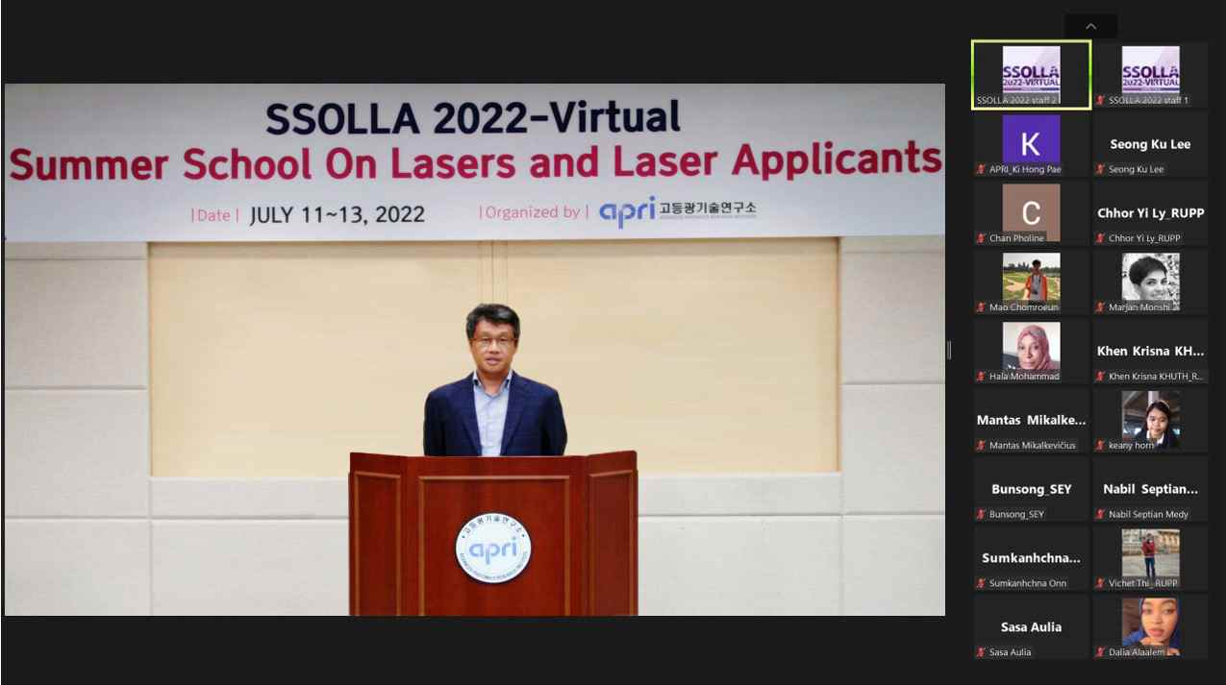
▲ Zoom capture screen of the Advanced Photonics Research Institute <SSOLLA 2022> (Welcome Address, Yeung Lak Lee, APRI Director)

GIST (Gwangju Institute of Science and Technology) Advanced Photonics Research Institute (APRI, Director Yeung Lak Lee) held the <Summer School On Lasers and Laser Applicants (SSOLLA) 2022> for young overseas students and researchers studying laser and optical technology.

* SSOLLA: Summer School On Lasers and Laser Applicants

The <Summer School On Lasers and Laser Applicants> is a global educational program that has been held since 2010 by the Advanced Optical Technology Research Institute, where young researchers studying laser and optical technology can stay in the GIST campus for 7 days to experience lectures and optical experiments. there are programs This year, like last year, to prevent the spread of COVID-19, the non-face-to-face online education was reduced from July 11 to 13 for three days.

A total of 22 students and researchers from five countries including Lithuania and Sudan, as well as Asian countries such as the Royal Cambodian University of Phnom Penh and Pakistan Institute of Technology, participated in this event.

Domestic optical experts, including GIST researchers, participated in 7 lecture programs in the field of optics and lasers ▴ basics and applications of femtosecond (1 trillionth of a second) laser and fiber laser ▴ nonlinear optics ▴ nanospectroscopy ▴ silicon photonics ▴ terahertz science.

In particular, APRI Dr. Seong Ku Lee's lecture on 'High Power Femtosecond Laser and Gist Ultra Power Laser Facility' received a high response from the participants.

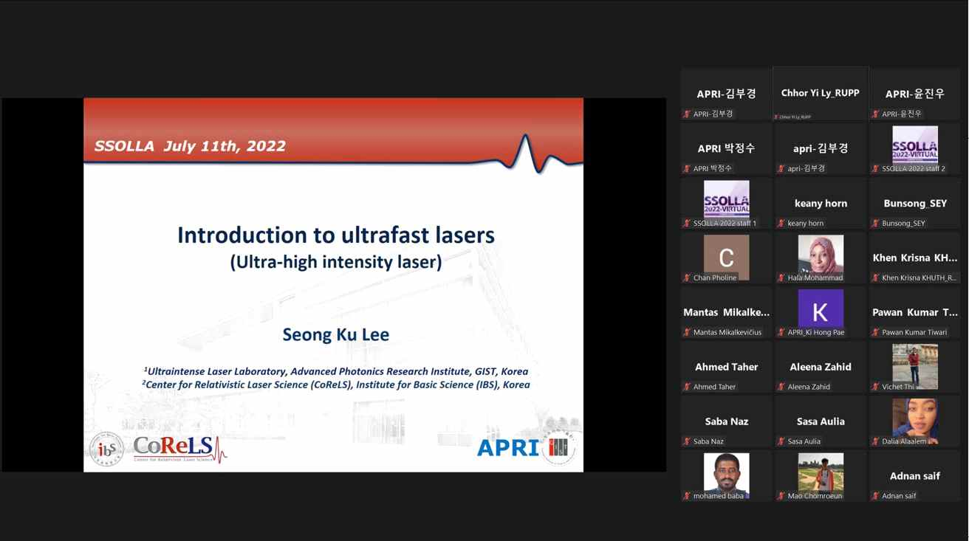
▲ Advanced Photonics Research Institute <SSOLLA 2022> Non-face-to-face online lecture

Director Yeung Lak Lee said, "Since 2010, the Advanced Photonics Research Center has held the annual Laser International Summer School event and has been strengthening the status of domestic optical technology research through active exchanges with overseas researchers in the field of laser optics. We will contribute to the development of domestic optical science and technology by expanding international exchanges in the field of optical technology in the future."

Meanwhile, the GIST Advanced Photonics Research Center, the only optical technology research institute in Korea, is celebrating its 21st anniversary this year and is the first in the world to produce a super-powerful laser of 20 femtoseconds (1 femtosecond: 1 trillionth of a second) and 4.2 petawatts (1 petawatt: 1000 terawatts). Recently, the research area has been expanded to the field of defense technology using laser and optical technology.



