Kang Dong Wook, a chemistry student team, won the grand prize at the start-up idea contest

– 1st place in the autonomous subject category with the idea of ‘protein-based mRNA vaccine protection material’ at the in-house startup idea contest
– First co-hosted with local midsize business DH Global

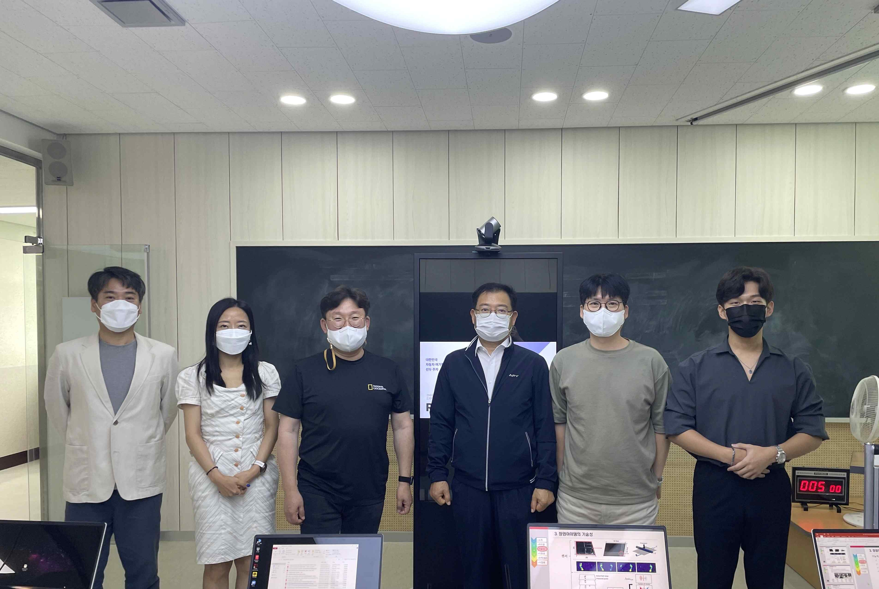
▲ Presentation of GIST Startup Idea Contest in 2022 (DH Global Vice President, 4th from the left, participated as a judge)

GIST has been holding the Startup Idea Contest every year since 2013 to revitalize student startups. In particular, this year, for the first time, the competition was jointly held with a prize of 4 million won from DH Global, a local mid-sized company.

In this competition, which was divided into two categories, A-track (autonomous theme) and B-track (smart home appliance), the student team Kang Dong Wook participated in the autonomous theme section and received the first prize for proposing vaccine development that can be stored at a relatively high temperature and in a general refrigerator unlike the cryogenic (-80°C) LNP (lipid nanoparticles) technology method, making it possible to develop an mRNA method with a low possibility of side effects.

Kang Dong Wook student team said, "This year, starting with the GIST Student Startup Club, we plan to build up various entrepreneurial experiences. Based on the confidence gained through participation in the startup program and winning the competition, we will actively participate in discovering ideas and business items for startups."

In this category, ▴ student Yunho Choi (Cultural Technology Major, Institute of Convergence Technology) won the Excellence Award for 'Metaverse moving device using high-resolution tactile sensor' and ▴ crowdsourcing-based driving content information from student team Seongjin Cho (Department of Electrical and Computer Engineering) 'Provided and recommended service' and 'Buzzing' of the ▴ Cheong Seung student team (Intelligent Robot Major, Institute of Convergence Technology) received the Encouragement Award.

In the smart home appliance (B-track) category that did not receive the grand prize, the student team, Hyun Park (School of Electrical, Electronic and Computer Engineering), announced 'Customized refrigerator design solution for self-employed product characteristics (customized design can optimize inventory management according to self-employed industry)' received the Excellence Award. Student Ho Kim (AI Graduate School)’s idea of ‘voice assistant service that provides AI-based customized delivery food recommendation’ and Jiho Park’s student team (Department of Chemistry)’ idea of ‘portable COVID-19 molecular diagnosis device capable of on-site diagnosis’ received the Encouragement Award.

In March, the GIST Business Incubator publicly recruited start-up ideas for GIST college students and graduate students by dividing it into two categories: A track (autonomous subject) and B track (smart home appliance). By mid-May, a total of 23 startup ideas has been received.

After that, after going through the first document screening, the startup items participating in the final announcement screening were selected, and the final 7 winners were selected for the announcement screening in June. The competition was held in the form of a business plan presentation.

In addition to competitions, GIST provides opportunities to produce and verify startup ideas in the form of initial prototypes, such as the GIST Sprint for Startup (GSS) and the Innopolis campus project, by linking various programs that can advance startup ideas.

GIST Business Incubator Director Byeong-gwan Cho said, "For medium-sized enterprises in the local community, companies and universities will cooperate to discover start-up ideas and create a foundation for joint projects."



