GIST Social Contribution Group 「PIUM」 hosts <Visiting Science Camp>

– 7.11~12. Visit Cheongsan, Wando-gun for 2 days and 1 night, and donate talents such as science experience and career mentoring
- Professor Kangwook Kim held a special lecture for 19 students on the topic of ‘microwave technology’

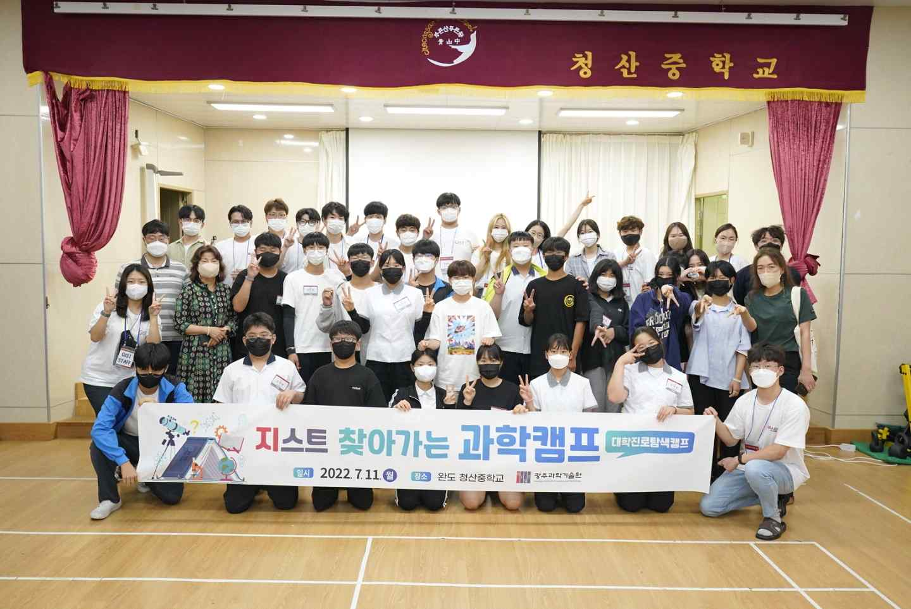
▲ GIST's social contribution group 'PIUM' visits Cheongsan Middle School in Cheongsan-do, for <Visiting Science Camp> and takes a commemorative photo with students in Cheongsan-do.

GIST (Gwangju Institute of Science and Technology, President Kiseon Kim) social contribution group 'PIUM' visited Cheongsan Middle School in Cheongsan-do, Wando-gun, Jeollanam-do, on July 11-12, and held a "Visiting Science Camp," which is a volunteer social contribution activity.

* PIUM: The name of the social contribution group at GIST. It is an acronym for Positive Interaction Understanding Mind, which means 'Let's sow seeds in our society through social contribution activities, and give water and fertilizer to make new flowers bloom.'

<Visiting Science Camp> is one of GIST's various social contribution volunteer activities. It is a talent donation program that provides interesting and diverse science experience programs and career mentoring by directly visiting middle schools located in remote areas such as islands in Gwangju and Jeollanam-do.

Following Shinui Middle School in Sinuido, Jeollanam-do last year, the camp was held for 2 days and 1 night at Cheongsan Middle School this year and included subjects of science and engineering that students could easily understand and appreciate ▴ group challenge for all 19 students! ▴ climate change and energy ▴ astronomy and space exploration ▴ the story of blood, etc.

Ten GIST students who participated in the camp deal with a variety of topics, from climate change and carbon neutrality to astronomy, space exploration, and biological fields identified by blood and antigen/antibody reactions. They drew the interest of students by making a 'solar car kit' together.

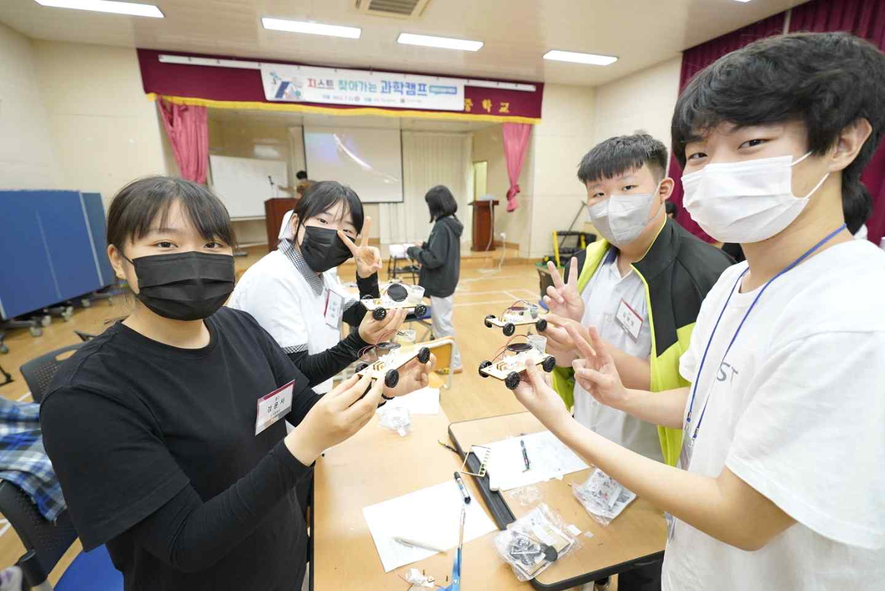
▲ Students from Cheongsan Middle School in Wando-gun are taking a commemorative photo after completing the 'Salt Water and Solar Vehicle Making Kit' in the 'Climate Change and Energy' program at the <Visiting Science Camp> hosted by the GIST social contribution group 'PIUM.'

In addition, for a more substantial and richer camp program, GIST School of Electrical Engineering And Computer Science Professor Kangwook Kim visited Cheongsan Middle School with his students and gave a lecture on the topic of 'Microwave Technology, the Expansion of Human Capabilities.'

A student from Cheongsan Middle School who participated in the science camp said, "It was interesting and fun to be able to experiment with various kits that were difficult to come across often. I am very grateful to the mentor teachers who came all the way from Gwangju to here, and I was able to participate happily because the class was fun and well done.

'PIUM' is a social contribution group composed of GIST students and is operated with the purpose of contributing to reducing the gap between learning opportunities and career experiences by providing science experience programs in an easy and interesting way to young people in underprivileged areas.

In addition to the <Visiting Science Camp> held three times this year*, 'PIUM' offers programs for ▴ LAN mentoring (online learning and career mentoring) ▴ AI Dream Tree Camp (offline experiential AI education program) to bridge the educational gap that has deepened due to COVID-19) ▴ Knowledge sharing activities are actively carried out through science camps held at the GIST campus).

* Cheongsan Middle School in Wando-gun, Jeollanam-do, Geumsan Middle School in Goheung, Jeollanam-do, Mangyeong Girls’ Middle School in Gimje, Jeollabuk-do

Due to the activities of 'PIUM,' which carries out various educational donation and career experience programs, GIST was selected No. 1 in Jeolla and Jeju for the "University Career Exploration Camp Project" organized by the Ministry of Education and the Korea Science Creative Foundation for two consecutive years last year.

President Kiseon Kim said, "<Visiting Science Camp> is a great opportunity to arouse curiosity and interest in science among young people and to remind GIST students of the meaning of studying science and technology through knowledge sharing. We will continue to carry out social contribution activities on a wide and continuous basis so that more young people can meet GIST students who donate their talents."



