GIST-Gwangju Chamber of Commerce and Industry-Academic Cooperation Meeting

– Discussion on ways to revitalize the local economy, such as discovering companies with technical difficulties, consulting for technical support, and creating local jobs

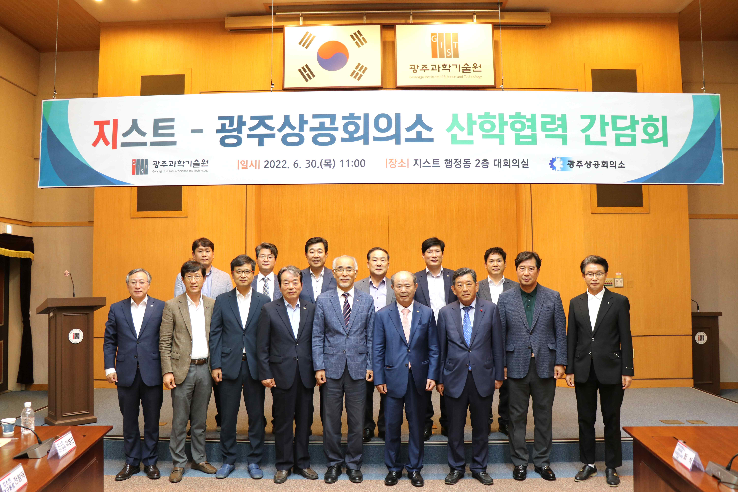
▲ GIST-Gwangju Chamber of Commerce and Industry-Academic Cooperation Meeting

(from left) Vice President for Public Affairs Young-jip Kim, GIST External Cooperation Advisory Committee member Yong-beom Lee, GIST GTI Director Byung-Geun Lee, GIST External Cooperation Advisory Committee member Heon-taek Park, GIST Research Institute Director Chang-Duk Jun, GIST Development Foundation Chair Jung-joo Koh, GIST External Cooperation Advisory Committee member Hyeon-cheol Kim, GIST President Kiseon Kim, Gwangju Chamber of Commerce and Industry Vice President Jong-man Choi, Gwangju Chamber of Commerce and Industry Chair Chang-sun Jeong, Gwangju Chamber of Commerce and Industry Managing Director Hwa-seok Chae, Gwangju Chamber of Commerce and Industry Vice President Sang-Won Han, Gwangju Chamber of Commerce and Industry Planning Director Huh-Hyeong Lee, Gwangju Chamber of Commerce and Industry Vice President Bogon Kim, and Gwangju Chamber of Commerce and Industry executive member Seok Choi

GIST (Gwangju Institute of Science and Technology, President Kiseon Kim) and the Gwangju Chamber of Commerce and Industry held an industry-academic cooperation meeting to discuss industrial-educational cooperation in the region and revitalization of the regional economy on Thursday, June 30th.

At the meeting held in the GIST Administrative Building conference room on the same day, GIST President Kiseon Kim, Vice President for Public Affairs Young-jip Kim, GIST External Cooperation Advisory Committee member Yong-beom Lee, GIST GTI Director Byung-Geun Lee, GIST External Cooperation Advisory Committee member Heon-taek Park, GIST Research Institute Director Chang-Duk Jun, GIST Development Foundation Chair Jung-joo Koh, GIST External Cooperation Advisory Committee member Hyeon-cheol Kim, Gwangju Chamber of Commerce and Industry Vice President Jong-man Choi, Gwangju Chamber of Commerce and Industry Chair Chang-sun Jeong, Gwangju Chamber of Commerce and Industry Managing Director Hwa-seok Chae, Gwangju Chamber of Commerce and Industry Vice President Sang-Won Han, Gwangju Chamber of Commerce and Industry Planning Director Huh-Hyeong Lee, Gwangju Chamber of Commerce and Industry Vice President Bogon Kim, and Gwangju Chamber of Commerce and Industry executive member Seok Choi attended the meeting.

Through the meeting, the two organizations discussed ways to revitalize the local economy, such as ▴ discovery of companies with technical difficulties and consulting for technical support ▴ creating local jobs ▴ support for local start-ups ▴ GIST-Gwangju Chamber of Commerce and Industry joint research and development.

On this day, the Gwangju Chamber of Commerce and Industry commemorated the visit to GIST and delivered an air purifying sterilizer from DK, a representative home appliance company in the region, to GIST to promote the purchase and use of products produced by local companies.

GIST President Kiseon Kim said, "Through this meeting, we were able to understand the actual needs of local businesses. As a regional innovation institution, GIST will do its best to overcome difficulties in the industrial-educational cooperation process and revitalize the local economy."

Gwangju Chamber of Commerce and Industry Chair Chang-sun Jeong said, "With today's meeting as an opportunity, the two organizations will cooperate more closely so that our region can be competitive in the global market and develop artificial intelligence (AI). We will strive to lead the next-generation core industries such as future automobiles."



