Cooperation in the development of educational and experiential contents for youth to enjoy cultural facilities

– 3-way MoU: GIST-Seoul Seocho Smart Youth Center-Mixed Reality Design Group

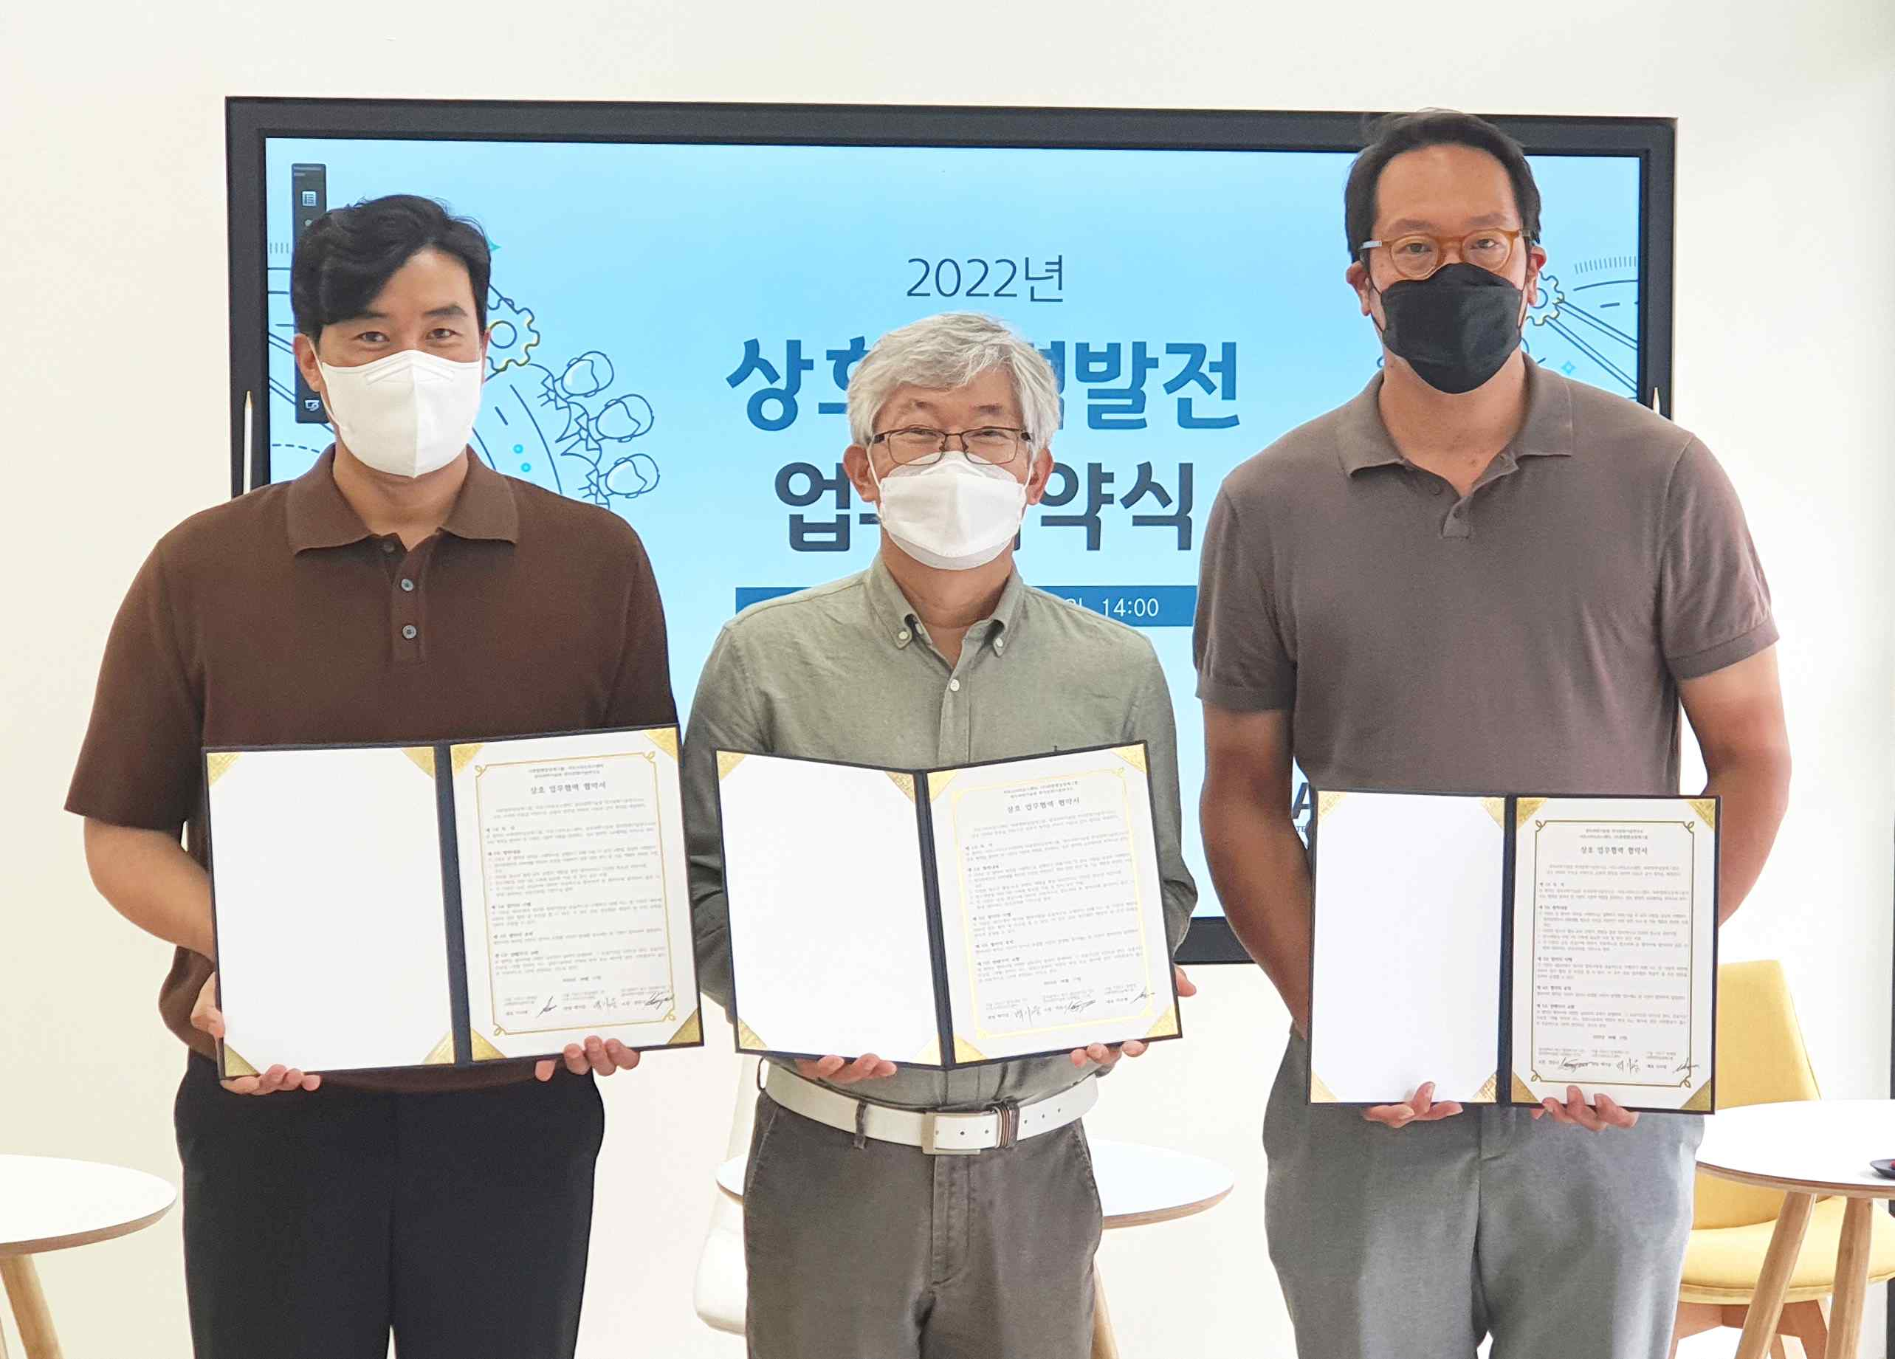
▲ (From left) Seocho Smart Youth Center Director Ki-woong Baek, GIST Korea Culture Technology Institute Director Moongu Jeon, and Mixed Reality Design Group CEO Woo-hyun Lee

GIST (Gwangju Institute of Science and Technology, President Kiseon Kim) Korea Culture Technology Institute (Director Moongu Jeon), Seocho Smart Youth Center (Director Ki-woong Baek), Mixed Reality Design Group (CEO Woo-hyun Lee) signed a business agreement for 'cultural technology research and development demonstration and service expansion.'

The signing ceremony was held at the Seocho Smart Youth Center on June 17 (Fri) with representatives and officials from three organizations in attendance.

The three organizations agreed to cooperate with each other in ▴ developing youth activities and educational contents ▴ developing and demonstrating technology to guarantee the right to enjoy cultural life ▴ research and development database (DB) construction data and exhibition space support.

GIST Korea Culture Technology Institute Director Moongu Jeon said, "Through this agreement, we will cooperate in the development of contents for education and experience using youth cultural infrastructure and expand demonstration services to increase cultural enjoyment."

Meanwhile, Seocho Smart Youth Center is a youth activity support organization established by Seocho-gu, Seoul, and is operating programs for career exploration, cultural and artistic experiences, self-development, and future technology education.

GIST Korea Culture Technology Institute is planning to introduce a service that allows users to experience cultural heritage information in an XR (mixed reality) environment in relation to the 'gesture and behavior recognition media wall service' under research and development at the Seocho Smart Youth Center in November. It plans to continue research and development using visitor experience and activity data.



