GIST Academy held the June Breakfast Forum

– Anasta Communication CEO Jin-young Park gave a lecture on 'Personal Branding and Speech for Me and the Company'

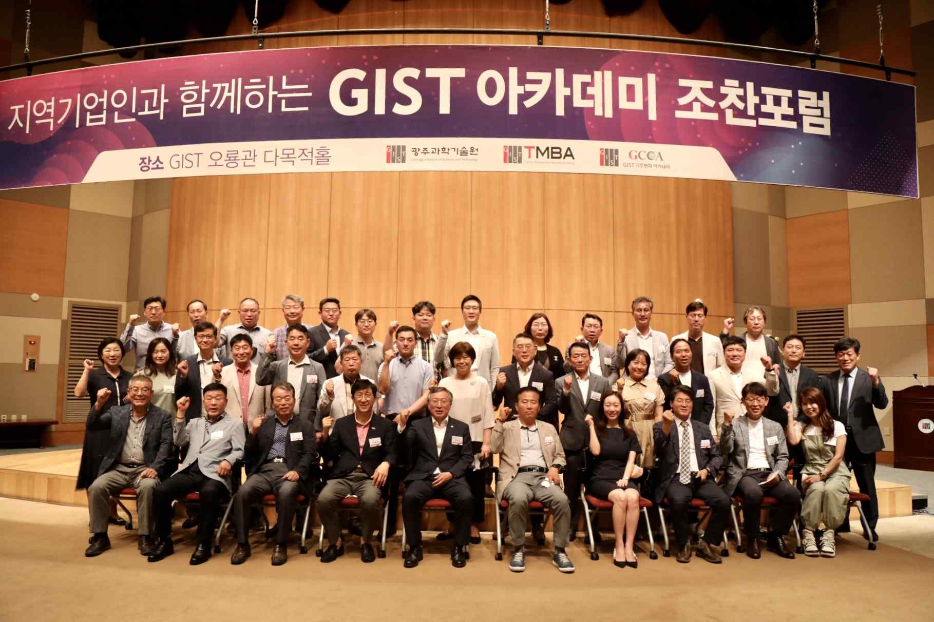
▲ (commemorative photo): GIST Academy June breakfast forum at Oryong Hall

GIST (Gwangju Institute of Science and Technology, President Kiseon Kim) Academy held the June Breakfast Forum on June 27 (Mon) at Oryong Hall with about 50 representative from companies from Gwangju and Jeonnam on the theme of 'Personal Branding and Speech for Me and the Company.'

Anasta Communication CEO Jin-young Park was invited as the speaker of the forum on this day and stirred the interest of the attendees with a lecture on consulting that can enhance the competitiveness of the industry with branding so that entrepreneurs in limitless competition can differentiate themselves from other companies.

CEO Park explained that the definition of personal branding that makes a person's and the company's identity is "a process that increases my own value that is differentiated in a specific field and makes me recognized," and explained strategies to create unique identity of "Nadaum" and "Inalternative" and branding my company.

In addition, CEO Park explained ▴ speech that can give confidence ▴ comfortable speaking ▴ speaking well using the emphasis method, etc. as speech skills for good communication, and he emphasized the importance of directing posture, gaze, and facial expression.

The GIST Academy operates the Techno Management Business Academy (opened in 2010) and the Climate Change Academy (opened in 2016) as non-degree programs. The 'GIST Academy Breakfast Forum' is held on the last Monday of every month, inviting experts from various fields as lecturers for alumni and local business executives.

GIST Academy is a business environment where managers in each field give lectures by the best experts in Korea. It fosters global management strategies and a sense of culture, supports the formation of a wide human network, and contributes to the vitalization of the local economy and industry-university cooperation.



