GIST - Intel Korea Co., Ltd. nurtures semiconductor programming talents!

– 6.23.(Thu) Signed a business agreement for the operation of FPGA programming training courses, etc.
– July Intel FPGA Verilog programming training opened, support for digital field basic competency development

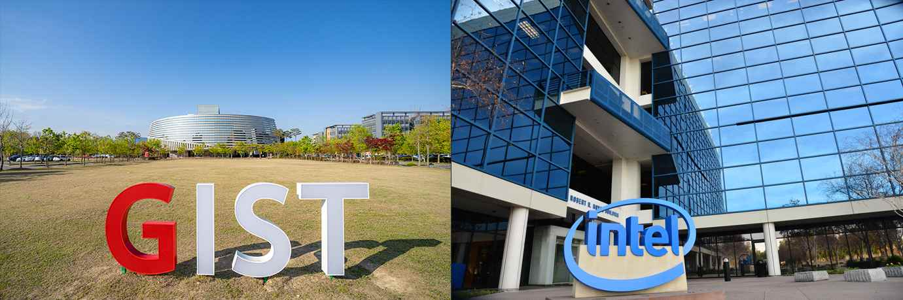
▲ GIST campus and Intel headquarters

GIST (Gwangju Institute of Science and Technology, President Kiseon Kim) and Intel Korea (CEO Myung-sook Kwon) signed a memorandum of understanding to nurture talent and strengthen competitiveness in field programmable gate array (FPGA), a type of non-memory semiconductor that can be programmed.

Through this agreement, GIST and Intel Korea Co., Ltd. will △ operate an FPGA education and training center using the Intel Developer Toolkit △ support for proof of concept PoC) with various companies △ cooperate in developing practical FPGA advanced courses △ promote the FPGA educational toolkit and education completion support.

First of all, the 'Intel FPGA Verilog Programming Curriculum' will be operated as part of the K-Digital Platform project (Research Director: DukJo Kong, Head of Research and Innovation Center / Adjunct Professor at GIST AI Graduate School) organized by the Ministry of Employment and Labor from July 4 to 8.

Starting with this training course, both sides opened a curriculum that was expanded to intermediate and advanced levels and cultivated professional workers to develop home appliances in Gwangju. By matching so that electronic companies can easily apply the latest semiconductors such as FPGAs, it plans to add strength to Gwangju, an artificial intelligence city that prepares for the digital transformation era.

GIST President Kiseon Kim said, "Through FPGA programming education, many students expect to grow into outstanding talents in the digital field. In the future, we will do our best to open various educational courses and cultivate advanced scientific and technological talents through close cooperation with Intel."

Intel Korea Co., Ltd. CEO Myung-sook Kwon said, "As the demand for skilled workers is expected to increase in the semiconductor industry, talent development is becoming increasingly important for future growth. Through this cooperation, Intel Korea will generously support the development of appropriate training courses and toolkits, and it is expected that this will contribute to nurturing young talents who will contribute to national competitiveness."

Meanwhile, the signing ceremony was held on June 23rd (Thursday).



