"Joint research for the development of the senior-friendly industry in the era of the 4th Industrial Revolution"

– Business agreement signed with the GIST Senior Friendly Industrial Support Center - Seongnam Senior Industry Innovation Center

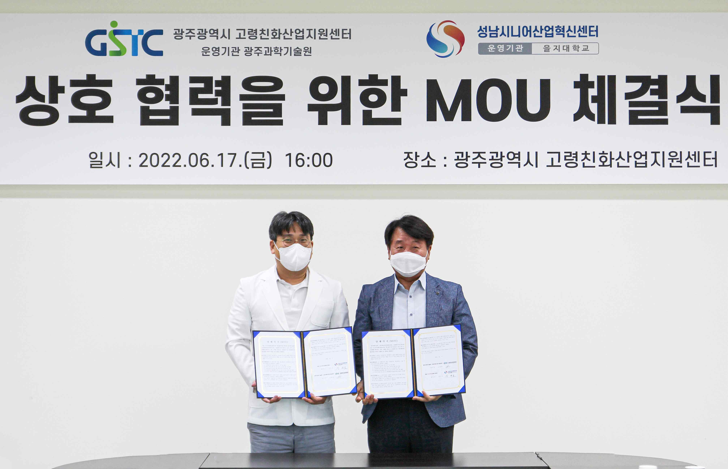
▲ GIST Senior Friendly Industrial Support Center and Seongnam Senior Industry Innovation Center are taking a commemorative photo after signing a business agreement for the development of an aging-friendly industry on Friday, the 17th. (From left: GIST Senior Friendly Industrial Support Center Director Chang-Myung Oh and Seongnam Senior Industry Innovation Center Director Gyu-ho Kim)

GIST (Gwangju Institute of Science and Technology, President Kiseon Kim)Senior Friendly Industrial Support Center (Director Chang-Myung Oh, Department of Biomedical Science and Engineering professor) signed a business agreement with Seongnam Senior Industrial Innovation Center (Director Gyu-ho Kim, Eulji University professor) for 'senior-friendly industry development.'

According to this agreement, the two organizations plan to actively cooperate for △ research on the development of an aging-friendly industry △ joint cohort study* △ industrial promotion policy development and joint project planning △ sharing infrastructure owned by institutions.

* cohort study: Refers to a group that shares characteristics such as region and occupation at a certain point in time. A cohort study is an epidemiological study that investigates personal information and eating habits of such a cohort group and then follows them for a long period of time to identify causal relationships between disease occurrence and health status.

The signing ceremony was held on the afternoon of June 17 (Fri) at the GIST Senior Friendly Industrial Support Center located in Nam-gu, Gwangju Metropolitan City, in the presence of the heads of the centers of the two organizations and the of the Gwangju Metropolitan City Future Industry Policy Division Director Hyung-joo Park.

The two institutions have been laying the groundwork for fostering age-friendly industries in each region, starting with the 2008 selection for the Ministry of Trade, Industry and Energy's comprehensive experience center for age-friendly products and services.

This agreement is in line with various efforts made so far to foster the elderly-friendly industry as a national growth engine industry and was promoted to actively respond to the aging-friendly industrial ecosystem that is changing due to the 4th Industrial Revolution.

GIST Senior Friendly Industrial Support Center Director Chang-Myung Oh said, "To accommodate innovative products and services based on various intelligent technologies following the new paradigm shift in the aging-friendly industry, we are laying the foundation for senior-friendly industry convergence technology, such as joint R&D with local companies and related policies and institutional research. It is expected that the two organizations will be able to create a great synergy effect in responding to changes in the aging-friendly industry ecosystem caused by digital transformation by sharing the convergence technology, equipment, and manpower possessed by the two institutions and establishing a multi-faceted mutual cooperation system."

Seongnam Senior Industrial Innovation Center Director Gyu-ho Kim said, "The Innovation Center is promoting various projects for the senior-friendly industry, such as commercialization support, technology convergence R&D, and operation of the senior living lab. By doing so, we are helping domestic senior-friendly companies to advance into overseas markets by increasing their competitiveness. In addition, this agreement is expected to have a positive effect on the innovative growth of the domestic aging-friendly industry."

Located at 37 Deoknam-gil (156 Haengam-dong), Nam-gu, Gwangju Metropolitan City, the GIST Senior Friendly Industrial Support Center is an experience space of about 470 pyeong for fostering an aging-friendly industry. It reopened on June 2nd by creating a △ living lab-based research facility along with a space where you can experience various contents such as △ healthcare △ entertainment △ planned exhibition zone.

As a hub for technology commercialization and creation of an age-friendly convergence industrial base that reflects the 4th industrial Revolution technology trend, the experience center is striving to strengthen the senior-friendly industry ecosystem and build a profit-generating model.

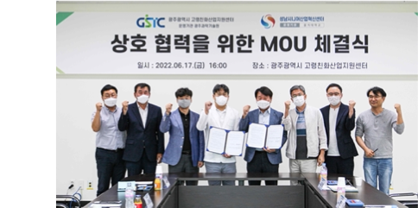
▲ (From left) Director Lee Sang-yoon of the Future Industry Policy Division of the Artificial Intelligence Industry Bureau of Gwangju Metropolitan City Hall, Nam-pyo Hong, Deputy Director of the GIST Senior-friendly Industry Support Center, Park Hyung-Joo, the Medical Industry Team Manager of the Future Industry Policy Division of the Artificial Intelligence Industry Bureau of Gwangju City Hall, and the GIST Senior-friendly Industry Support Center Director Chang-Myung Oh, Seongnam Senior Industrial Innovation Center Director Gyu-ho Kim, Deok-young Jeong, Deputy Director, Jang-won Han, General Team Leader, Min-seok Kim, Senior Researcher, GIST Senior-friendly Industry Support Center



